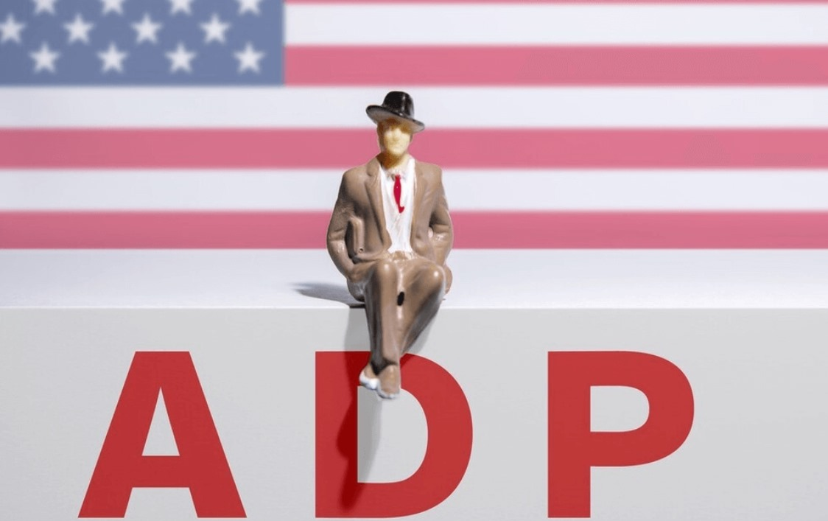

The private sector employment data released this morning showed a wave of layoffs spreading among small businesses, with the largest decline in employment since March 2023.

Following this data release, it indicates the current economic slowdown, which serves as an important signal for the Federal Reserve to consider cutting interest rates.

As a result, expectations for a July rate cut are rising.

However, nothing is certain yet. ADP data often sets the tone ahead of the official Non-Farm Payrolls report. But the market is already getting excited about the growing expectations for rate cuts…

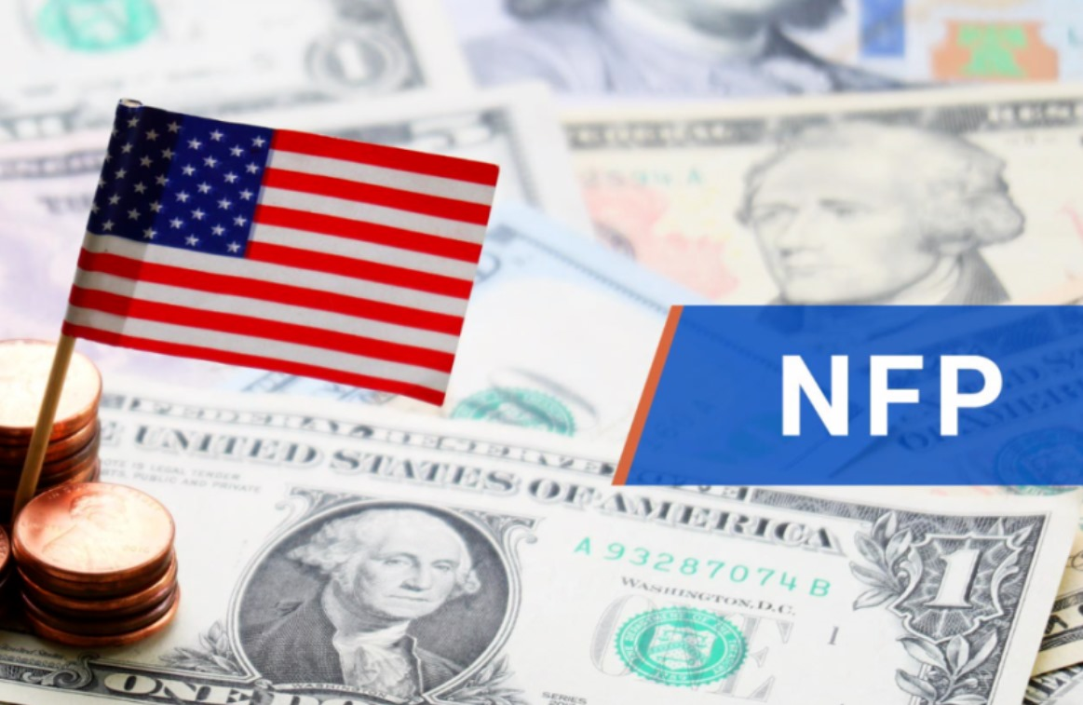

Here’s the latest update: Due to the U.S. Independence Day holiday, the June Non-Farm Payrolls report will be released earlier—at 8:30 AM ET on July 3rd.

On Thursday, U.S. markets will close three hours early, and the Non-Farm Payrolls report will be announced. So, what does that mean for all of us?

The Non-Farm report has been moved up to Thursday because of the holiday.

This data is expected to serve as the first critical signal to test the market’s expectations for rate cuts.

Meanwhile, it overlaps with several other risk events, including the trade agreement deadline and the vote on the “Big & Beautiful Act,” which together could trigger significant market volatility.

As of now, the outlook suggests the Non-Farm data will likely disappoint.

Plus, considering the latest round of layoffs at Microsoft, there’s a real possibility we’ll see a rise in unemployment.

That’s the uncertainty we’re stepping into tomorrow—the potential challenge of navigating heightened market volatility.

But personally, I lean toward the view that expectations for rate cuts will continue to strengthen.

The main reason is the weak employment data, which signals an economic slowdown—and that provides both data support and policy guidance for the Federal Reserve.

Of course, the Fed would prefer to see more certainty on the tariff front to help curb inflation—that would make the case for rate cuts even clearer.

Obviously, tomorrow—Thursday—offers only a half-day trading window. Many of these uncertainties will have to wait until next week to be resolved.

Meanwhile, the Big & Beautiful Act is making steady, albeit difficult, progress. Despite the challenges, there’s growing consensus around tax cuts, expanding the fiscal deficit, and raising the debt ceiling.

No matter how strongly people express opposition, what’s becoming clear is the country’s underlying political will and its determination to demonstrate real strength.

We need to understand—economic decisions require strong political tools to support them.

Because the credibility of U.S. Treasury bonds overrides everything. As long as the U.S. avoids default, the nation’s financial integrity holds firm—and only with that foundation can investors feel confident that their returns are protected.

As for the tariff policy deadline, even though there’s still room for back-and-forth, I personally believe in Trump’s TACO approach—and the familiar pattern in his leadership style: aggressive moves first, followed by negotiation and de-escalation.

That’s why I see this creating clear trading opportunities driven by market optimism.

The impact of tariffs is already diminishing at the margins, and right now, the only real reason for the Fed to resist cutting rates is the uncertainty surrounding tariffs.

But this tug-of-war is being overshadowed—and potentially neutralized—by the likely weakness in the upcoming Non-Farm Payrolls data.

There’s really only one scenario that could change this: if the Non-Farm data comes in surprisingly strong, with unemployment falling, that would almost certainly shut the door on a July rate cut.

But for now, speculation and anticipation have become the defining theme of Wednesday’s market dynamics.

So the real question is—what actions should we be taking? What hidden opportunities should we be looking for? And what have our past experiences already proven to be our key advantages?

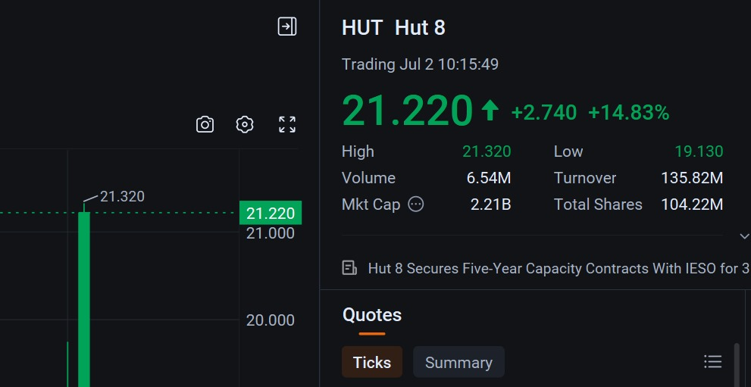

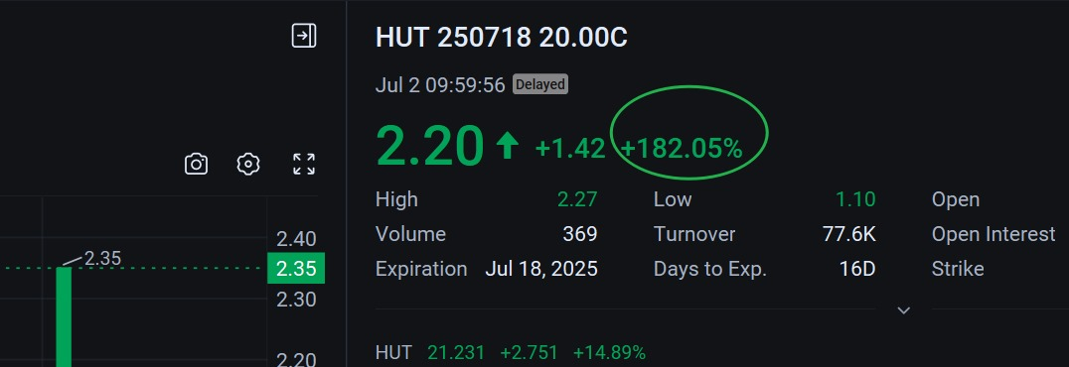

First, I want to sincerely thank every one of you who enjoys our quantitative strategy shares. I truly appreciate your participation in our compensation-backed verified stock trades!

You came because of trust—and we return profits to you.

Take a look at the stocks we’ve shared—how many have you been involved with?

One recent standout is HUT.

It’s the best gift I want to offer you this week!

Combining power energy and mining attributes, its sharp rise today was mainly driven by a five-year power capacity contract in Canada. This deal triggered an explosive jump in its valuation!

That led to a strong rally, with HUT’s options generating profits exceeding 200%. Yes, you heard that right—200%. Unless you missed that signal!

So whether you hold the stock itself or trade options, you directly gain from exercising at the target price. This creates a perfect safety-net trade and experience for you!

Do you like quantitative strategies like this?

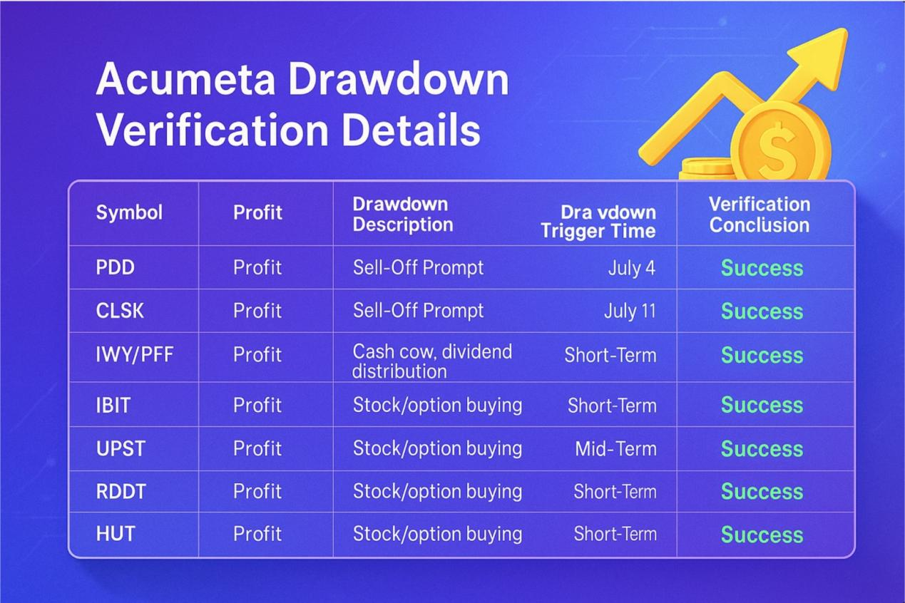

Other important verified stocks have continued to rise: IBIT, MSTR, RDDT, and UPST.

Of course, there are also dividend-sharing ETFs like IWY and PFF.

I deeply understand that the long-term value and short-term effects created by this portfolio mix complement each other beautifully!

Since you’ve just joined us, it’s important for you to gain a comprehensive understanding of who we are.

Right now, you know very little about me and about Acumeta, so I’m waiting for you to participate—and to share your honest impressions and experience.

My hope is that one day, just as we’re doing the right things now, you’ll regularly reflect this in your investment journey—and that after adopting and using Acumeta, it will all become even more real.

Our compensation-backed trades are not the goal in themselves. We aim to provide security and protection. We focus on safe investing and efficient profit generation—doesn’t that align with what you want?

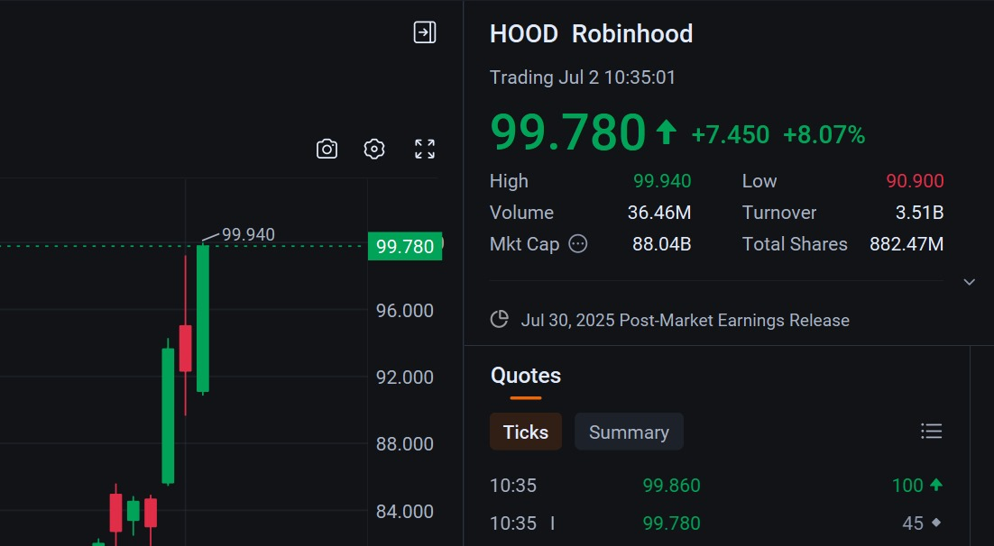

In yesterday’s quantitative strategy insights, I mentioned a key stock—HOOD.

Robinhood is a cutting-edge trading platform that integrates both crypto and traditional equities, and it has become incredibly popular across the U.S.

Recently, Robinhood dropped several “major bombs,” announcing plans to launch stock tokenization and staking services.

For years, the lack of real interaction and smooth liquidity between traditional capital and crypto has been a constant frustration for many in the digital asset space.

But since early 2024, things have started to shift. The approval of Bitcoin spot ETFs opened the door for traditional capital to engage with crypto, marking a new wave of institutional participation.

But in my view, that’s still not enough. The most critical link for true synergy—stock tokenization—has yet to unleash its full potential.

Among the players moving into stock tokenization, Robinhood stands out for its strong compliance track record. The company has also announced that it will offer stock tokens of OpenAI and SpaceX to users in the European Union—a clear sign of democratizing private equity markets.

Retail investors can now access stocks that were once entirely out of reach.

This is our opportunity to prove to the world what we’ve believed all along: crypto is so much more than a speculative asset. It has the potential to become a core pillar of global finance.

Over the past few years, Robinhood’s evolution—from a retail-focused brokerage to a rising crypto leader—has gone through its share of industry highs and lows. But looking back, it’s clear now that every step has been leading to this moment.

First, let’s address the obvious question — is this stock still worth buying?

In my view, HOOD reaching a $100 billion valuation is inevitable. So yes, I believe it’s worth buying — but be mindful of your position sizing, especially given the current price level, which is relatively high.

Beyond buying the underlying stock, I actually recommend considering options as your entry point, because options offer a lower-cost way to participate.

It’s all about understanding time value:

So, here’s my suggested options trade — HOOD 250801 115.00 CALL. Right now, the option premium is fluctuating around $4 per contract.

That means, for just $4 per share, you gain the right to capture the potential profit from one share of HOOD.

Given that the stock price is already approaching $100, this presents an efficient, lower-cost, time-sensitive way to get involved.

If this approach resonates with you — a strategy focused on lower capital outlay, higher potential returns, and leveraging time value — this could be your move.

And let’s imagine the stock continues to climb tomorrow, or next week. As the option premium rises, you could choose to sell early and lock in your profit — that’s essentially exercising your profit rights ahead of expiration.

Today’s recommended stock for a protective trade is RGTI, with a maximum holding period of 14 days. Suggested purchase size: 100 shares.

You can choose to trade either the underlying stock or participate through options.

If you prefer the options route, feel free to reach out to my assistant for the latest signals.

RGTI specializes in ultra-low-latency, integrated, practical quantum computing—and they already have hardware-level chip processors in place.

Looking at the current charts and technical setup, this stock is in a strong position for tactical trades. Plus, with the added tailwind of potential rate cuts, the stock price has room to continue climbing.

Now, circling back to HOOD. Its recent price rally is largely driven by the excitement around real-world assets being brought on-chain—a trend that’s fundamentally reshaping valuations.

One of the most talked-about examples? Robinhood’s upcoming launch of tokenized shares of OpenAI and SpaceX.

Naturally, that raises a fair question: neither OpenAI nor SpaceX is publicly listed, so how is this even possible?





What kind of Real World Asset (RWA) value can we actually derive from the tokenization of shares from these two iconic, yet still private, companies?

First, let’s be clear—every company has shares. It’s just that some are publicly traded, while others remain in private markets.

The fact that these two high-profile companies have chosen to partner with Robinhood to tokenize their equity—and make it accessible to the global crypto community—is not only a milestone for financial innovation, it’s a major win for blockchain technology itself.

It reminds us that bringing real-world assets on-chain doesn’t have to wait for a company to go public.

In reality, as we discussed yesterday, almost anything can be tokenized—a project, a company, even government bonds. The possibilities for on-chain assets are nearly limitless.

And in that same spirit, the token vouchers you received today through our Quant Think Tank follow the very same logic.

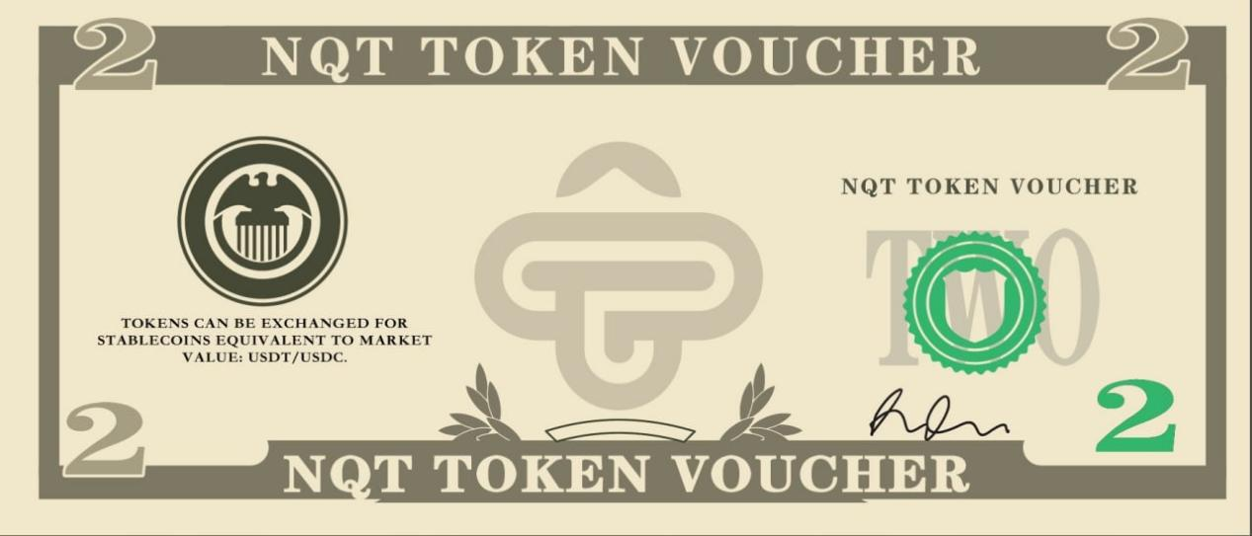

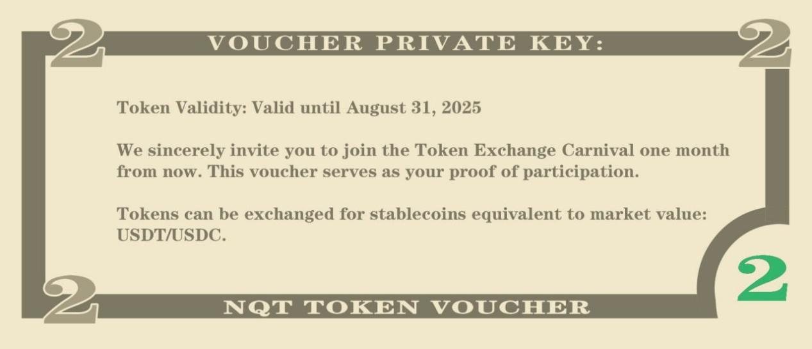

When you join our NOVA Quantitative Think Tank Center, we reward your participation, collaboration, and feedback with our own token as an incentive.

So, what exactly is a token voucher?

Think of it as the tokenized representation of our on-chain assets within the Think Tank. In other words, it’s similar to holding a digital share of our yet-to-be-listed equity—packaged as a token.

This token voucher serves as proof of ownership for the tokens you’ve been granted. But more importantly, it symbolizes the partnership we’re building together—one rooted in mutual support, shared achievements, and long-term collaboration.

Through this process, we aim to earn your trust by delivering verified, data-driven results. That’s how we collectively advance both our quantitative strategy ecosystem and Acumeta itself.

And as we grow—expanding our impact, elevating our valuation—the value of those tokens you hold will continue to rise.

In this way, your token voucher isn’t just a gift—it’s a reflection of trust, and a tangible piece of the long-term value we’re creating through disciplined, intelligent quantitative strategies.

Do you love the sound of that?

This morning, after I presented my analysis on the potential rate cut in July, both the U.S. stock market and the crypto market showed a strong upward move.

It’s been incredible to witness this wave of capital excitement together — a true celebration of the markets.

Unfortunately, a few people joined us a little too late and missed out on some of the more abundant profit opportunities.

But the good news is — every moment is the best moment to start. Why do I say that?

Because the story of wealth in our Quantitative Think Tank Community starts with our token vouchers.

And I hope they bring you all the good luck and momentum you need for the second half of the year!

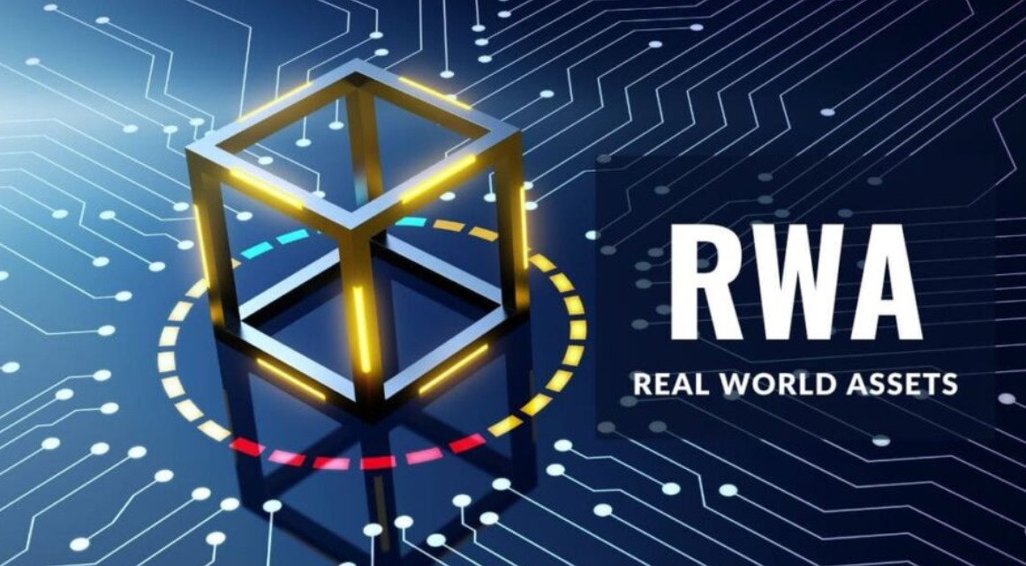

Over the past two days, I’ve shared my thoughts on the innovative financial trend of real-world asset tokenization — and how that connects to the strong rally we’ve seen in HOOD stock.

This is a company that combines crypto and stock trading services, now stepping into a new era of tokenized stock licenses.

So, what exactly is stock tokenization? Simply put, it means taking the stocks we see and trade every day on markets like Nasdaq, and representing them in tokenized form.

The only real difference? One trades on traditional U.S. exchanges, the other trades through global crypto trading platforms.

In the first case, the trading currency is U.S. dollars. In the second, the trading currency is digital — it could be BTC, ETH, or most likely a stablecoin.

But as we know, stablecoins are pegged to the value of the U.S. dollar — essentially maintaining a 1:1 exchange rate.

So, when you look at it this way, the structure feels different, but the underlying value is fundamentally the same.

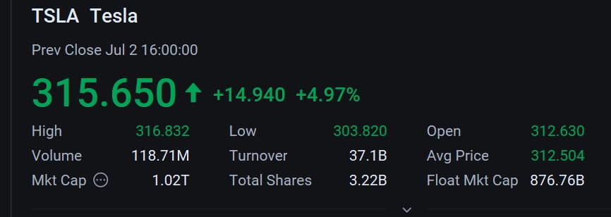

Take $TSLA for example — today, we saw a strong rebound in the U.S. stock market, and its corresponding tokenized stock mirrored the same upward move.

The reason is simple: the value of the token is directly pegged to the value of the stock itself.

When the stock’s valuation rises, the token’s valuation rises with it.

So, at its core, the purpose of stock tokenization is to make trading more accessible and to expand the range of trading opportunities. Beyond that, the analytical logic behind tokenized stocks remains consistent with traditional stocks — it’s really straightforward.

But what happens when we’re talking about a company that isn’t publicly listed yet?

How do we determine the value of its tokenized stock?

Just like Robinhood is preparing to tokenize the shares of two globally recognized tech giants — OpenAI and SpaceX — how should we understand the pricing logic behind these tokens?

According to Acumeta’s comprehensive data analysis, top-tier Wall Street institutions currently value OpenAI at $300 billion and SpaceX at $350 billion.

But how are these valuations determined?

In fact, these valuations are based on “private transactions” — meaning they’re not priced through a public stock exchange, but rather through deals made on private markets or through employee stock option liquidity events.

It’s similar to how highly anticipated pre-sale products work — they haven’t officially hit the market yet, but eager buyers are already willing to pay a premium.

This kind of valuation acts like an early “market value label.” It reflects not only the market’s confidence in the company’s future potential but also provides employees and investors with a potential liquidity path.

Exactly — whenever a project, a unicorn company, a highly creative product, a piece of art, or even traditional assets like government bonds establish a valuation, they naturally establish a price.

So, once that asset is brought on-chain, it immediately gains a price anchor for its token.

Take OpenAI as an example. With a $300 billion valuation, if you divide that by the total number of shares, you get the price per share — or in this case, the price per token.

That’s the key to understanding how token pricing works for companies that haven’t gone public yet.

And of course, looking at it from the other side, when a company’s valuation continues to rise, its tokenized stock price will increase accordingly. It’s a direct, proportional relationship.

Does that make sense to you?

With those two well-known examples of stock tokenization from leading companies, it becomes much easier to understand the concept behind our token vouchers.

As a forward-thinking Quantitative Think Tank Center rooted in frontier technology and venture capital, we’ve built Acumeta — a world-class financial tool designed to help investors access investment solutions that go beyond the limitations of traditional markets. It’s built to assist you intelligently, providing the safest and most optimized protection for your capital.

As you probably know, we are working hard to strengthen both our brand presence and user value. Our clear goal is to reach a $3 billion valuation. Right now, we’re still in an undervalued stage at $500 million.

But as we continue to grow, achieving that goal is only a matter of time. And along with that growth, the value of our token will rise as well — both its price and market capitalization will deliver meaningful premium returns.

The long-term development and continuous optimization of the Acumeta quantitative system requires significant investment. That’s why, from the very beginning, we’ve been committed to driving innovation at the intersection of AI and blockchain — and using this approach as a means to secure funding. In this process, our token serves as the financing vehicle.

The more people recognize the value of our quantitative strategy services and the strength of our research team, the more buyers we attract — especially institutional capital.

That’s the motivation behind our hard work and dedication every single day.

Even if you’ve only recently joined our community, or have been enjoying our wide range of services — all of that is offered to you for free.

Because right now, we’re focused on validating and proving the true value of Acumeta. And I believe it won’t be long before more institutions join in and compete to get involved — naturally driving our valuation higher and higher.

So why is it that today we’re only offering token vouchers from the Quantitative Think Tank Center — and not the actual tokens themselves?

That’s such a great question.

A voucher, in essence, is a promise — it represents trust, a shared belief in value, and reflects exactly what decentralized blockchain technology is designed to protect: transparency and integrity that cannot be tampered with.

We don’t want to rush into promoting or distributing tokens before you’ve had the chance to truly experience our platform and independently validate its performance.

We believe the most genuine respect we can show to investors is giving them space to build objective awareness and real conviction, based on their own experience and results.

That’s why, when we want to express our gratitude and encouragement, we choose to do it through token vouchers — just like receiving a Walmart voucher that can be redeemed once certain conditions are met.

It’s really that simple.

So tell me — are you ready to keep engaging, to share your feedback, and explore with us? Do you want to see Acumeta grow stronger? And are you excited to watch your trading signals and returns here steadily increase?