The Impact of The Big Beautiful Act:

Winners and Losers:

Chip manufacturers, traditional energy companies, airlines, and manufacturers that produce within the United States will all receive significant tax breaks and policy support, which could drive their stock prices higher. That means, in the long run, stocks in these sectors have clear growth potential, and the tech stocks we hold are already benefiting from this trend.

However, at the same time, certain subsidies for electric vehicle producers are being removed, logistics companies may lose tax exemptions on small parcels, and some healthcare and welfare programs could face challenges.

Tesla’s significant drop at the market open today clearly reflects this negative impact.

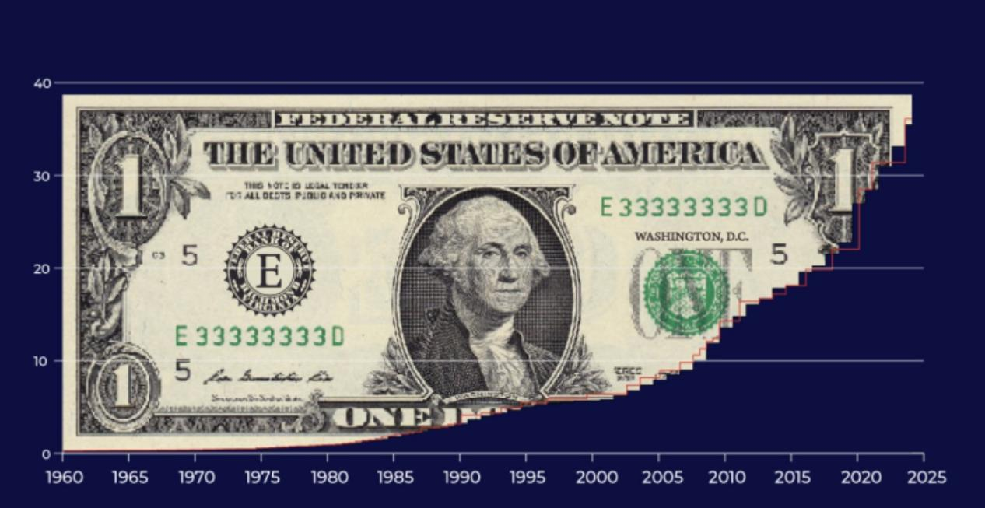

Fiscal Deficit and Inflation: U.S. National Debt Approaching $40 Trillion

The massive spending under this Act will further expand the U.S. federal deficit, which could push Treasury yields higher and increase inflation expectations.

If inflationary pressures persist, the Federal Reserve will likely become even more cautious about cutting interest rates — and that could weigh on growth-oriented tech stocks, especially those tied to blockchain innovation.

We already saw a short-term dip in these stocks on Monday, mainly driven by emotional sell-offs rather than fundamental risks.

But this kind of short-lived pullback isn’t a deeper market threat — in fact, it’s a chance to buy quality assets at better prices.

Why do I say that?

Because the inevitable expansion of U.S. Treasury issuance can only happen under a lower interest rate environment to ensure affordable financing and borrowing costs.

At the simplest level, U.S. Treasuries are the government’s way of borrowing money — backed by America's reputation and legal credibility — in exchange for fixed interest payments. Each Treasury bond is essentially a formal loan certificate.

Since new U.S. Treasury issuance is only favorable in a low-interest-rate environment, a Fed rate cut is inevitable!

So, why won’t we see a rate cut in July?

In last Thursday’s analysis, I already shared my core view on this, but I want to expand on that today: The ongoing economic growth and declining unemployment rate are giving the Federal Reserve more time to evaluate their policy decisions.

That’s exactly why this month’s CPI report is especially critical.

We all know the Fed is focused on controlling inflation — but they also want to see steady economic growth, fewer layoffs, and more jobs created.

However, the lasting effects of current tariff policies are driving up long-term inflation pressures, which is delaying the Fed’s decision to cut rates.

Why do I believe that we’ll see a rate cut in September?

One of the key reasons is the Non-Farm Payroll data — and the evolving tariff situation also plays a role.

Looking back to last Thursday, right before the official jobs report, the ADP numbers showed a decline in private-sector hiring. Yet, the Non-Farm Payroll data still came in with an increase.

What does that tell us? It reflects job growth primarily within the public sector, including a rebound in federal employment after layoffs within the Department of Government Efficiency came to an end.

In reality, this points to deeper, hidden risks of economic slowdown or even stagflation.

That’s exactly why I believe the Non-Farm Payroll report for July won’t reflect overly strong expectations for economic growth.

On another note, the new tariff policy originally scheduled for April was delayed to July 9th, and its enforcement has been postponed again to August 1st.

What does that timing signal?

No matter how the negotiations play out, this delay has effectively given global suppliers and buyers over three months to complete shipments and fulfill orders ahead of the tariff implementation.

Those deliveries, of course, aren’t affected by the updated tariff rules — which means in the short term, we are unlikely to see significant inflationary pressure in the U.S.

And that is exactly one of the subtle but crucial reasons I remain optimistic about the likelihood of a rate cut in September.

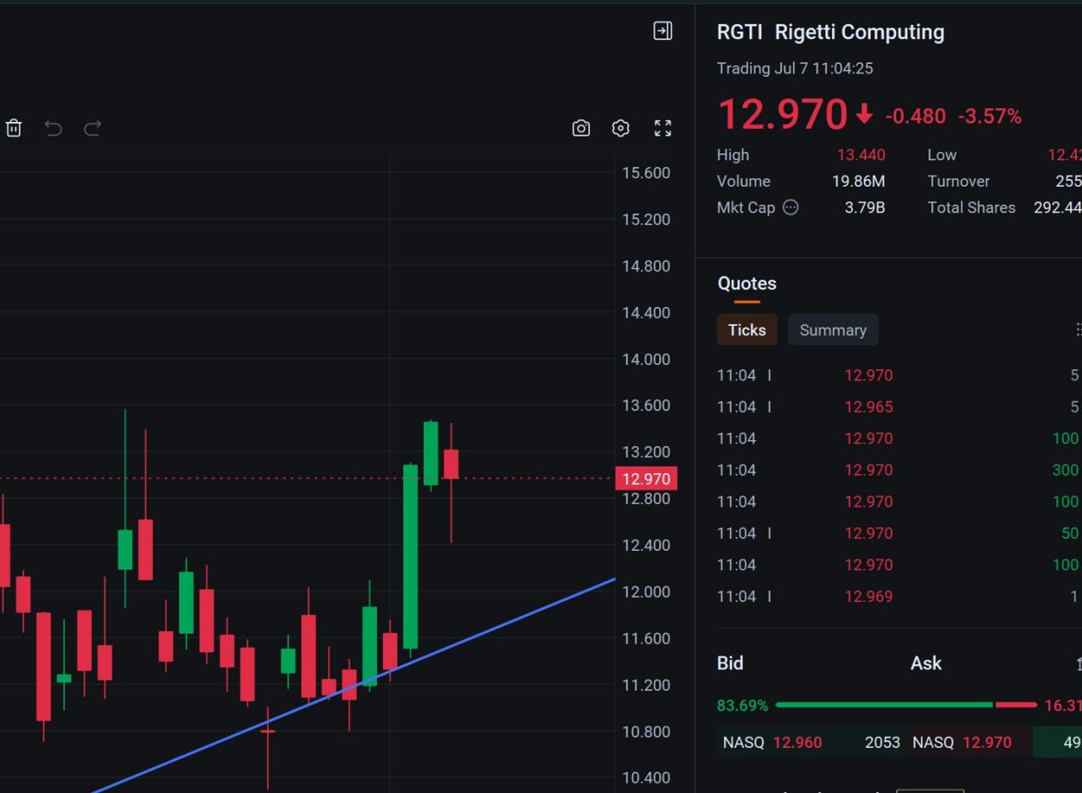

So holding some stocks in the blockchain space won’t be negatively impacted—in fact, it’s a continued buying opportunity!

Certain tech stocks are benefiting from the tax breaks in the Big Beautiful Act. For example, after a steady rise, RGTI saw a slight pullback today, which actually signals another chance to buy ahead of the next upswing.

In last week’s trading progress, your compensation-backed validation method remained effective.

Meanwhile, HOOD continues to offer you opportunities to participate. This crypto trading platform is riding the wave of stock tokenization, with its future valuation poised to grow significantly—potentially reaching the hundreds of billions.

These trading targets highlighted Monday’s new winners, and community members who have already joined are now enjoying well-deserved profits!

An even more important hedge trade to keep your eye on: UVXY and UVIX.

After consolidating at lower levels last week, both finally delivered visible hedge performance on Monday. As market fears around the looming tariff deadline and broader uncertainty spread again, these volatility indexes pushed higher — boosting ETF returns in the process.

This type of risk-hedge strategy works especially well in the lead-up to major data releases or policy shifts.

And when the volatility index is hovering near historical lows, building short-term hedges like this aligns perfectly with tactical trading logic.

If you followed my recommendation last week and entered this trade, I suggest continuing to hold for now — aiming for a target exit once we see gains exceed 5%.

Remember, the goal of hedging is to protect your portfolio from sharp market downturns or panic-driven selloffs. This isn’t a long-term profit strategy — it’s designed for short-term application only!

The Nasdaq just hit its fourth record-high close of the year.

Many market indicators are flashing signs of overheating — and we’ve officially entered that familiar tug-of-war moment between sellers locking in profits and new buyers chasing momentum.

In the short term, there’s still room for the market to grind higher — we could easily see the Nasdaq stretch toward 20,800 to 21,000, and the S&P 500 toward 6,500.

But let’s be honest — that upside doesn’t justify the level of risk we’re facing right now. For us, it’s time to shift fully into defense mode.

Looking at recent performance, the Dow Jones has been particularly resilient, gaining 2.3% over the past week.

Following last week’s stronger-than-expected jobs report, the broader market surged to new all-time highs, and naturally, there’s growing speculation the Dow could keep pushing higher.

We’ll be watching closely — and if we see those new highs materialize, it’ll be a perfect window for us to start trimming some equity positions.

The Big Beautiful Act

On the surface, it’s a tax cut. But let’s be honest — it’s wealth redistribution disguised as policy, and not in a way that helps the people who need it most. Beneath the headlines, this act delivers a sharp blow to the clean energy transition. Subsidies for electric vehicles? Gone. Just like that, Tesla’s $1.2 billion a year in government support has vanished overnight.

Meanwhile, funds slashed from social programs have been quietly redirected to support traditional energy and military spending. Unsurprisingly, Musk wasn’t having it — he fired off 23 back-to-back tweets slamming the bill as “a recipe for national bankruptcy” and warning of “debt slavery.” And in true Elon fashion, he’s launched the America Party, aiming to disrupt Congress and break the two-party gridlock.

Musk is ready to throw $20 billion behind this political project — but the markets clearly aren’t impressed. Tesla’s stock plunging in pre-market trading says it all.

At the same time, Trump has played his next card in this high-stakes game: a wave of 12 global tariff ultimatums, with rates starting at 10% and topping out at 70%, squarely targeting China, India, and other BRICS-friendly nations. His message? Take it or leave it.

But here’s the strange part — markets are unusually calm. Just back in April, the mere threat of tariffs sent stocks tumbling. But today? The S&P is hitting fresh highs, and the VIX, Wall Street’s fear index, barely budges.

Why? Because Wall Street has been betting on what insiders are calling the TACO trade — Trump Always Chickens Out.

But I wouldn’t be so sure this time. Trump’s poll numbers are slipping, key swing states are in play, and he’s desperate to revive his “tough guy” image. Tariffs are his political gamble that could define his campaign. The delay is until August 1st? Just buying time. The real tariff shockwave hasn’t even landed yet.

I’ll be back tomorrow with a complete breakdown of this week’s trade roadmap. Stay tuned — we have a lot to navigate together.

Today, the US stock market fluctuated and fell, mainly affected by the various changes in tariff negotiations. The market view is more patient than in April, and everyone can better understand Trump's concessions on tariffs.

This expected judgment puts temporary pressure on the stock index. Panic sentiment rose slightly on Monday, and the willingness to sell was not strong, so after the stock index fell, the willingness to buy increased.

Therefore, it can be foreseen that TACO is expected to become a new sentiment indicator for the stock market.

Trump's new tariff deadline window on August 1 will naturally not bring greater surprises. The market's rational view of this has brought new trading opportunities this week.

Many of you may have been wondering — why did Trump insist on launching a tariff war? And why hasn’t the Biden administration taken such aggressive action?

If you’re already asking these questions, it shows you’ve started thinking more deeply — analyzing investment from a broader, long-term perspective.

First, we need to understand this fundamental concept: when countries do business with each other, when goods and resources are exchanged across borders, we call that trade.

And trade relies on currency as its foundation. But there’s no single, unified global currency, so exchange rates and foreign reserves play a critical role in this system.

Let’s say Country A wants to sell goods to the United States — they receive U.S. dollars in return. But if Country A also wants to buy American high-tech products, they need U.S. dollars to do so.

In this kind of trade relationship, if Country A consistently sells more goods and resources to the U.S. than it buys from the U.S., the result is simple: the U.S. ends up paying more dollars to Country A. In other words, Country A profits from the trade, while the U.S. plays the role of the consumer, spending its money in the process.

So under this scenario, what kind of economic changes does the U.S. face?

It leads to more capital outflow and more manufacturing shifting to lower-cost regions in Asia, which in turn drives up unemployment rates in the U.S. This is a key factor slowing down America’s economic growth.

At the same time, as a major consumer nation, the U.S. is heavily dependent on imported goods, which are easily influenced by price fluctuations driven by various global factors. When U.S. interest rates decline, it often triggers price increases and adds inflationary pressure.

This is why, during Trump’s administration, tariffs became a tool to try and rebalance trade.

Continuing with the example of Country A — Trump’s goal was for Country A to pay higher tariffs when selling goods and resources to the U.S., so the U.S. could collect more tax revenue.

Meanwhile, American exports of high-tech products to Country A would ideally benefit from lower or equal tariff rates, helping the U.S. earn more from that trade relationship.

This approach also encouraged U.S. companies to increase domestic investment, create more local jobs, and benefit from policies like The Big Beautiful Act — a series of tax incentives aimed at attracting capital back to the U.S.

In essence, this was Trump’s interpretation of making America great again — through trade, taxation, and strategic economic shifts.

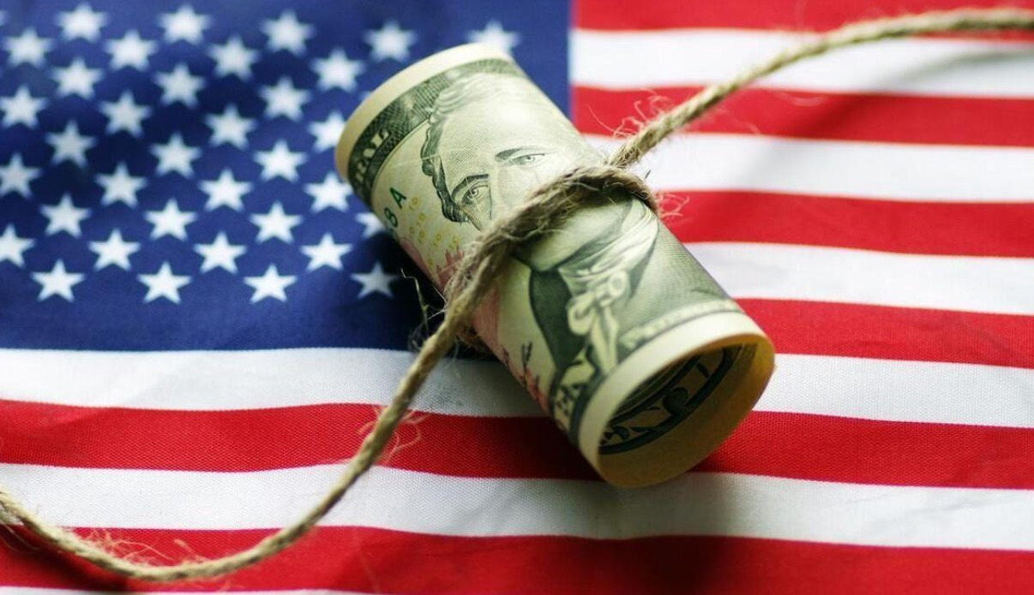

At a deeper level, tariffs are fundamentally tied to the strength of the U.S. dollar.

As we all know, the United States is a major consumer market. For countries around the world that want to sell their resources and products, the U.S. is a critical destination.

At the same time, the U.S. is a global leader in high-tech products and equipment — think AI, semiconductors, and other advanced technologies. If you want to purchase American high-tech equipment, you need to pay in U.S. dollars.

And the most direct way to acquire U.S. dollars is through trade — doing business with the U.S. and earning dollars through exports.

This global demand for access to the U.S. market naturally fuels the need for countries to hold U.S. dollar reserves. The tariff war, in this context, becomes a tool to influence and, in some ways, accelerate that reserve process.

If a country wants to earn more U.S. dollars, it may need to accept new terms or conditions in exchange for tariff exemptions. This, in turn, strengthens their position in trade with the U.S. — and gives them greater access to the dollars they’re pursuing.

This tariff-driven pressure ultimately serves one core purpose — to push other countries to accept higher quotas for purchasing and holding U.S. debt in the future.

That’s why negotiations are, at their core, a constant balancing act — both sides weighing the pros and cons of how they want to conduct business together.

If Country A is unable to establish more trade ties with the U.S., its companies may struggle to sell their products and generate profits. For Country A, this situation could trigger economic decline and rising unemployment at home.

Under that pressure, if Country A eventually agrees to Trump’s terms, the tariff situation can ease, creating more favorable trade conditions.

But if Country A refuses to accept Trump’s terms, tariffs will increase sharply, leading to a real risk of domestic economic downturn or even recession.

So what’s Trump’s real goal behind all of this? Selling U.S. debt. To put it simply — the idea is that you hold more of our debt, give those U.S. dollars back to us, and, in a way, lend the dollars you earned from trade right back to the U.S.

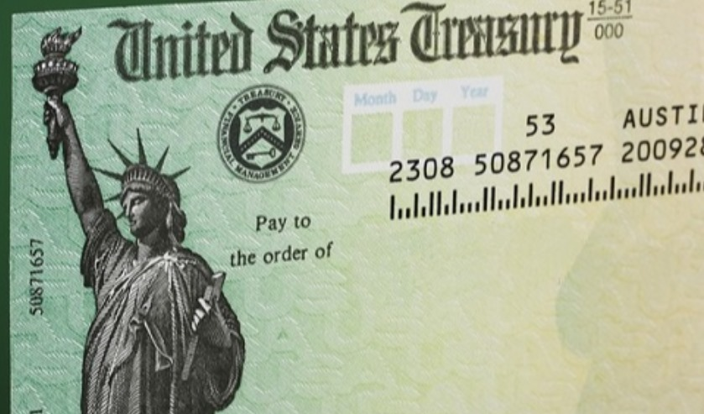

Yes, U.S. Treasury bonds are essentially an IOU — a formal certificate of debt.

The U.S. Treasury needs more buyers for its government bonds — and those buyers need to accept lower interest rates.

That’s exactly why the debt expansion under The Big Beautiful Act aims to push total U.S. debt to $40 trillion. Only then can fresh capital start flowing back into the U.S. economy, providing the liquidity needed for the next stage of economic growth.

With this in mind, we can better understand the core purpose behind tariffs — they are also part of the broader strategy to manage the U.S. debt crisis.

Trump is working on two fronts: securing the authority to raise the cap on new bond issuance, while simultaneously looking for new buyers for those bonds.

And the final piece of this puzzle? The Federal Reserve’s rate cuts.

When new government bonds can be issued at lower interest rates and attract more buyers, the financing generated doesn’t just cover old debts — it also creates room for renewed economic expansion.

That’s how Trump’s political agenda takes shape — leveraging debt, trade, and monetary policy to “Make America Great Again.”

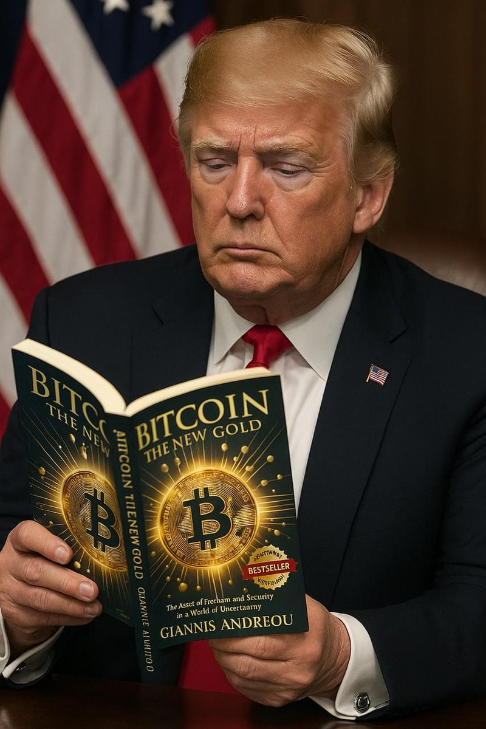

In this context, a different voice has started to emerge — some countries, let’s take Country A as an example, are beginning to explore ways to bypass the U.S. dollar in their international trade.

This approach is known as reducing dollar dependency.

So, how did Trump prepare for the potential downside of his tariff pressure strategy? How did he try to counteract the risk that countries might move away from the dollar?

The answer, in fact, lies in cryptocurrency — specifically, Bitcoin.

As for the deeper reasoning behind that, I’ll be sharing a full series of insights once I’m officially back with our regular sessions. So be sure to stay tuned for my daily updates.

Once we understand why Trump launched the trade war, and why it keeps getting extended — this time to August 1st — it becomes clear that the goal goes beyond short-term inflation relief. It’s also about securing more favorable negotiations with countries like A.

On the other hand, this also explains why the current market volatility hasn’t stopped the stock market from pushing higher in the short term.

Because we know, at a deeper level, the trade war is only the surface. The real objective is to ease tensions, gain leverage, and secure greater benefits through negotiation.