
Good morning folks, and happy Wednesday.

I'm the founder of the NOVA Quantitative Think Tank Center and one of the developers behind the Acumeta quantitative system. It's been a pleasure to hear many of you refer to me as “Doctor”—a title that momentarily transported me back to my academic years.

This forum is dedicated to the exploration and sharing of insights on quantitative strategies and systematic thinking in trading. I hope that by joining this community, you will find thoughtful approaches to some of the more complex challenges in your investment journey. It is also my aspiration that the platform we’ve built continues to deliver a steady stream of meaningful, well-structured content—offering you, at the right moments, practical decision-making signals to help restore clarity and confidence in your trades.

If you’re new here, please don’t hesitate to reach out to my teaching assistant, Claire Miller. She’ll guide you through our onboarding process. And should you be seeking additional support in the equity markets, I encourage you to approach with sincerity—we value genuine curiosity and goodwill.

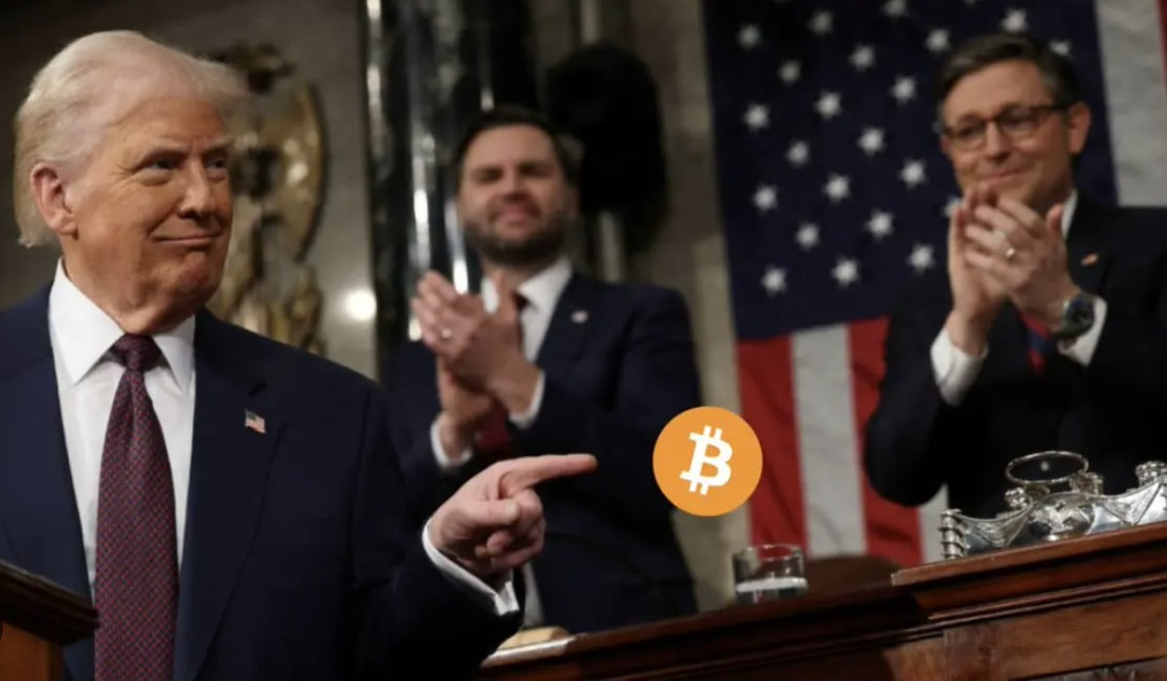I hope you can all sense the energy in the air—familiar, yet undeniably invigorating.

We are already a third of the way through July, swiftly approaching a pivotal window: September, and with it, the much-anticipated arrival of Crypto Week.

This is more than a date on the calendar, my friends. It represents a pause—a moment to reassess, to realign, and for those with foresight, an opportunity to fundamentally reshape the contours of their financial future.

Allow me to offer a reminder: history’s most enduring fortunes have often been forged in times of upheaval and transition.

As the traditional financial order confronts mounting pressures, we must also recognize the emergence of a transformative digital tide—one that is not simply disruptive, but foundational. I am speaking, of course, of the accelerating rise of crypto assets.

Have you heard it?
The expectation of a rate cut this September is gaining undeniable momentum. But this isn’t merely a technical adjustment by the Federal Reserve. It sends a far more decisive signal: the gates of liquidity are poised to reopen. Capital will once again seek higher ground, and risk assets are likely to reach a renewed apex in their appeal.

Opportunities that may have seemed elusive—or were missed in the past few months due to hesitation—are now reemerging with greater clarity and force, inviting us to engage with intention.

What makes this moment all the more compelling is the convergence ahead; as September draws near, so too does the global spotlight of Crypto Week.

This will be a concentrated inflection point for the digital asset ecosystem. We can expect a wave of innovation—new technological breakthroughs, evolving use cases, and the forging of meaningful partnerships.

It may well mark the moment when traditional finance and the digital economy shake hands in earnest—a launchpad for institutional capital to enter the crypto space not as a curiosity, but as a strategic allocation.

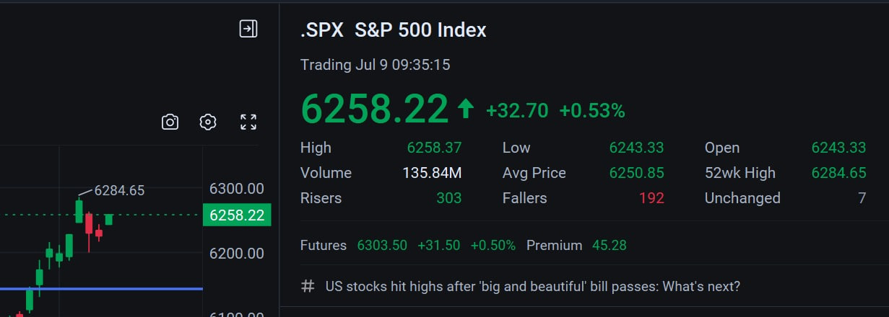Equity index futures showed strength in the pre-market hours this Wednesday, suggesting a higher open and the potential for the S&P 500 to once again approach new record territory.

However, the market remains caught in a pendulum swing between numbness and uncertainty—largely shaped by the postponement of the tariff deadline and President Trump's shifting stance. This ambiguity may well be a key factor behind the market's tendency today to rise early, only to pull back later in the session.

Although the tariff decision has been deferred to August 1st, the volatility surrounding trade policy has already introduced paralysis into the corporate decision-making process. Many firms are being forced to reevaluate their supply chains and cost structures in real time, in an effort to mitigate the downstream effects of potential price increases triggered by shifting tariffs.

This uncertainty makes it difficult for the market to adopt a resolute position. As a result, bullish sentiment faces resistance—creating the likelihood of an intraday reversal following an initial surge.

In navigating this environment, our trading approach must remain both disciplined and deliberate. When appropriate, short-term profit-locking strategies should be employed with clarity and conviction.

Another key point of focus today is the release of the Federal Reserve’s June meeting minutes, scheduled for 2:00 PM this afternoon.

In simple terms, these minutes represent the public disclosure of the key discussions and decisions made during the Federal Open Market Committee’s June policy meeting.

What impact might this have on the market?

The minutes are expected to offer clearer guidance on the trajectory of potential rate cuts—providing investors with a more definitive internal perspective. If the record reveals that the majority of voting members support a policy shift toward easing, both in number and conviction, markets will likely interpret this as a strong signal that an actual rate cut could materialize in September.

However, if the path toward rate cuts appears hesitant—or suggests fewer than two reductions ahead—the equity markets may come under pressure in the afternoon session.

As a result, the release of the minutes could trigger increased volatility after midday, with a meaningful risk of a pullback as uncertainty tempers early optimism.

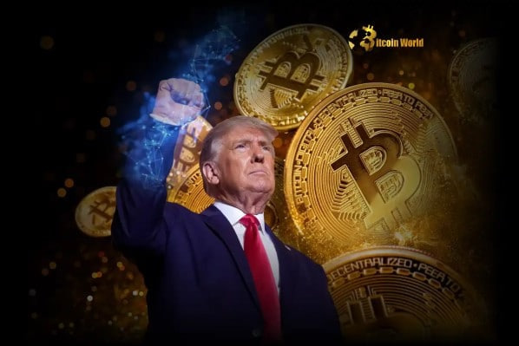There is, however, encouraging news on the horizon: July 14, 2025, will mark the beginning of “Crypto Week,” an initiative introduced by Republican members of Congress. It signifies a pivotal moment for the digital asset industry.

As the party currently in power, President Trump has repeatedly stated his intention to position the United States as the global capital of crypto.

But how does one build such a foundation?

The first step is the formal recognition of Bitcoin as part of the nation’s strategic reserves—akin to gold. This policy has already been enacted through a presidential executive order. At present, states across the country are beginning to accumulate Bitcoin as a strategic asset. Several large technology firms have followed suit. Most notably, $MSTR, a prominent public company, now holds close to 600,000 Bitcoins.

We referenced the significance of this development in last week’s trading commentary.

In addition, BlackRock’s $IBIT fund now holds over 690,000 Bitcoins, positioning it as the world’s leading institutional holder of the asset.

Together, these actions affirm that the United States is taking a leadership role in the global movement toward sovereign crypto reserves—a milestone in what many view as a broader cryptographic transformation. Whether or not one holds Bitcoin, the implications are becoming increasingly difficult to ignore.

What, then, is the second step in establishing the United States as a global crypto capital?

Following the forceful passage of the Big Beautiful Act, championed by President Trump, Congress is preparing to shift its focus to the next strategic front: cryptocurrency regulation.

The U.S. House of Representatives has officially designated the week of July 14th as “Crypto Week,” during which it will deliberate three major legislative proposals: the CLARITY Act, the GENIUS Act, and the Anti-CBDC Act.

Bringing these bills to the President’s desk represents not only a legislative commitment to protecting the financial privacy of the American people—it is also a meaningful step toward realizing the vision of making the United States a center of gravity for the digital asset economy.

A new era is arriving in America. And now is the time to see this vision through.

But do we fully understand the kind of wealth revolution these three acts could unlock?

Accordingly, whether it’s crypto-related equities in the stock market or the price movements of tokens in the digital asset space, the passage of these three landmark bills could usher in an era-defining wave of wealth creation—one with the potential to reshape the global digital asset order.

This reform marks the end of a decade of regulatory ambiguity in the crypto industry, offering a long-awaited, clearly defined framework that enables institutional capital to engage with greater confidence.

Let’s take a closer look at what these three pieces of legislation represent.

The CLARITY Act — Defining Regulatory Boundaries

This act draws a clear line between the regulatory authority of the SEC and the CFTC with respect to crypto assets. It provides exchanges, project developers, and investors with a transparent and navigable compliance framework, and is widely seen as essential to unlocking innovation within the U.S. crypto economy.

In simple terms, it proposes a more open regulatory environment for the purchase, circulation, and custody of digital assets—moving away from the obstructive and interventionist posture of the past.

The act also seeks to protect retail investors and trading platforms from the undue burden of SEC enforcement actions.

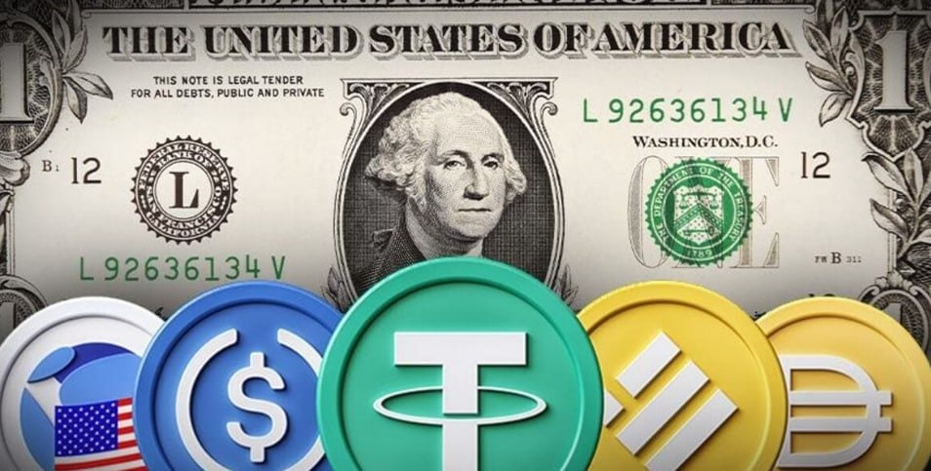The GENIUS Act — Stablecoin Regulation

This legislation, already passed by the Senate, seeks to establish a unified national regulatory framework for the issuance of stablecoins.

Under the Act, all stablecoins must be fully backed by U.S. dollars or equivalent high-liquidity assets. Issuers with a market capitalization exceeding $50 billion would be subject to mandatory annual audits. In addition, the bill outlines specific compliance standards for foreign-based stablecoin issuers operating within the United States.

President Trump has expressed his intention to sign the Act into law by August, signaling the Republican Party’s broader strategic vision: to strengthen the dollar’s role as the cornerstone of the global digital economy through the creation of a fully compliant, dollar-backed stablecoin infrastructure.

Put simply, this legislation is designed to safeguard your stablecoin holdings—in other words, the digital dollars you hold on-chain, such as USDC or USDT.

In our own community forum, when you complete a simple task and receive a prize code, you may have the opportunity to be rewarded in one of these stablecoins.

The Anti-CBDC Act — A Defense of Financial Privacy

This legislation aims to prohibit the Federal Reserve from issuing a central bank digital currency (CBDC) directly to the public.

At its core, the bill is a safeguard—designed to protect citizens’ financial privacy and prevent the federal government from leveraging CBDCs as instruments of comprehensive surveillance and control.

Put simply, the proposal reflects a clear stance: the Federal Reserve should not issue a digital dollar in the form of an on-chain CBDC. Such a system, by definition, would remain centralized—contrary to the very ethos of blockchain technology.

The bill thus affirms the importance of decentralization as a foundational principle of the blockchain economy. This isn’t merely a technical distinction—it represents a structural rethinking of how wealth is stored, transferred, and protected.

To embrace blockchain is to embrace decentralization.
And to embrace decentralization is, in essence, to reclaim the true privatization of wealth.

Perhaps you’ve never realized how close digital assets have come to your own life. But they are now here—and whether one is prepared or not, the upcoming Crypto Week will mark the formal beginning of a new financial movement, one whose signals will resound from Capitol Hill outward.

So, as we look ahead to the much-anticipated Crypto Week, how can we make informed trading forecasts and sound quantitative strategy decisions this Wednesday?

Let’s first review the crypto-related equities we’ve previously tracked in our trading signals:

1. Crypto platform operators – HOOD. Yes, we are still holding this position. Stay with it—it remains a viable trade.

2. Bitcoin reserve holders – MSTR and IBIT. I suggest considering these as part of a medium- to long-term strategic reserve allocation. In particular, IBIT—as an ETF—offers both safety and steady profit exposure. I strongly recommend holding it.

3. Mining and computing power companies – CLSK and HUT. These are typical Bitcoin mining firms. As we know, among all the ways to acquire Bitcoin, mining rewards remain the most cost-effective, though mining difficulty continues to rise. Still, computing power is also improving.

After all, chip performance continues to advance—just consider how NVIDIA has become the first $4 trillion company globally. That alone illustrates why the U.S. places such strategic emphasis on mining firms.

Therefore, these blockchain-related equities are often best approached after a brief pullback—when seeking opportunities for a second entry.

That said, we have already anticipated the trajectory of this coming wave of wealth creation.

Have you kept up with it guys? The moment is near.

Naturally, if you have a foundational understanding of cryptocurrencies, you may consider positioning yourself early by directly holding some Bitcoin—an approach that, in many ways, mirrors the nation's emerging strategy of digital reserve accumulation.

Consider this: those who aligned with the government’s gold reserve strategy decades ago have, over the past fifty years, reaped the long-term benefits of holding substantial physical assets.

Bitcoin, often referred to as digital gold, may prove even more compelling. Its scarcity is mathematically enforced, surpassing even gold in terms of finite supply—and thus, its appreciation potential is considerable.

The total supply of Bitcoin is capped at 21 million units, of which fewer than 2 million remain to be mined. The halving mechanism continues to make new issuance increasingly difficult over time. This built-in deflationary structure is precisely what gives Bitcoin its value as a hedge—against both U.S. dollar debasement and unchecked monetary expansion.

Have you truly grasped the generational opportunity embedded in this shift toward cryptographic assets?

What’s even more exciting is that the three major legislative bills introduced during Crypto Week have once again confirmed the strategic advantage of my token-based approach at the Quantitative Think Tank Center.

I firmly believe that the passage of these three crypto-related bills will trigger a broad wave of tokenization.

The recent surge in tokenized stocks is a clear example of how traditional assets are beginning to transition into crypto assets, in response to this new era of financial transformation.

That is why my Quantitative Think Tank Center has issued tokens to support fundraising within the crypto markets—specifically for the development of the Acumeta system. This effort is increasingly aligned with favorable industry dynamics. So just imagine: when you hold one of our token vouchers, you are holding a key to redeem future tokens. As the value of those tokens continues to appreciate along with broader tailwinds in the crypto industry, wouldn’t the value of what you redeem in the future be considerably higher?

Folks, do you know how to acquire more of these token vouchers?

As part of this engagement-driven reward initiative—rooted in goodwill and a disciplined investment mindset—you may earn our token vouchers through the following channels:

1. Offering thoughtful feedback and perspectives within our community forums and group discussions. Constructive participation strengthens rapport and is often recognized.

2. Inviting like-minded investor peers to join the platform, with their identities verified directly through me.

3. Actively contributing to our content ecosystem by sharing original insights and observations—an effort that meaningfully advances both our collective understanding and your individual decision-making capabilities.

4. Participating in compensation-backed trades aligned with our strategic signals. A simple screenshot to document your action ensures it’s recorded and appreciated.

We have developed multiple pathways for engagement, each offering distinct forms of recognition. Among them, our token vouchers are becoming a vital mechanism for rewarding meaningful participation.

Why do I say their value may exceed your expectations?

So why is it that today we are offering token vouchers from the Quantitative Think Tank Center—rather than distributing the tokens themselves?

It’s a fair and important question.

A voucher is, in essence, a promise—a representation of mutual trust. It embodies the core value of blockchain: decentralized, immutable consensus.

We have no desire to promote our token prematurely, before you’ve had a chance to truly experience, explore, and validate its underlying logic and utility. To present it otherwise would be to place marketing ahead of substance, and that’s not our ethos.

By offering token vouchers, we are expressing appreciation. Much like receiving a store credit from a place like Walmart, these vouchers become redeemable upon meeting certain conditions. That’s all. Nothing more, nothing less.

So let me ask you:
Are you willing to continue engaging with our quantitative strategy dialogue and sharing your insights?
Do you believe in what Acumeta is building—and wish to see it grow stronger?
Are you ready to align yourself with a system designed to refine decision-making and elevate trading conviction?

This Wednesday, no matter what market turbulence we may face—or how former President Trump steers the tone of investor sentiment—we must hold fast to a single conviction: a rate cut in September remains all but certain. Just as crucial is our confidence in the momentum brought by Crypto Week. This is not the time to hesitate, but rather to continue holding positions in crypto-related equities or directly accumulate Bitcoin as a form of strategic reserve.

More importantly, we must grasp the favorable implications within The Big Beautiful Act—particularly for companies positioned at the foundational layers of the chip and semiconductor sector. NVIDIA’s rise to become the first $4 trillion company in global equity markets is emblematic. It affirms a deeper trend: to embrace technology and AI adoption is to align oneself with the long arc of value creation.

When the anticipated rate cut in September converges with the momentum of Crypto Week, what emerges is not merely an investment opportunity—but a catalytic force for capital reallocation on a historic scale.

This is the moment we’ve long prepared for: a tide powerful enough to activate our Acumeta quantitative strategies at full throttle, unlocking their potential in an environment aligned with conviction, clarity, and structural transformation.

Let’s reconvene this afternoon.


A tranquil afternoon, an invigorating Wednesday—good afternoon.

Guys,

We are witnessing a defining moment in history: the world’s first $4 trillion company—NVIDIA—has officially emerged.

Today marks a singular milestone, one that will stand out among many remarkable days ahead. Years from now, as you look back, perhaps you’ll remember—we were here together when it happened.

So let‘s be prepared. Set aside hesitation. Let our perspective cut through the noise of the markets, and focus with clarity on what is poised to unfold.

With Acumeta’s rigorous analysis and resolute execution, we stand ready to engage in this unfolding chapter of capital formation.

This September offers a rare window of opportunity. Let us meet it with conviction—and shape a legacy of enduring value.

The market is laying before us a table full of opportunities.

While the Federal Reserve held steady in July, expectations of a rate cut in September have already begun to stir the waters on Wall Street. The 10-year Treasury yield has slipped from 4.629% to 4.277%, the dollar has softened, and cryptocurrencies have ignited—flaring like fireworks on Independence Day.

This is no ordinary July. It is a high summer for the discerning investor.

I remain convinced that a September rate cut will inject renewed energy into both equity and bond markets, while this week’s momentum in crypto signals the vast, untapped potential of blockchain innovation.

Consider this—just as Steve Jobs once noted, “The greatest innovations are always born on the edge of revolution.” Today, we stand at such an inflection point—where data meets discernment, and vision transforms into value.

Whether through the precision of quantitative strategies or bold movements in the cryptocurrency market, this July invites us to act—with intention and with courage.

Are you ready? Let us move forward—toward the future we are prepared to shape.

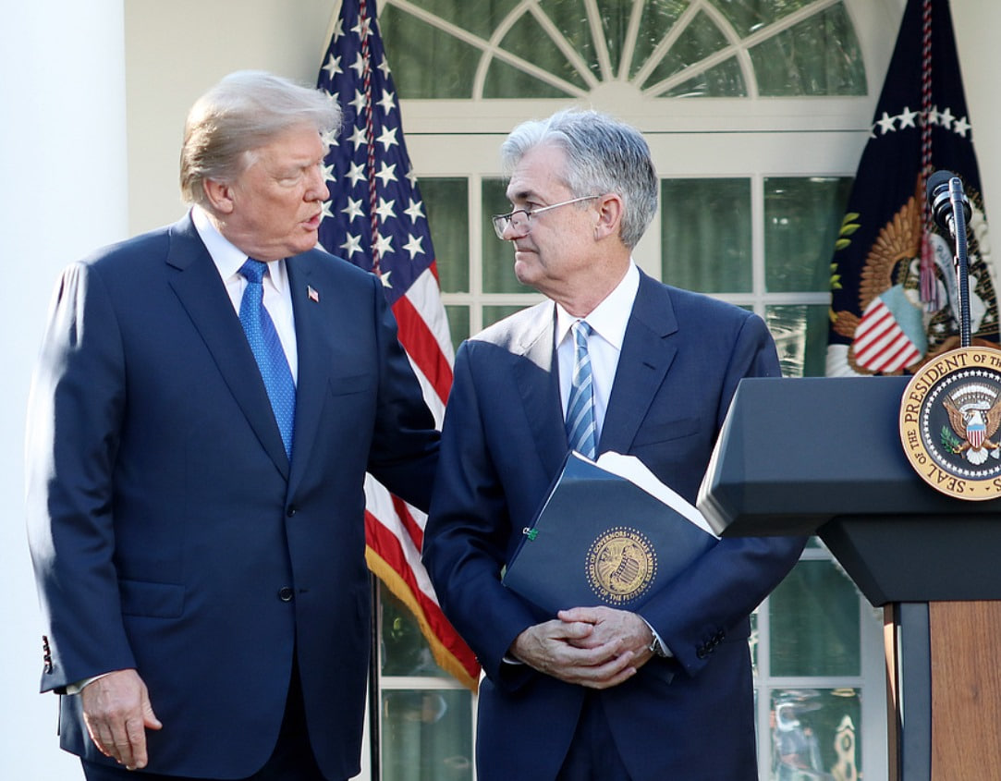This afternoon, global capital markets turned their attention to the minutes of the Federal Reserve’s June policy meeting.
Based on the official release, I’ve distilled the internal debate within the Fed into three primary positions:

A majority support rate cuts later this year, while ruling out action in July;

A minority advocate holding rates steady for the remainder of the year;

And a smaller faction argue for immediate easing at the next meeting.

Acumeta has provided a comprehensive analysis of these three camps by synthesizing macro data, historical precedents, and behavioral patterns—a framework I continue to reference closely.

In my view, the recent decline in Treasury yields is being driven, in part, by mounting pressure from former President Trump on Chairman Powell to implement a substantial rate cut.
Trump publicly posted that the current federal funds rate remains at least 300 basis points too high.

He is now reportedly seeking a new candidate for Federal Reserve Chair—someone who would align more closely with his monetary policy views.

Against this backdrop, I remain firmly positioned in anticipation of a 25 basis point rate cut at the Fed’s September meeting.

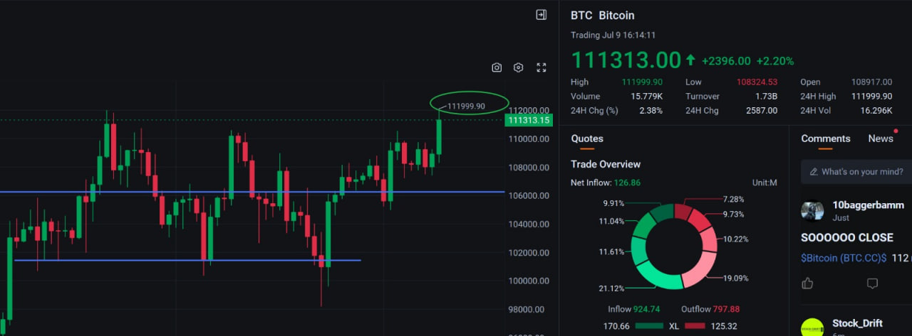The excitement in capital markets today was not driven by equities, but by the cryptocurrency space—most notably, Bitcoin and Ethereum, the two most established digital assets.

The spotlight was squarely on Bitcoin, which returned to $110,000 per coin for the first time in nearly a month.
Yes—this is what valuation looks like when confidence reasserts itself.

This surge was not without context. Heightened uncertainty surrounding tariffs has curbed risk appetite in the equity markets, prompting a significant reallocation of capital into crypto. This is, in part, a signal of how seriously the market is beginning to regard the upcoming “Crypto Week” in Congress.

Markets do not lie. Capital speaks plainly—revealing where opportunity resides, and where risk accumulates.

Naturally, the strength in Bitcoin and Ethereum has lifted adjacent equities as well. CLSK, for example, staged a sharp rebound.
And if you observe closely, you’ll notice: it is often after a measured pullback that these assets gain renewed momentum.

This is precisely what I mean when I speak of rhythm as the essence of quantitative strategy. It is never about impulse—it is about timing, structure, and restraint.

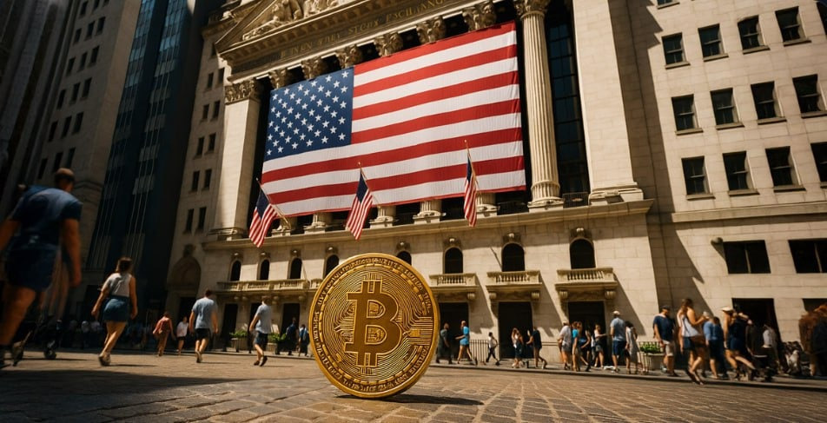Why has Bitcoin become President Trump’s preferred asset and considered America’s strategic reserve?

This is a profound topic. It would likely take me half a year of thorough, multifaceted explanation to fully clarify it for you. But today, I will offer a very basic analysis to explain why you should own Bitcoin rather than more houses, cars, cash, or gold.

As is widely known, Bitcoin was born after the 2008 financial crisis. Over the past sixteen years, it has gone from obscurity to global recognition, with many vying to own it.

Earlier this morning, I mentioned why the three major bills during Congress’s upcoming Crypto Week are so important. Essentially, they are providing us with a legitimate, compliant framework for on-chain assets. This marks a new era—much like the first time you held a bank card—ushering in a greater form of wealth.

We all understand that the $37 trillion scale of U.S. national debt was not issued merely over the past two years. Rather, it reflects the shift the U.S. government made after formally detaching the dollar from the gold standard and, subsequently, after the weakening of the petrodollar peg, by introducing a credit-backed anchor.

In other words, the dollar was once issued anchored by gold, then by the petrodollar system. But as globalization advanced, the dollar’s issuance lost the value of that oil backing.

The U.S. government began to consider how to elevate the dollar’s standing on the international stage—thus giving rise to the credit-backed dollar.

The issuance of U.S. Treasury debt is determined by Congress, which deliberates and agrees on the amount of debt to be issued to support the issuance of dollars.

As a result, the cash we hold in our hands continues to be printed by the Federal Reserve.

So how does the Federal Reserve actually print these dollars? What is the basis for it?

Once Congress agrees to raise the government’s debt ceiling, the Treasury issues government bonds—U.S. Treasuries.
At this point, the Federal Reserve, as an independent financial regulator, purchases a portion of those bonds.

But where does the money the Fed uses to buy those bonds come from?
It is printed by the Federal Reserve itself, since the Constitution designates the Fed as the sole legal issuer of U.S. currency.

Therefore, the newly printed dollars are used to purchase Treasury bonds, and after the Treasury receives these dollars, it deploys them toward economic stimulus, social welfare, infrastructure, defense spending, and so forth. This cash then begins to circulate throughout the economy.

As the scale of government debt grows, so too does the amount of dollars the Fed prints, which in turn flow around the world.

Do you now understand the source of the cash you hold in your hands?

As the United States deepens its involvement in global trade, the dollar flows alongside commerce, reaching countries and regions across the world.
The strength of the U.S. military, coupled with the stability of American political institutions, has fostered a global consensus on the dollar’s reliability and security.
Consequently, the dollar’s international status continues to solidify and strengthen.

This is why, in recent days, President Trump has repeatedly emphasized that those who undermine the dollar will pay a price.
Defending the dollar’s leadership on the world stage is, in essence, a victory in a global conflict.

At the same time, the trade deficit results in more dollars leaving the domestic economy, and the core risk of this outflow is the persistent expansion of U.S. debt.
Thus, since taking office, Trump has pursued trade tariff policies—from version 1.0 to 2.0—as part of this ongoing trade war.

So what is the relationship between Bitcoin, the trade tariff war, and U.S. debt and the dollar?

The answer lies in President Trump’s recent call for additional tariffs on BRICS nations.
These countries have been advocating for trade settlement that circumvents the U.S. dollar—in other words, conducting transactions directly in their respective national currencies, or even turning to cryptocurrencies.

Such actions pose a de-dollarization risk—one that Trump doesn't want to see.

Bitcoin, by contrast, emerged with the defining features of blockchain technology: decentralization, immutability, and a cryptographic foundation for trust that is not subject to the will of governments or individuals.
This, in essence, creates a trust architecture—what I refer to as the trust mechanism and consensus layer of blockchain.

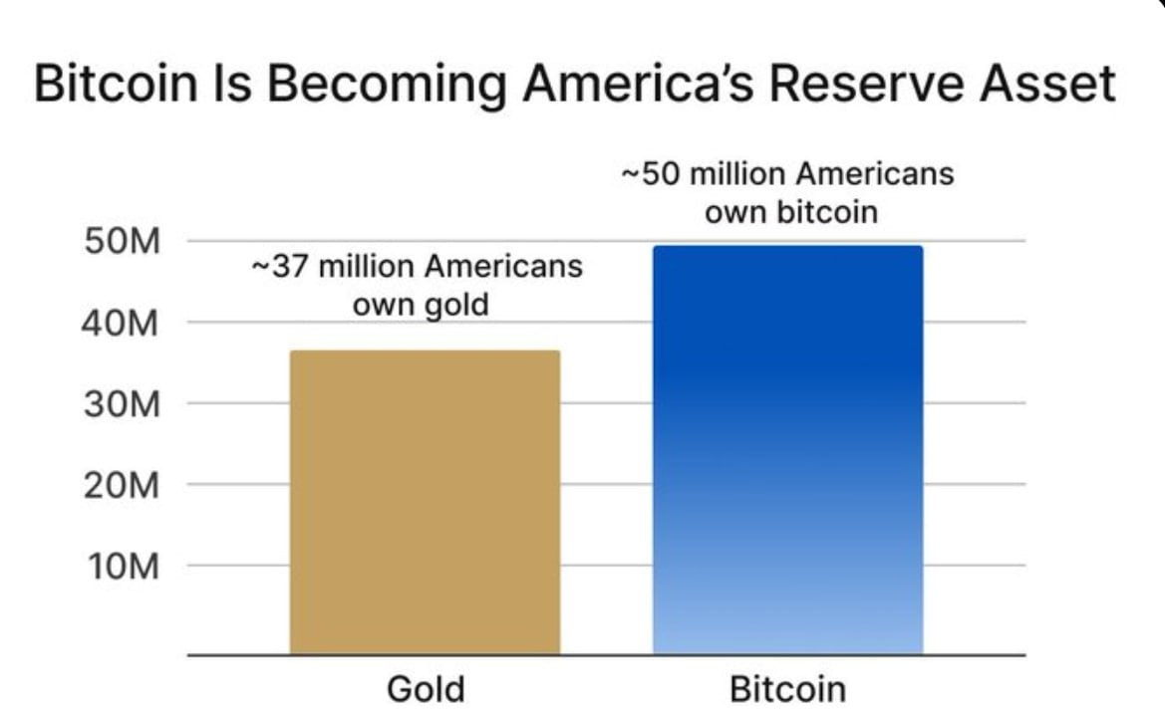When an asset becomes a mechanism of trust consensus—while also possessing an inherently deflationary halving model and the structural advantage of decentralization—its efficiency and cost of transfer far exceed those of gold.

Consider this: if I were to transfer 100 grams of gold from London to you in New York, the logistical and regulatory complexity would be considerable. But to transfer 100 Bitcoins? The process is markedly faster, more efficient, and substantially more secure.

This is precisely why, during his second term, President Trump shifted away from his previous stance toward Bitcoin and the broader crypto ecosystem—moving instead toward active endorsement and adoption. It is because of the structural advantages of the asset that are increasingly difficult to ignore.

There are, fundamentally, three ways to acquire Bitcoin:

Mining rewards.

Direct purchase using stablecoins.

Exchange through other cryptocurrencies—which themselves are often acquired with stablecoins.

As such, for most individuals today, the most accessible and practical approach is to hold stablecoins like USDC or USDT, and to use them to purchase Bitcoin directly.

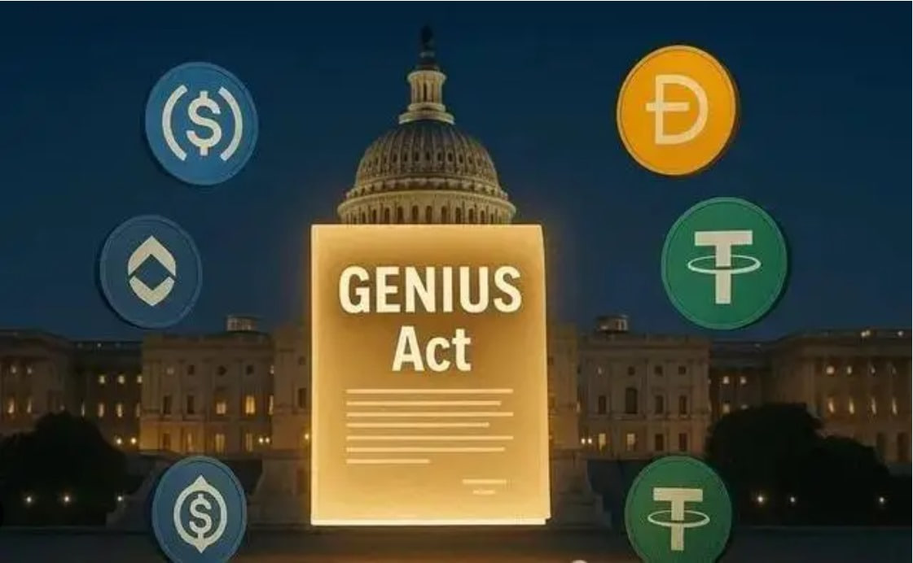So where do stablecoins come from?

The simplest way to understand stablecoins is to compare them directly to the U.S. dollars sitting in your wallet or bank account—they operate on a 1:1 ratio.
Why 1:1? Because stablecoins have become the primary unit of account within the cryptocurrency ecosystem. To put it plainly: just as every item in a Walmart is priced in USD, nearly every digital asset in crypto is denominated in USDC or USDT.

When you purchase Bitcoin, its value is quoted in stablecoins like USDC or USDT. The same holds true for other cryptocurrencies. Do you see the pattern?

Even the Quantitative Think Tank Center voucher you may be holding right now will—when redeemed in the future—be priced in stablecoins such as USDC / USDT.

And importantly, stablecoin issuers must obtain regulatory approval and undergo regular audits. This framework is part of what was addressed in one of the key legislative proposals discussed earlier today during “Crypto Week”: the GENIUS Act.

The issuance of stablecoins is not arbitrary—and for good reason. Just as the U.S. government cannot print money at will and must do so through the Federal Reserve, based on the volume of Treasury bonds purchased, the same logic applies to stablecoins.

To issue stablecoins, one must either hold U.S. Treasuries or deposit an equivalent amount of U.S. dollars in regulated banks under supervision. In some cases, Bitcoin may also serve as reserve collateral.

For example, if you wish to issue 10,000 USDC, you are required to hold $10,000 worth of short-term U.S. Treasuries. In doing so, you obtain the full faith and credit backing of the U.S. government.

This is precisely what gives on-chain stablecoins their sense of stability and security. And the more stablecoins are minted, the more Treasury buyers are created.

In the same way, the greater the demand and market price for Bitcoin, the stronger the incentive to mint stablecoins—indirectly expanding the pool of Treasury bondholders.

This mechanism effectively creates new channels and pathways for the U.S. government to issue debt and attract a broader base of global buyers.

That is, at its core, why President Trump seeks to establish a national crypto capital, and why Congress is pushing forward the three major legislative acts.

Do you see the underlying logic now?

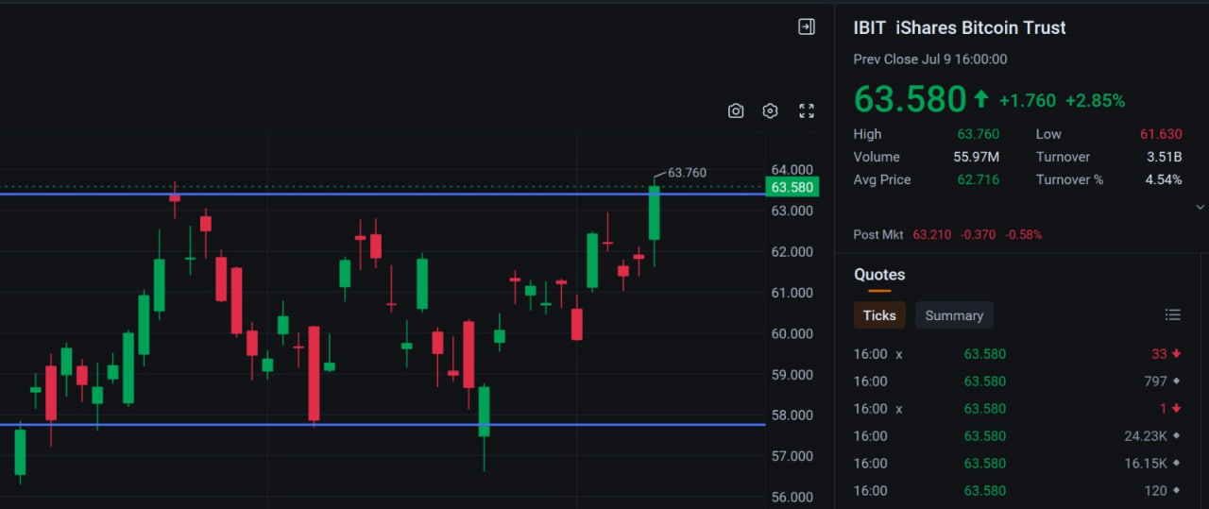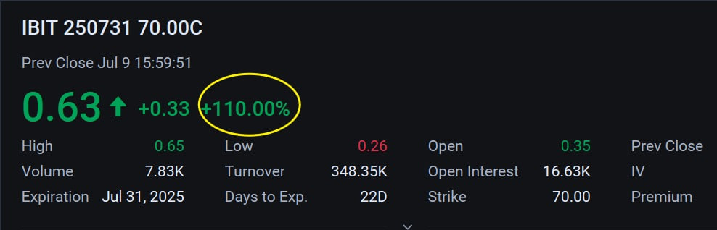Folks, if you’ve read this far, you likely already understand the strategic importance of Bitcoin to the United States.
And more importantly, you should recognize that it is never too late to begin holding Bitcoin. This is a long-term evolution in the architecture of wealth—on-chain and enduring.

Today’s equity markets are affirming what we’ve long anticipated: the foresight and validity of our investment convictions.
Take a look at your positions in blockchain- and crypto-related equities—MSTR / IBIT / CLSK / HUT / HOOD.
Each of them has delivered both meaningful returns and positive results.

At this moment, I believe Acumeta has achieved a clear milestone. And that success belongs to you, to me, and to all of us together.
Would you agree?

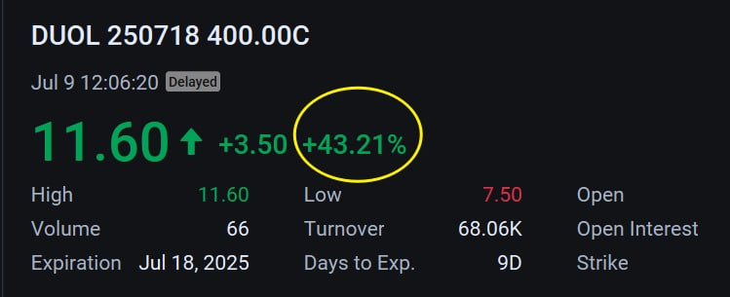Now take a look at APP / DUOL. In the wake of NVIDIA’s historic surge in market capitalization—solidifying its place as the world’s No. 1 chipmaker—we are witnessing the dawn of a new chapter in applied AI.

The computational power behind The Stargate Project is carrying that narrative forward, adding both breadth and momentum to what lies ahead.

Guys, do not second-guess your choices. The intraday highs followed by pullbacks in APP and DUOL were entirely within my expectations. Their behavior in the options market, in particular, was even more compelling.
If you’ve yet to experience the mechanics of options trading, you may often miss the kind of short-term upside that can exceed 30%—not from speculation, but from structure and timing.

As shown in the chart: when you enter through option pricing, you secure the right to act with lower upfront cost, while preserving the flexibility to exit and lock in gains.
It is a disciplined and dynamic strategy—an arena where asymmetry works in your favor.

In the end, profit remains the most objective measure of sound judgment. And each successful outcome not only deepens our mutual trust but also strengthens the foundation for a long-term partnership—and, what's more, a future marked by shared vision and enduring returns. Wouldn’t you agree?

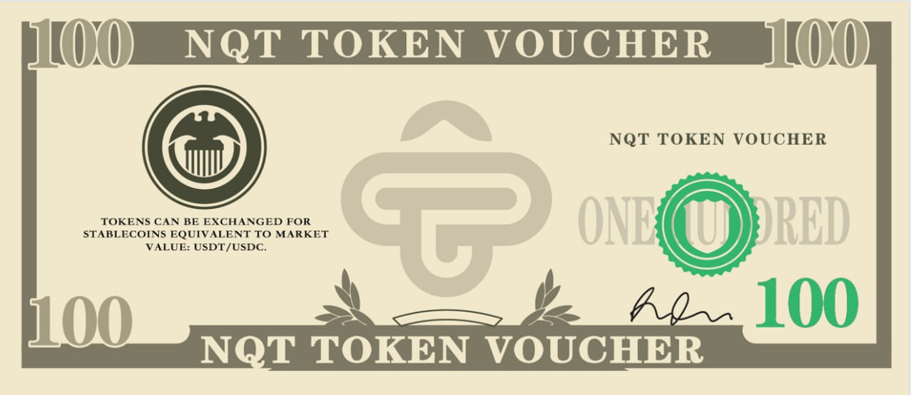Folks,
The joy of fulfillment is, at its core, universal. Along this journey of trading we’re on together, even if you haven’t yet captured outsized profits, our compensation-backed verification strategy has safeguarded you against risk—and that sense of protection for you is something I prefer.

As you know, the investment world is marked by uncertainty, noise, and actors of varying integrity. Choosing the right, trustworthy, long-term trading partner is much like choosing a life companion—something rare, and genuinely worth cherishing.

Of course, I believe you’ll continue to grow. And if you sense that my team and I are acting in good faith, then open your arms, spread your wings, and come fly with us.

That concludes today’s session. Thank you for your engagement—at Acumeta, we remember every gesture of sincerity and participation with great care.

Now for a small bonus round—our "Easter egg" moment. Answer the following questions and enjoy a special reward:

1. Why do we offer token vouchers instead of direct tokens? Do you like them?

2. On which day has the U.S. Congress designated “Crypto Week”, and which key bills are being reviewed and voted on?

3. Today, which stock and which cryptocurrency reached historic highs in market value and price?

Feel free to respond and share your answers with my assistant. It’s our way of staying connected—see you again Thursday.

Good night.

