
Good morning, guys—it's a pleasure to reconnect with you on this invigorating Thursday.

Welcome back to our Quantitative Strategy Forum, a space where thoughtful dialogue has not only fostered enduring relationships, but also, perhaps unexpectedly, unlocked a deeper understanding of long-term capital appreciation.

Allow me to state this clearly: at this very moment, we are standing at a point of genuine historical significance in the global wealth continuum.

Can you feel it?

There is a quiet intensity in the air—a momentum that belongs unmistakably to a new era.

Just before our eyes, we have witnessed NVIDIA ascend to the pinnacle of global market capitalization.

But this is more than a triumph of valuation—it is a definitive coronation of artificial intelligence as a transformative force of our time. And for those who had the foresight to believe that technology could, and would, reshape the world, this moment offers a generous reward.

What NVIDIA has achieved reminds us that true innovation transcends conventional boundaries. It turns uncertainty into possibility. It affirms, in the clearest terms, that the future is not something distant—it is already here.

This milestone is, above all, a resounding validation for those who choose to invest with vision.

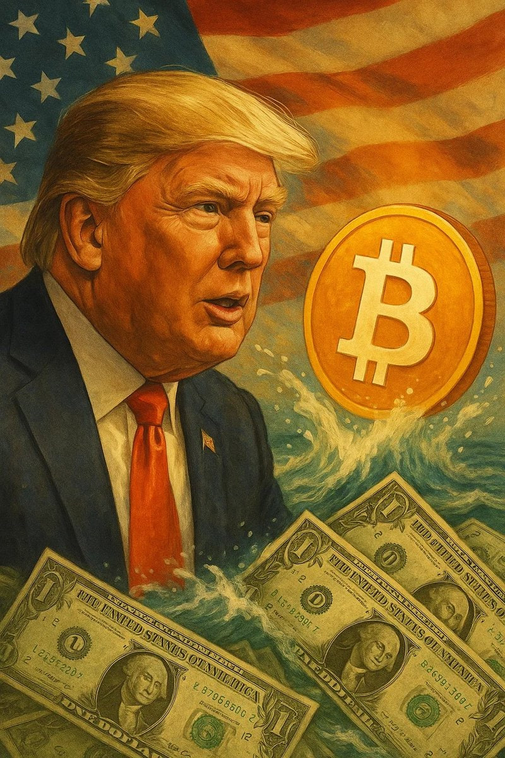At the same time, across the vast and evolving landscape of digital assets, Bitcoin has once again surpassed its previous all-time high.
This is not merely a triumph for cryptocurrencies—it is a renewed affirmation of the core principles behind decentralized finance, and a deepening trust in the foundational integrity of blockchain technology.

It demonstrates that, against the backdrop of volatility in traditional markets, this form of “digital gold” is not only a store of value, but increasingly, a compass—pointing the way toward a new horizon of wealth creation.

The two milestones—NVIDIA’s rise to the top of global market capitalization, and Bitcoin’s historic new high—are far from coincidental.
Rather, they mark a visible convergence of legacy capital and emergent innovation. Together, they offer compelling evidence that capital is not static—it is reallocating, flowing decisively toward domains where potential outpaces convention.

What emerges is an inspiring blueprint: technology and digital assets, functioning as twin engines, now poised to drive the next chapter of wealth generation.

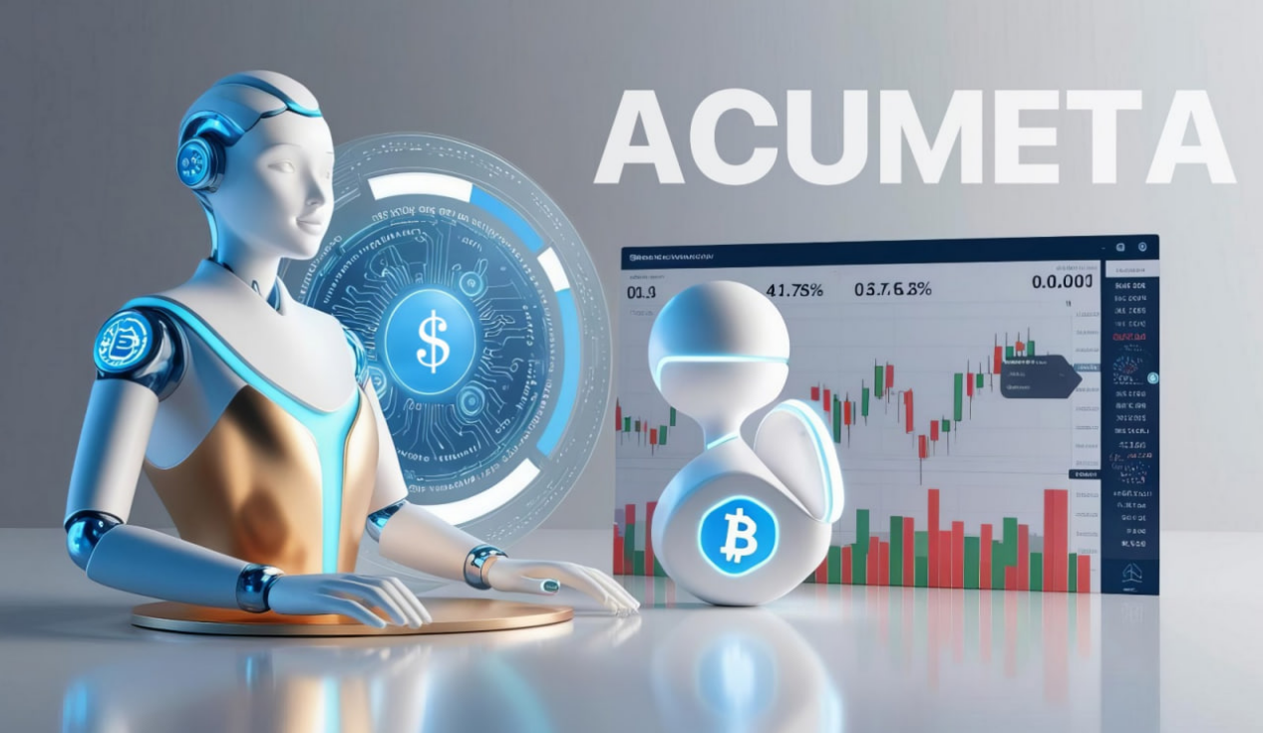Well—when I committed myself to building the Acumeta quantitative system, to creating a more reliable tool for the investment world and unlocking new ways of thinking for global investors, witnessing AI reach the Top 1 position in global market capitalization affirmed my belief: this is the right track. There is no better track than this.

Indeed, quantitative systems have long been prevalent on Wall Street. But traditionally, these systems have been used by quant funds to pursue high-frequency, high-win-rate profits.

Today, however, my vision for Acumeta is something entirely different.
It is becoming a highly intelligent entity—both in software and hardware—powered by AI’s computational and reasoning capabilities, designed to support and assist individual investors directly.

What can Acumeta actually do?

If you’ve only recently joined us, please log in and visit our secure official site at: https://www.novaquantpro.com/news, You’ll find detailed documentation there.

As a quantitative system, Acumeta is designed to respond to real-time market dynamics—incorporating information flow, policy signals, major current events, chart pattern recognition, data fluctuations, and millisecond-level monitoring capabilities. It offers a range of intelligent trading support features, including secure trade alerts and custodial execution tools.

In essence, for a successful system like Acumeta, code is law.
Every layer of its architecture is built upon my own investment philosophy and the distilled experience of many years in the field. For this reason, it requires extensive training and refinement in order to reach its optimal state—only then will it be finalized and released globally.

At this critical stage of development, your ongoing feedback and firsthand observations are both welcome and essential.

Acumeta’s Current Quantitative Strategy Signals for Equities

All of our past equity trading decisions have ultimately been executed through Acumeta. My team of analysts and I assess each decision within this analytical framework, applying objective judgment before subjecting it to real-world market validation.

Looking at the recent period of trading activity, the system has demonstrated a notable degree of consistency.
There have been no significant drawdowns across the selected equities; on the contrary, the strategies have yielded encouraging results.

I fully acknowledge that some portion of this outcome may be attributed to timing or favorable conditions.
Yet the fact remains: Acumeta has successfully delivered compensation-backed equity strategies that have enabled members of our forum community to pursue returns with a greater margin of safety.

Take a moment to reflect—have you experienced these trades for yourself?

So, how shall we approach Thursday’s trading?

First, based on the performance of index futures before the market opens, we can expect the market to open lower—suggesting that trading sentiment is not particularly strong today. With the weekend approaching, there may also be some downside pressure from risk-off or pessimistic selling.

The market’s cautious tone is largely due to Trump’s tariff policy, which is beginning to show its constraining effect.
Previous optimism around TACO expectations is now being leveraged by Trump, who has made it clear that August 1st is the final deadline, with no further extensions.

This has introduced a mild sense of panic in the market. But in reality, such fear may soon give way to a new wave of upward momentum.
After all, the broader market has already anticipated the impact of the tariffs, and any further selling pressure appears to have been largely priced in.

Another factor contributing to today’s relative weakness in the equity indexes is the shifting expectation around Federal Reserve rate cuts.

Next week’s CPI data may well trigger a fresh wave of concern, causing the market to adjust its pricing accordingly. Yet, in my view, the broader upward trend in equities is likely to persist in the near term.

So, where do we find our edge in trading?

The answer lies in Congress-designated “Crypto Week,” as well as stocks in the artificial intelligence sector.
These have been the focal points of our active engagement and trading over the past couple of weeks.

When it comes to selection, I continuously analyze new trading candidates, while also revisiting stocks we have previously traded—seeking refreshed opportunities for entry and exit.

It is important to emphasize that trading should be executed with agility, outcomes must be transparent, and participation should integrate options strategies within compensation-backed trades.
Please stay attentive to the ongoing updates and tracking shared through our community forum.

To begin with, yesterday’s “Crypto Week” highlighted two key elements: the timeline and the significance of three major bills currently under discussion, vote, and potential passage in Congress.

Within this timeframe, I believe the passage of all three bills is not only likely—it is necessary. It represents a foundational step in establishing the United States as a global hub for digital assets.

One of the core proposals involves regulatory reform. Its intent is to create a more accommodative legal framework, replacing the legacy model of restrictive oversight with a more supportive structure—one that allows the industry greater room to operate, and that enhances both investor accessibility and transactional security.

This presents a rare and meaningful opportunity. Regulation is the first and most critical layer of transformation.

And within the regulatory sphere, which two equities stand at the center of national relevance?

COIN / HOOD. These two companies represent the leading U.S.-based spot trading platforms. Their core function is to facilitate the buying, selling, and transfer of digital assets. More importantly, they are poised to become key venues for the tokenization of equities. In other words, stocks listed on Nasdaq could, through these platforms, be introduced to a global network of crypto participants.

The long-term valuation potential is, understandably, substantial.

That said, today may not be the ideal entry point. There is wisdom in waiting for more favorable buying conditions.

So, what exactly is stock tokenization?

Simply put, it means that a publicly listed company, once approved by the SEC, can issue its own stock tokens on an exchange regulated under the Money Services Business (MSB) framework.
In other words, the token’s value is anchored to the shares of that listed company. The token’s price reflects the company’s stock price.

While fractionalization may be involved, at its core, stock tokenization represents a diversified means of financing—a new revolution in on-chain capital raising.

Take NVIDIA as an example. To invest in NVIDIA today, you need a U.S. stock brokerage account. For many non-U.S. investors, opening such an account requires going through various service providers.

However, if NVIDIA were to tokenize its stock, owning a U.S. brokerage account would no longer be necessary. Instead, trading could be conducted simply through an account on a cryptocurrency exchange.

This illustrates the convenience of stock tokenization and the enormous potential it holds for future wealth creation.

On another front, addressing stablecoins liquidity is crucial. One of the key legislative priorities during “Crypto Week” is to establish a clear, lawful, and compliant framework for stablecoins—so that every holder of USDC / USDT around the world can rest easy.

We understand that to trade U.S. equities today, a U.S. dollar account is required. In other words, if you are in Europe, you must exchange euros for dollars before you can buy U.S. stocks. Whether you are in Asia, Africa, or Australia, the same process applies: converting your local currency into dollars to fund a brokerage account and purchase shares like NVIDIA.

Stock tokenization, however, simplifies this cumbersome step and improves efficiency.
Now, all you need is to hold stablecoins such as USDC / USDT to purchase tokenized shares of NVIDIA.

This marks a new era—one in which the dividends of global AI leaders are shared broadly and seamlessly.

Why, then, is the United States so committed to supporting the financial innovation of stock tokenization?

At its core, the answer lies in the broader strategic vision behind Trump’s push to establish a “crypto capital” of the world—an ambitious initiative designed, in part, to mitigate the U.S. sovereign debt crisis.

Stock tokenization drives demand and circulation for stablecoins.
As the issuance of USDC / USDT expands, so too does the requirement—by legal mandate—for each new stablecoin to be backed by the purchase of U.S. Treasuries.
In effect, this opens the door for global crypto participants to become indirect holders of U.S. government debt. Over time, as both individuals and institutions worldwide gain exposure to these assets, the market for Treasuries could expand significantly.

The stronger and more vibrant the crypto ecosystem becomes—especially with improved infrastructure and more engaging trading experiences—the more this positive cycle reinforces itself.

This, as I see it, is a central reason why the three major “Crypto Week” bills are likely to pass.

The vision for America’s crypto capital is not only feasible—it is destined to flourish.
Have you fully grasped the magnitude of this coming wealth transformation, and the underlying logic that drives it?

Therefore, once you understand the strategic magnitude of the emerging crypto capital, it becomes clear that equities within the blockchain sector do not inherently carry systemic risk. Instead, they present entry opportunities during periods of price pullback.

As anticipated, Thursday’s market saw a modest correction. In light of that, it may be appropriate to reduce the frequency or scale of trading activity today.

At the same time, positioning around “Crypto Week” remains very much in play.

Take HUT, for example—it continues to offer a compelling trading opportunity. If you’ve already sold once, it’s entirely reasonable to re-enter.
If you’ve yet to participate, today still offers an attractive entry point. As a mining company holding over 10,000 Bitcoin, HUT stands to benefit as the broader index trends higher over time.
Short-term drawdowns like the one we’re seeing now should not be perceived as disqualifying risk.

And if you prefer to trade through options, feel free to reach out to my assistant for signal updates.

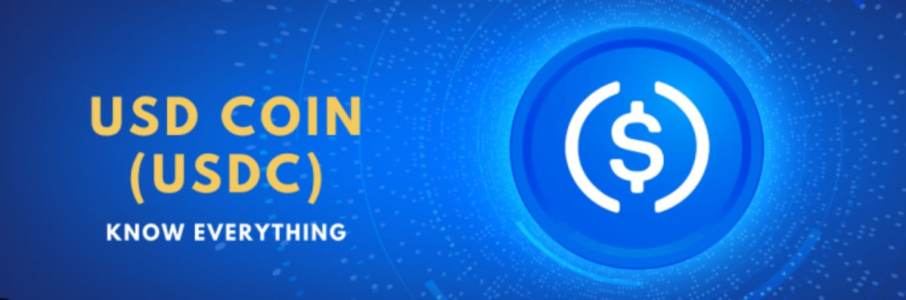Now turning to one of the rising stars in the crypto-financial landscape: CRCL, the issuer behind the stablecoin USDC.

At present, CRCL's total market capitalization remains below $45 billion, with its most recent entry point falling just under $200 per share. The company has issued over $60 billion worth of USDC to date.
This suggests not only significant asset under management, but also a recurring income stream derived from the yield on reserves—namely, U.S. Treasuries—which directly contributes to the firm’s profitability.

I view this as a company with long-term potential to exceed a $100 billion valuation. And notably, the USDC you’ve earned through our community forum activities is issued by this very institution.

From a trading perspective, the current setup strongly supports an options-based strategy. The optimal expiration date appears to be August 8.
The momentum driven by Crypto Week is expected to continue fueling investor interest in this name.
As a relatively new listing, the stock is subject to elevated volatility. For this reason, I recommend engaging through compensation-backed trades, with a suggested allocation not exceeding $2,000.

For access to the specific trade signal, please reach out directly to my assistant. Once you’ve entered the trade, kindly share a screenshot with her for confirmation.

Friends, Thursday’s market pullback is hardly a reason to hit the panic button.

Much like a light drizzle over an Independence Day barbecue, it’s a passing moment in the natural rhythm of trading—one that, in fact, opens up a window of opportunity for those with the clarity to recognize it.
Think of it as seizing a fumble during the Super Bowl—an unexpected chance to take the lead with precision.

Yes, markets may be slightly unsettled under the weight of tariff negotiations, but don’t lose sight of the broader picture: expectations for a rate cut in September are building, the dollar is weakening, and the momentum from Crypto Week is gaining force—trading activity is surging with the kind of intensity typically reserved for Black Friday.

This is the moment to deploy Acumeta’s high-probability quant strategies—to position ourselves with conviction on a path toward long-term wealth creation.
Markets do not wait. As in baseball, the opportunity for a home run is fleeting—you must swing when it counts.

By aligning with Acumeta’s data-driven precision and harnessing the energy of Crypto Week, we are poised to strike with purpose and illuminate our own trajectory in this evolving financial era.

Are you ready? Step in with confidence.
We’ll regroup after the closing bell.

How do we rediscover the quiet joy of investing under the sunshine of a Thursday afternoon?

As markets close, our journey continues—an exploration into the perfect quantitative strategy. This is more than a forum; it’s a living, evolving community where ideas intersect across equities, cryptocurrencies, ETFs, options, and futures.

At its core, this effort reflects a deeper ambition: to build a research-driven platform capable of serving the world's leading quantitative institutions. Our work seeks to close the cognitive gap that still persists in how humanity approaches capital markets.

If, in time, Acumeta emerges as the preferred tool for discerning investors, then we will know we’ve contributed to something enduring—perhaps even quietly transformative.

Of course, to realize this vision, we continue to build from within—seeking not just talent, but principled investment partners willing to test and refine the rigor of our strategy alongside us.

Good afternoon—and welcome.

This is not a moment for spectatorship—nor for hesitation.

Now is the time to set aside uncertainty, to engage with clarity and conviction in a wave of innovation-driven value creation. With the precision of our quantitative strategies, we aim to discern and capture the very opportunities shaped by the giants of this era.

I believe that through dedicated effort, we will not only participate in this historic shift in wealth—but also help author our own enduring legacy within it.

Let‘s seize this pivotal moment—ignited by both NVIDIA and Bitcoin—as a gateway to disciplined exploration, renewed enthusiasm, and multidimensional growth.

What, in today’s market, has caught your eye? What signal stood out amid the noise?

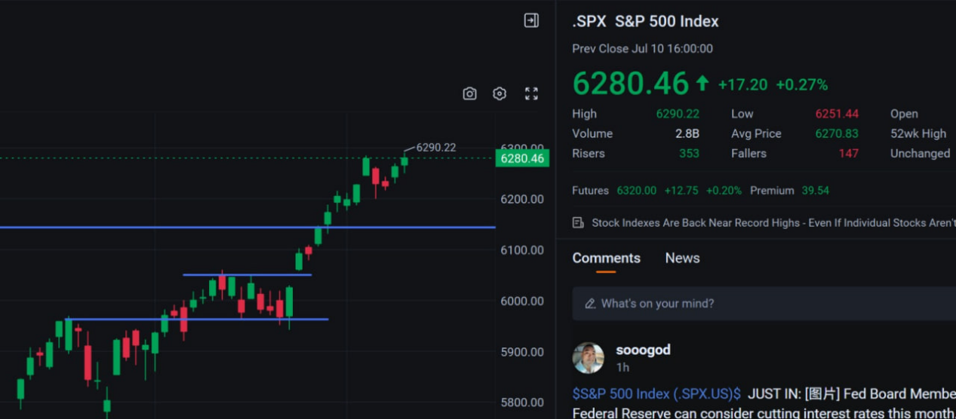Judging from today’s close, the S&P 500 is undergoing a meaningful breakout—continuing along the path I anticipated earlier. Another all-time high has been recorded, and the index now stands just a step away from 6,300.

This sustained rally, as it appears today, is being led by marquee names in AI—companies like NVIDIA and Google. But in reality, what global capital is gravitating toward is another major catalyst: the crypto sector.

Well—“Crypto Week”—a term formally defined by Congress. The capital markets have every reason to take it seriously. I’ve shared several in-depth and objective analyses on this theme, and I trust those who’ve followed along already grasp the wealth-building potential it represents.

With this positive backdrop, Thursday can rightfully be called a celebration for crypto—a carnival of on-chain assets.

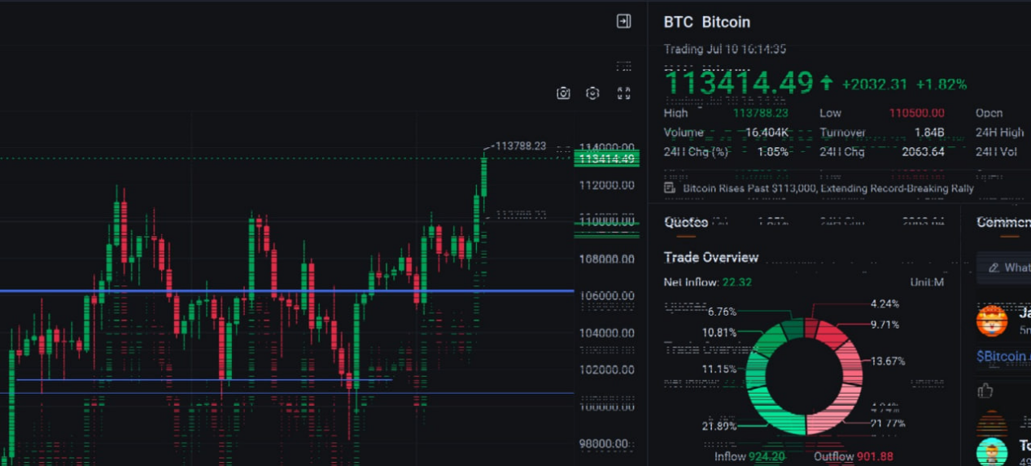Take a moment to look at the Bitcoin price chart—perhaps today is your first encounter with it, or perhaps you've long been familiar with it.

It’s entirely possible that you already hold or are actively accumulating it.

Wherever you may fall within our community—what matters most is that you are not among those who reject or fear it.

Why do I say this? First, Bitcoin has already entered the realm of national strategic reserves. If you are doing the same, it suggests you are aligned with policy direction—and more importantly, you’ve recognized the underlying potential it holds.

It also means you are not easily swayed by market noise. You understand how to define your own store of value. You possess long-term perspective, investment discipline, and—above all—clarity and conviction.

Folks, I’ve spoken on numerous occasions about the fundamental problem Bitcoin is designed to solve.

But today, rather than approaching it purely from a cryptocurrency lens, I’d like to consider what the equity markets themselves reveal about this broader shift in capital formation.

Looking back, Bitcoin has become increasingly significant as a reserve asset—gradually eclipsing gold in appeal. Across the United States, both the volume of holdings and the number of individual holders continue to rise. And, of course, this trend extends well beyond American borders.

Therefore, such sustained accumulation has driven continued price appreciation and growing visibility. The introduction of ETF flows has further validated institutional participation, signaling enduring demand from long-term allocators.
The next chapter may well involve the inclusion of Bitcoin in 401(k) retirement accounts—an inflection point that would formally embed it into the architecture of American savings. At that stage, whether by choice or design, we will all, in one form or another, have a relationship with Bitcoin.

President Trump has made it clear that he intends to position the United States as the capital of crypto. In every public forum, he actively promotes the advantages of blockchain technology and is pushing forward relevant legislation in Congress. This is not merely a narrative—it is a crypto initiative backed by real policy action.

So how do we, as investors, profit through the public markets?

First, we need clarity on which assets are closely tied to Bitcoin. Within the ETF space, IBIT stands out as a leading name.

Yes, we own it. Our quantitative strategy identified it early on. Have you kept up? Even now, the choice remains available to you.

IBIT is a fund issued by BlackRock, the world’s largest asset manager. It is structured specifically to hold Bitcoin in custody. Put simply, every dollar invested into the fund is used to purchase Bitcoin, and returns are generated—and distributed—based on the appreciation of those underlying holdings.

It’s that simple.

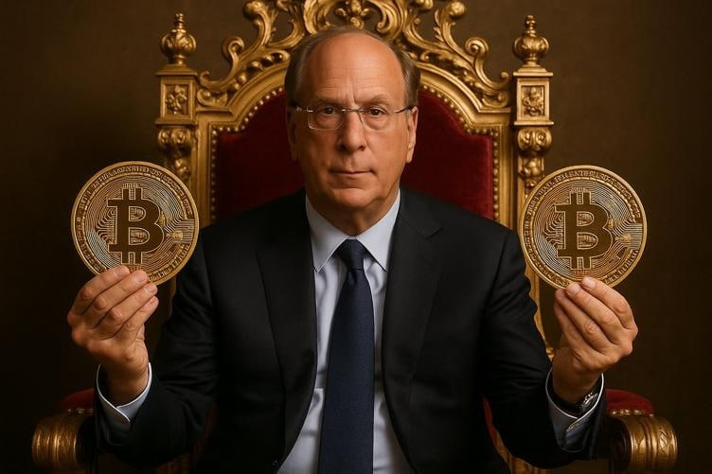Consider this: I began taking action when Bitcoin was priced at $60,000—and I continue to do so now, even as it trades above $113,000. At present, this ETF holds over 680,000 Bitcoins.

Doesn’t that scale—and the conviction behind such accumulation—reflect a forward-looking investment thesis and a highly disciplined allocation framework?

Would one question the depth of BlackRock’s due diligence or its ability to assess Bitcoin’s structural value?

As the world’s No. 1 asset manager, BlackRock brings not only expertise but also unmatched access to institutional-grade research and Wall Street infrastructure.

To invest in this ETF today is, in effect, to place trust in the quality of its underlying asset. As Newton once said, “If I have seen further, it is by standing on the shoulders of giants.”

Each share of IBIT you hold stands on BlackRock’s shoulders—anchored by scale, built on strategy.

Yes, today’s returns may serve as early validation of our thesis—but they are not the story in full. Far more valuable is the clarity of insight that precedes sustained wealth. Wouldn’t you agree?

Of course, as an important investment target, besides directly purchasing IBIT, you can also choose a very simple and efficient trading method—using IBIT options.

Yes, this options approach exists for all these stocks, including MSTR / HOOD / CLSK / HUT / CRCL.

So why am I so keen on recommending participation through options? Because it is the lowest-cost way to pursue the greatest profit in a short-term manner.

First, options are an investment trading tool. Second, you only need to pay a small portion of the capital to achieve the same trading result. For example:

For HOOD, buying 100 shares at $95 requires paying $9,500.

But if I want to pay less for this trade, even though I am still optimistic about it, I can choose to participate through an option instead. The option’s strike price is not $95 per share, and it only costs $5 per share.

One option contract equals 100 shares, so you only need to pay $500.

From a cost perspective, do you see the advantage?

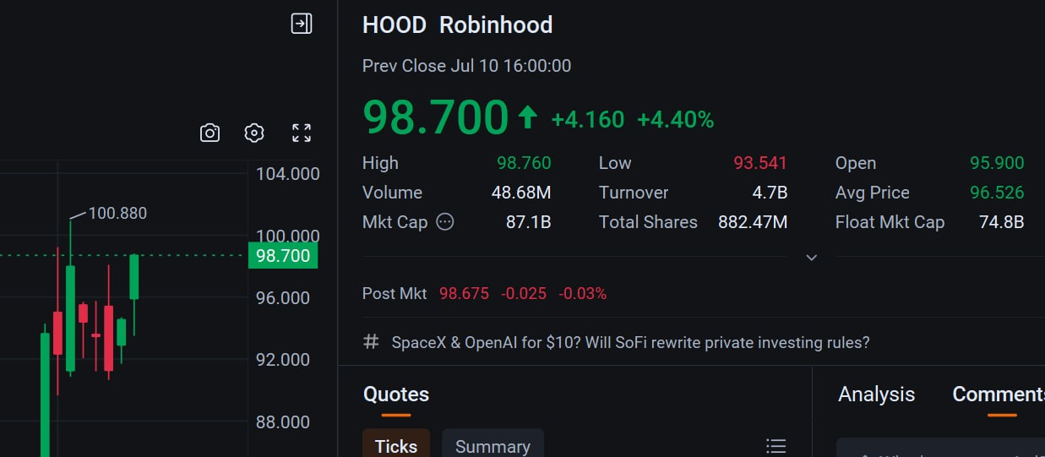As the chart illustrates, suppose HOOD stock rises today to $98 per share.

That translates to a $3 gain per share, or $300 total profit.

But what about the options profit?

If the option’s mark price rises to $10 per share—that is, the premium increases, also known as the option price rising—then by choosing to lock in your gains, your profit on the option is $5 per share.

Since one option contract equals 100 shares, that’s a $500 profit.

Indeed, when comparing capital outlay and returns, your profit doubles—100%. Yet for someone holding the underlying stock, in the same single day, the gain amounts to less than 1%.

This is the same underlying asset, but two very different approaches creating a meaningful disparity in results.

Have you recognized the appeal and opportunity inherent in this trading method?

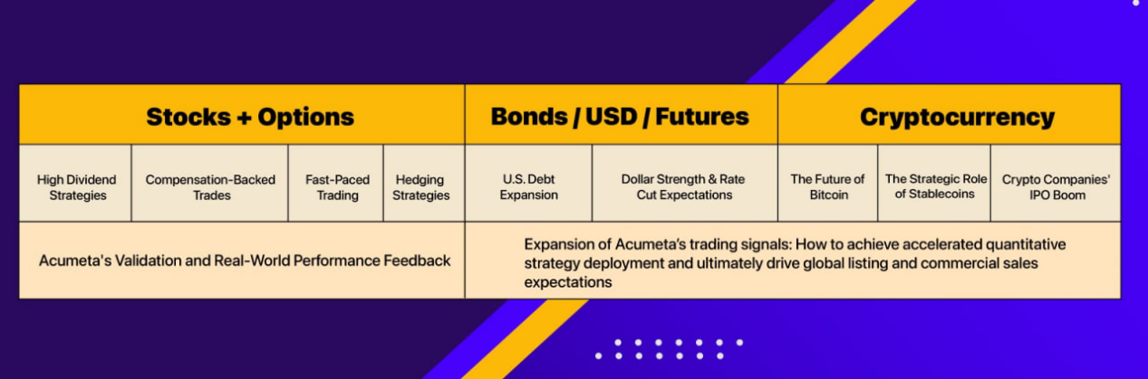Of course, there is much to understand about trading options compared to holding the underlying stock. Today, I am merely offering a brief comparison and rough calculation.

In practice, options trading requires consideration of time value, strike prices, and numerous other technical factors.

That said, with the assistance of Acumeta, these complexities will become remarkably simple.

My quantitative strategy forum is designed to introduce you to fresh, reliable, and efficient investment approaches—this commitment fuels my work and motivates me to share continuously.

As the chart illustrates, my upcoming long-term course series will deliver these essential concepts in a comprehensive and systematic manner. Are you ready to become an engaged participant?

In recent days, an increasing number of new members have joined us, making our community livelier and more vibrant.

I believe the primary reason is the compelling profits generated by the quantitative strategy signals I have shared through my in-depth analysis of the crypto sector.

Well, the current gains are temporary and modest at best.

What I truly aspire to achieve is for every community member to possess Acumeta, to attain profound financial freedom, and to emerge as the next generation of leading on-chain asset holders.

The journey ahead remains long and demanding. Much like an NBA superstar, who must endure countless early-morning practices, exhaustive training sessions, and relentless post-game reviews.

When that champion finally claims the title, it marks the beginning of his greatest opportunity to realize value. This is precisely the path we are on.

Clearly, our efforts are being noticed—and among the many forms of value we’ve extended to you is our blockchain token project. Yes, this token is issued by my Quantitative Think Tank Center.

We are embracing the momentum of a new era of on-chain financing, aiming to achieve a more streamlined and efficient capital-raising process.

This token issuance has already gained meaningful traction and is now providing solid financial support for the continued development and refinement of Acumeta.

This direction aligns closely with the current wave of interest in tokenized securities. The broader process of tokenization is attracting increased attention and institutional focus.

As Paul Atkins, the Chairman of the U.S. Securities and Exchange Commission, recently stated, tokenization represents a major innovation. He affirmed that the SEC “should concentrate on how to advance tokenization in the marketplace,” adding that the era of relying solely on enforcement to regulate the space “is over.”

In his words: “Every stock, every bond, every fund—every asset—can be tokenized.”

And today, as you receive our token voucher, you are holding a future instrument of value conversion. This future is not far away. Simply take a look at the redemption date on the voucher, and you’ll see—your opportunity to exchange it is approaching quickly.

The tokenization of equities offers a new perspective on wealth:

On the one hand, it feels inevitable.
The stock market is only open from 9:30 a.m. to 4:00 p.m. on weekdays. That’s almost absurd.
Imagine if your mailbox closed at 4:00 p.m. every Friday and didn’t reopen until 9:30 a.m. on Monday—what would that feel like?

Not to mention how slow settlement still is.
Remember the headlines last year when equity markets moved from T+2 to T+1?
Are we really celebrating reaching the operational speed of 1934?
Ask anyone who experienced the shift from floor trading to electronic systems—it's telling.

So, embracing the concept of tokenization means embracing a new form of wealth.
We hope you'll complete more small tasks and receive our token vouchers in return.

That wraps up today’s community forum session. And now, a little surprise at the end: answer the questions below for a chance to receive a special reward!

1. In which month will the Fed begin cutting rates, as I firmly state?

2. Will equity tokenization help mitigate the U.S. debt crisis? Share your reasoning in 30 words.

3. Who was the world’s first publicly listed stablecoin issuer? Do you believe its stock price still has room to grow?

Please send your responses to my assistant. Let the perfect answers be a gift to your better self.
Good luck—and see you Friday.

