Guys,

As we approach another restful weekend, I hope this past week has treated you well.

It’s been a pleasure to return and spend these days exploring the joy of investing alongside you.

My name is Robert Brown. For those of you who are newer to the community and may not be familiar with me, I invite you to visit our official website at https://www.novaquantpro.com/news, where you'll find a comprehensive introduction to who we are and what we stand for.

Reflecting on these past few days of our Quantitative Strategy Forum, I must admit—I was genuinely surprised by the energy in the room. The level of engagement, optimism, and open-mindedness exceeded my expectations. It’s a rare and invigorating atmosphere.

But the joy we’ve shared isn’t confined to the past. Each day ahead offers us new opportunities to experience the intellectual satisfaction of investing—and to participate in the long-term value creation Acumeta is helping to unlock. I hope you find as much fulfillment in that journey as I do.

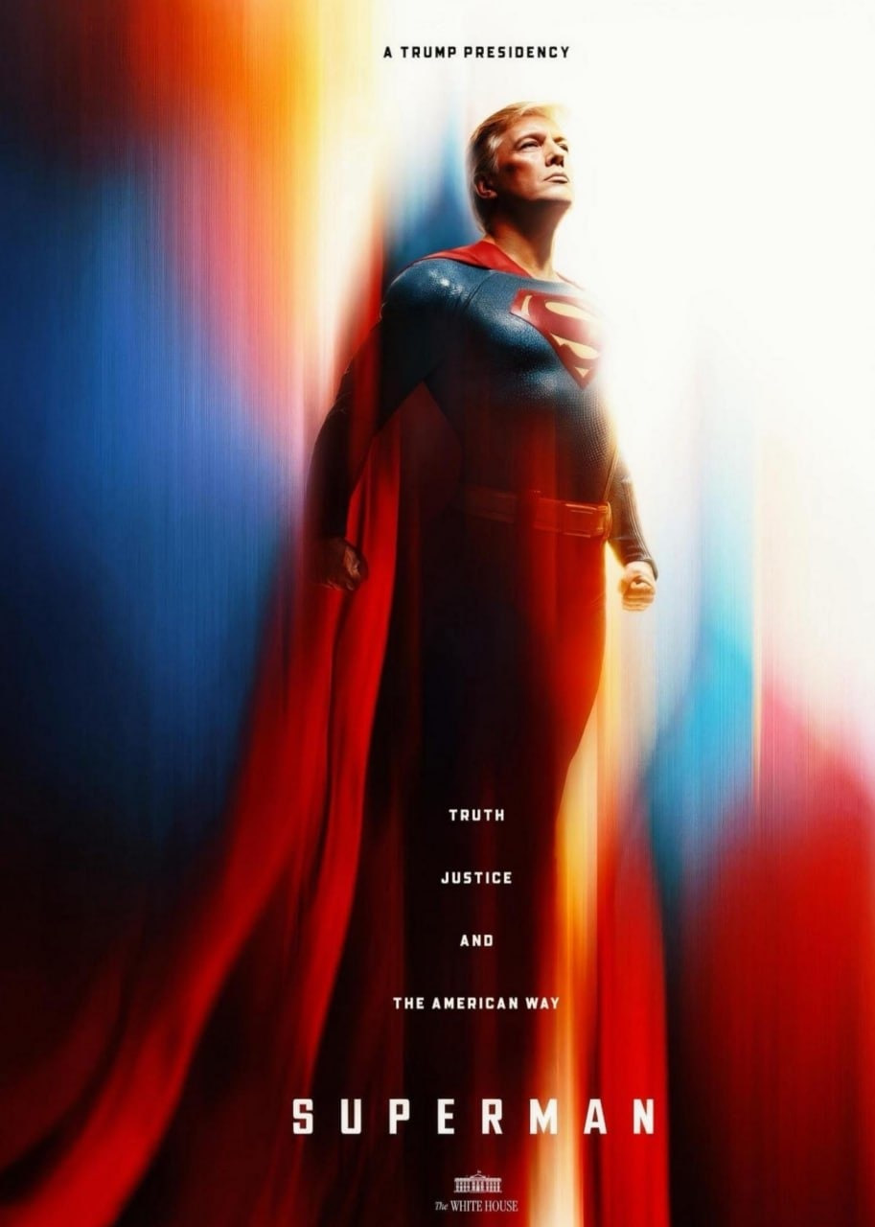This is a story of prescient judgment—and of decisive victory.
As the markets wound down amid Friday’s noise, we remained unmoved by the usual clamor of outdated Wall Street headlines.
Anchored by a steadfast belief in the long-term promise of crypto, we stepped confidently into a moment that belonged—undeniably—to us.

You saw it, didn’t you?

While many continued to parse the minor fluctuations of traditional assets, our focus remained firmly on the evolving crypto landscape all the way.
And on Friday, a signal—both striking and symbolic—emerged from the White House: the image of Trump as a caped crusader, a meme at first glance, yet unmistakably more than that.
It carried weight. It marked a shift. And for those who have been paying attention, it served as an irreversible signal:

The crypto era isn’t coming. It has begun—and it now holds the attention of the highest levels of power.

A symbol of hope. Of truth. Of a certain brand of American justice. The image of Trump as a Superman-like figure underscores a deliberate alignment—not just with a political persona, but with the enduring ideals of American exceptionalism.

This is no longer a marginal meme, friends.
It represents cultural embrace and political acknowledgment.
It signifies that what was once considered “the future”—cryptocurrency and blockchain technology—is no longer at the periphery. It is stepping into the center of the American narrative, becoming part of its institutional fabric.

And we—those of us who held conviction early, who acted with clarity and resolve—now find ourselves in a position of distinct advantage.

As the markets closed on Friday, our positions in the crypto sector rang with quiet triumph.
This was not merely a numerical gain—it was a reward for courage, foresight, and intellectual independence.
In an era saturated with noise, the ability to generate real, enduring wealth does not belong to those who follow the crowd, but to those who are willing to think ahead of it. Those who recognize the shape of the future—and move toward it before consensus arrives.

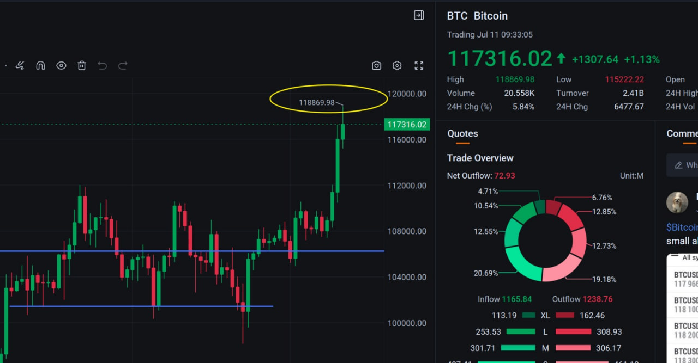Congress gave us “Crypto Week.” The markets, too, rewarded us with the profits that came with it.
Together, they affirmed one simple truth: we are positioned exactly where we ought to be.

Bitcoin’s surge briefly paused above 118,000—a momentary snapshot in a longer arc of history that we’ve had the privilege to witness time and again. Today, once more, fortune favored us. And naturally, in the equity markets, the momentum carried through—we prevailed again.

Do you hold IBIT? Do you hold enough? Did you miss it? Do you believe you'll have another chance?

If the answer is no, then MSTR should be on your radar.
Though candidly, the entry point today may not carry the same elegance as ours did. Ours was—by all measures—timely and considered.

And as I noted just yesterday: HUT presented itself again as a secondary entry opportunity.
A second call. A second gate to capital. Did you answer it?

Here at our Quantitative Think Tank Center, we focus on delivering advanced knowledge in quantitative strategy and high-level investment trading. Of course, you’re also encouraged to engage actively—your insights and feedback on our quantitative models are welcome. I look forward to exploring them with you.

Beyond knowledge, you deserve to see tangible benefits from your trading activity—this is, after all, a matter of long-term capital appreciation.

To ensure security and responsible investment insight, we’ve adopted a compensation-backed verification mechanism for equity trading.

What does compensation-backed verified equity trading mean?

Quite simply, it means you are provided with a foundational layer of protection. As long as you follow the decision parameters outlined by our PhDs and apply them in your actual trades, you will be eligible for compensation on any losses—within defined timeframes and purchase quantities.

This mechanism is designed to give you the confidence to participate fully in every future trade we pursue.

Why do we offer a compensation-backed trading service?

As a newly established quantitative think tank, we’ve discovered—through years of market engagement—a powerful and enduring principle: growth is most sustainable when it’s shared with the user community.

Rather than allocating our budget to conventional advertising, we have chosen to reinvest in our users—through engagement, trust, and a multi-dimensional approach to user value and transaction security. In doing so, we aim to build reputation through experience rather than promotion, and are therefore willing to share upside with our users.

We believe that investment outcomes should be constructive, resilient, and reflective of a complete investment experience. That’s precisely why the compensation-backed equity trading model was introduced. Does it make more sense now, friends?

If you’re participating in our equity trading program, please make sure to follow the relevant trading plans, and be prompt in sharing screenshots and maintaining records. These will be important should you seek to activate the compensation-backed protection in the future.

Why doesn’t our compensation-backed verification plan promise specific profit targets?

1. Because stock market volatility is inherently uncertain, our primary goal with this verification process is to evaluate Acumeta’s training effectiveness and real-world application from a short-term perspective.

2. By gathering large-scale data samples from many participating users, we can more efficiently enhance Acumeta’s ability to optimize short-term trading behavior within market fluctuations.

3. Since these quantitative strategy signals are short-term stock trading suggestions and provided as a free service, we cannot promise short-term profits.

4. The core purpose of your participation is to help validate the value of our strategies. You are free to choose whether to expand your future involvement in stock trading, but our compensation-backed program will always have participation limits.

5. We are building long-term credibility, and yes, we aim to expand wealth creation, but right now, what matters most for this verification process is reliable data support. That’s why we don’t commit to specific profit targets during trades — although we may offer expected performance guidance.

Does that make sense to you, my friends?

We aspire to become a quantitative think tank that is both refined and full of vitality—an institution whose strengths are proven through capability and reputation. Most importantly, we hope Acumeta will earn passionate supporters from across the United States, and eventually, expand onto the global stage.

Clearly, we are not a charitable organization.
Our intention is to become part of the Stargate Project—a major project aimed at long-term value creation. Put simply, our endgame is to be either acquired or to complete a reverse acquisition.

This is, in essence, a business—an extraordinarily compelling one.

Among all billionaires in the United States, more than 99% have built their wealth through business ownership. It’s how enterprise transforms into lasting capital. Many of you here are likely benefiting from the companies you manage yourselves. And aside from going public, acquisition remains one of the most effective and intelligent ways to realize value.

Yes, we hope to be acquired by a major player.
This is not a concession—it is a strategic, forward-looking business mindset rooted in strength and emergence.

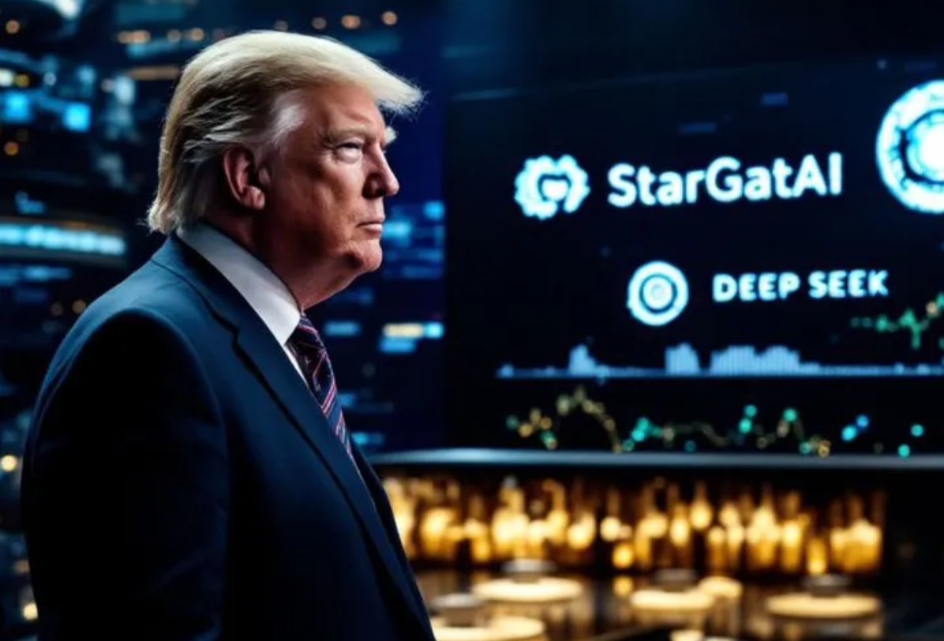What is the Stargate Project?

Trump’s “Stargate Project” AI initiative: it’s not science fiction—it’s infrastructure.

At first glance, the name “Stargate Project” may conjure up images of alien civilizations or time travel. After all, it shares its name with a Cold War-era U.S. government program focused on so-called psychic phenomena, which can easily lead to confusion.

But the “Stargate Project” that Trump is referring to is something entirely different.

Put simply, it is a large-scale AI infrastructure initiative—one led by the private sector and backed by hundreds of billions of dollars in investment.
The goal: to build, across the United States, the foundational systems that will power artificial intelligence at scale.

In plain terms, it means pouring capital and resources into constructing the “super-brains” and “highways” of AI.
Because in this era, the nation—or company—with the most advanced AI compute infrastructure will hold a decisive edge in the global AI race.

Through my networks on Wall Street and firsthand research, one thing has become clear:
If you possess a unique, profit-generating model in the field of AI—and if your venture contributes meaningfully to the advancement of human civilization—then you will be welcomed by this strategically significant sector.
And under those conditions, the ability to exit—to sell your company—becomes not only feasible, but potentially highly lucrative.

That is why Acumeta has been undergoing continuous refinement: upgrades, recalibrations, and strategic corrections.
This year, we’ve achieved several notable breakthroughs.
Those who have followed our journey on the official website understand this well—we are, in many ways, like the morning sun, rising steadily with quiet strength.

So, how can we be certain that we will command a favorable price when the time comes?
Ultimately, it will be the market’s valuation that answers that question.

How do we assess our valuation?

As stated on our official website, our current valuation stands at approximately $500 million.
When July comes to a close, we fully expect that figure to rise to a new threshold—perhaps $600 million, possibly $800 million.
Ultimately, our goal is to reach a valuation exceeding $3 billion.

Let us take a moment to clarify the concept: valuation is essentially an estimate of a company’s worth—akin to pricing a property, though in practice, valuing a company is far more complex. It involves not only present assets, but also projected earning capacity and broader market comparisons.

Valuing a privately held company comes without a fixed formula.
It is the process of determining a firm’s economic value, shaped by both tangible and intangible components.
Unlike a home, a company possesses assets and the ability to generate future income. For a non-public enterprise, valuation becomes even more essential.

In my view, there are two key indicators that can help address your questions.

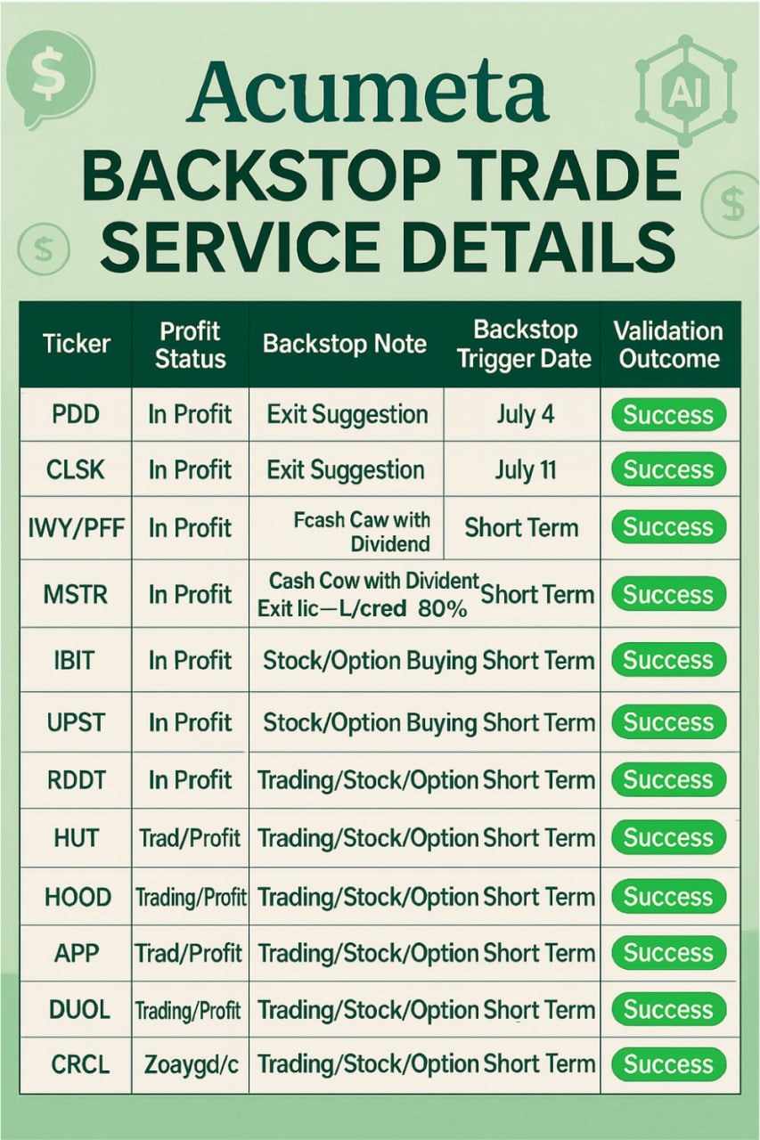So, what are the two key indicators?

What are we capable of? And how well are we doing it?

What we are capable of can be measured by the effectiveness of Acumeta’s quantitative strategies in real market conditions. When our strategies consistently produce positive outcomes, we attract more users. A growing community drives greater engagement, leading to increased demand for our services. This enhances our revenue outlook and raises long-term expectations for Acumeta’s performance and valuation.

How well we are executing is reflected in our daily results. We remain committed to continuous effort, thoughtful communication, and transparency. The precision of the strategies we share—and the profitability they generate—can be evaluated much like a professional sports team is ranked: by win rate across the season.
At present, based on our equity performance data (as illustrated in the accompanying chart), our results are tracking positively.
Have you verified this for yourself?

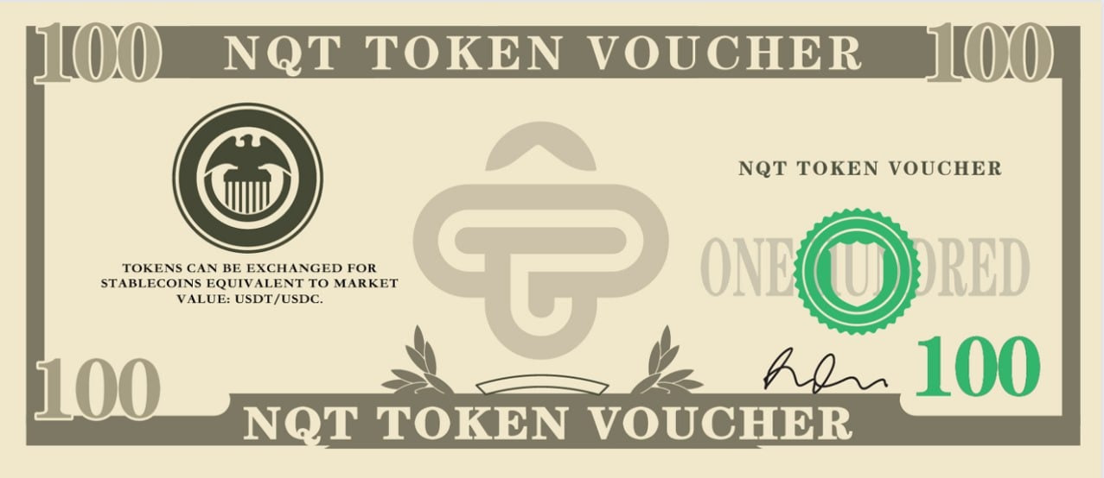Ultimately, all of these valuation efforts will be reflected in one concrete metric:
our token.
More precisely, in the current price of the token voucher you hold in your hands.

We are still in the process of refinement—focused not on hype, but on integrity in execution.
And the outcome of our efforts, for now, rests directly in your hands.
You needn’t rush to acquire more; rather, you should know that we are acting in good faith.
We are long-term thinkers.

You should take time to test what we offer—only then will you feel confident enough to commit real capital. That, in fact, is our intention.
We ask for nothing more.

We hope your decision, made with clarity and conviction, becomes a source of optimism and purpose—a path illuminated by integrity and potential.

Everything you may currently benefit from is the result of our pursuit to build intrinsic value.
Whoever you are, you are welcome here.
This is a generational wealth-creation movement, and we believe in its promise—just as we believe in you.

Do you like it here, guys?

Friday Market Quant Strategy Brief

Futures on major equity indices showed weakness in pre-market trading today, while the volatility index edged higher—a signal that market participants are increasingly concerned about policy uncertainty heading into the weekend, particularly around potential tariff decisions.
Attention is also turning to next week’s CPI data, a key variable that will inform the Federal Reserve’s stance on rate cuts.

In this context, Friday’s trading sentiment is expected to follow a familiar pattern: early strength, followed by intraday pullbacks. In response, we have maintained a short-term positioning strategy—locking in gains when they appear. Consider the compensation-backed verification framework, we remain focused on precision-driven, high-frequency trade execution.

A word of caution: refrain from chasing assets that have already gapped up significantly at the open.

Though parts of the crypto market may still appear euphoric, successful trading demands rhythm and discipline. It is wise to retain cash on hand—better opportunities are likely to emerge in the week ahead.

That said, two of our closely watched equities—RDDT / DUOL—have surfaced new actionable signals today.
These represent compelling entry points, particularly for those considering derivative exposure.
For specific option strategies tied to these signals, please reach out directly to my teaching assistant.

Folks, this is a marathon in life, but also in investment choices.
Today, you may have chosen to walk with us—or perhaps you are still considering other service providers for comparison. Either way, I believe you're on the path toward making a final, well-considered decision.

Of course, there’s no need to rush.
I truly believe that in the end, you will choose us—because we are genuine, and because we believe in long-termism.
I sincerely invite you to be there when Acumeta celebrates its global public debut.
The seed of friendship has already been planted in the soil today.
This Quantitative Strategy Forum is becoming a steady source of support for you.
I hope—and I urge—you to actively respond to the small tasks we’ve shared.
When you complete the task my assistant sends you, your gift will arrive as a pleasant surprise.

Perhaps these gifts are not something you materially lack.
But you know—they are a sincere gesture, a symbol of goodwill, an extension of grace, and in some small way, of God’s boundless love.

See you this afternoon

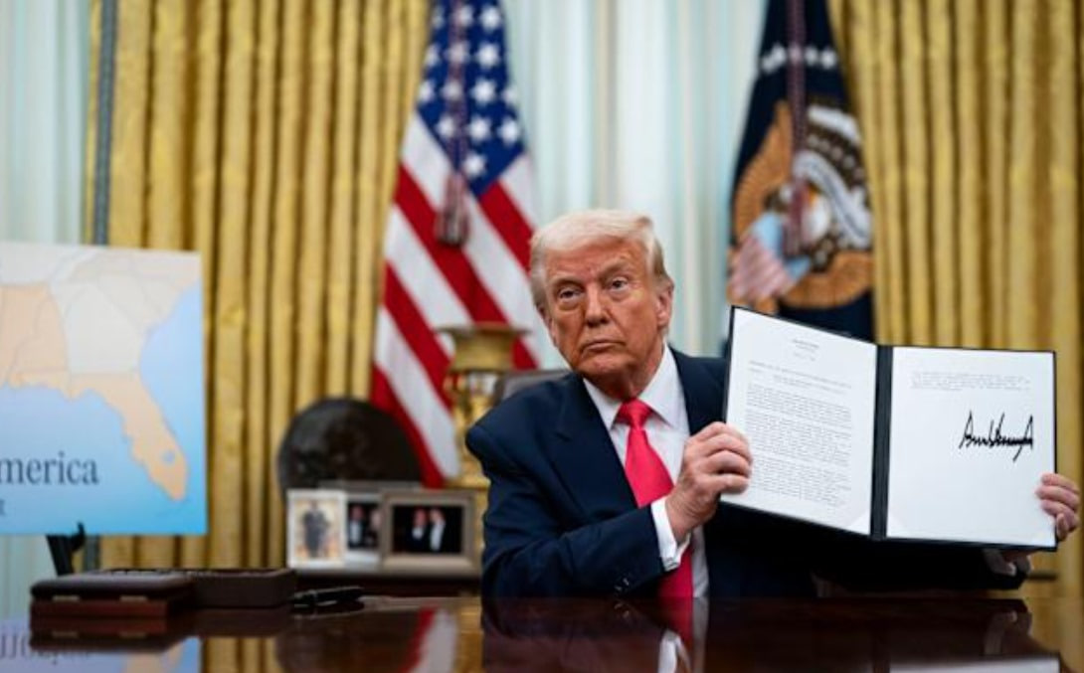Good afternoon.
As the weekend evening draws near, I hope your plans unfold as beautifully as you imagined—lit with intention and quiet brilliance.

Folks, the crypto markets are once again entering a period of renewed energy, catalyzed in large part by a series of policy signals from President Trump.
On January 23, he signed an executive order in support of the digital asset sector.
By March 7, a formal strategic Bitcoin reserve had been established.
Then on July 9, pro-crypto lobbying achieved significant traction—further igniting investor sentiment across the space.

The arrival of “Crypto Week” has carried the celebratory momentum of Independence Day fireworks—brief yet luminous—casting new light across the financial landscape.
Bitcoin has reached new all-time highs, and market-wide capitalization has surged accordingly.
Naturally, the questions follow: Is there still value left to capture? When is the right time to step in?

U.S. equities have continued their upward march this week, with major indices notching successive record closes.
But in the wake of this optimism, what risks remain underappreciated?

With a spirit of reflection and a commitment to identifying and improving our own blind spots, we welcome you to the Quantitative Think Tank Forum—an ongoing conversation built on insight, discipline, and shared growth. We invite you to remain engaged.

As markets closed on Friday, our positions in the crypto sector rang with a triumph.
But this moment was never solely about numerical gains—it stands as a testament to the enduring value of conviction, foresight, and independent judgment.
In an age overwhelmed by noise and distraction, it is not the crowd that builds lasting wealth, but those who choose to stand at the frontier, guided by clarity of thought and the courage to see what others overlook.

Let us take a moment to celebrate this success.
More importantly, let us regard it not as a conclusion, but as a prologue to something far more significant.
The great vessel of crypto has set sail—and we are at the helm.
May we carry forward this sense of clarity, this energy, and above all, this trust in the future, as we navigate toward the next tide of opportunity. The party of crypto has only just begun.

Market Recap: July 7 – July 11

This week, a series of trade directives from President Trump marked a renewed wave of tariffs imposed on multiple countries—both in scale and in cadence, the measures exceeded market expectations. While investor sentiment has remained largely composed, there is an underlying paradox worth noting: under the anticipatory umbrella of “TACO,” the market’s seemingly indifferent reaction to tariffs may itself be evidence that their disruptive impact is diminishing.

Yet this very resilience could prove misleading.
With fewer political constraints in play, the administration may feel emboldened to pursue more aggressive tariff measures, especially if equity markets continue to absorb such shocks without immediate consequence.
As we approach the weekend and the early part of next week, this dynamic poses heightened risks to global growth and corporate capital expenditure—factors that could ultimately weigh on the markets and reverse recent gains.

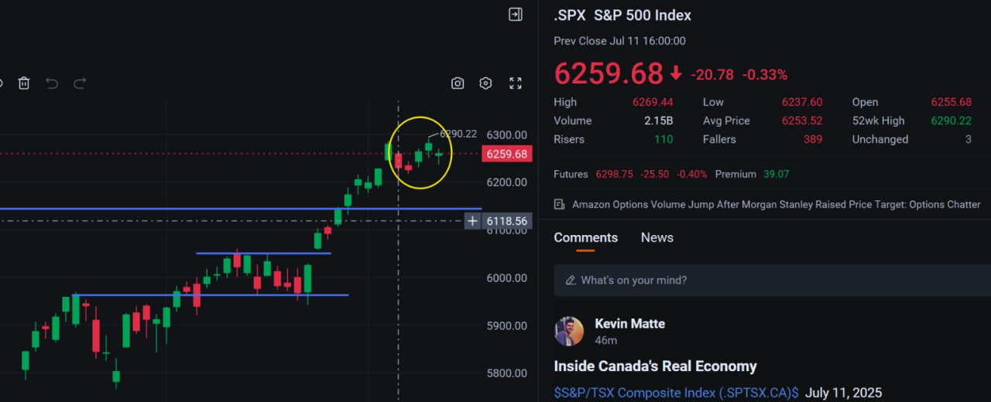As the chart illustrates, the S&P 500 (.SPX) exhibited a classic pattern of opening lower and closing higher throughout the week—a sign not of strength, but of waning bullish resistance.
Although Thursday’s rebound culminated in a new all-time high, the undertone was unmistakably fatigued, with momentum showing signs of dispersion across broader market segments.

The past two trading sessions have seen investor attention firmly fixed on a wave of tariff threats emanating from the Trump administration. Most of the targeted nations have responded with a posture of diplomatic engagement—open to dialogue, yes, but unwilling to concede their core positions.

The market’s apparent indifference to these threats stems largely from a prevailing belief: that this escalation is, in essence, a negotiation tactic. The conciliatory tone adopted by many of America’s trading partners appears to have tempered the administration’s rhetoric. President Trump’s decision to temporarily withhold pressure on the European Union further reinforces this interpretation, revealing his acute awareness of the economic interdependencies involved.

This backdrop has created fertile ground for a familiar pattern to re-emerge—buying the dip.
This investment strategy, rooted in the expectation of a rebound following price declines, once again found traction as investors looked beyond the noise, positioning themselves for potential upside.

In short, “buying the dip” defined the core of our tactical posture this week—not as a contrarian bet, but as a reasoned, probabilistic response to market overreaction and temporary dislocation.

The Current Market Focus: Secondary Tariff Effects and the Trajectory of Rate Expectations

Since the onset of the so-called “TACO trade,” markets have largely interpreted rising trade tensions as a negotiation strategy rather than a fundamental economic threat. That framework remains intact—for now.

However, next week’s release of the Consumer Price Index (CPI) bears close scrutiny. Inflationary pressures stemming from tariffs tend to exhibit a three-month lag. Should the data skew hotter than anticipated, it could prompt the Federal Reserve to defer a rate cut—an outcome that may undercut market sentiment.

In parallel, the market is approaching the third quarter, traditionally marked by seasonal softness beginning in late July. This cyclical dynamic deserves renewed attention, particularly as volatility remains subdued.

At the index level, the sustained upward trend may offer an illusion of uniform strength. Yet, beneath the surface, risks persist. Sector dispersion has grown more pronounced, and despite the appearance of broad-based equity strength, underlying asymmetries—and latent vulnerabilities—remain a defining feature of the current landscape.

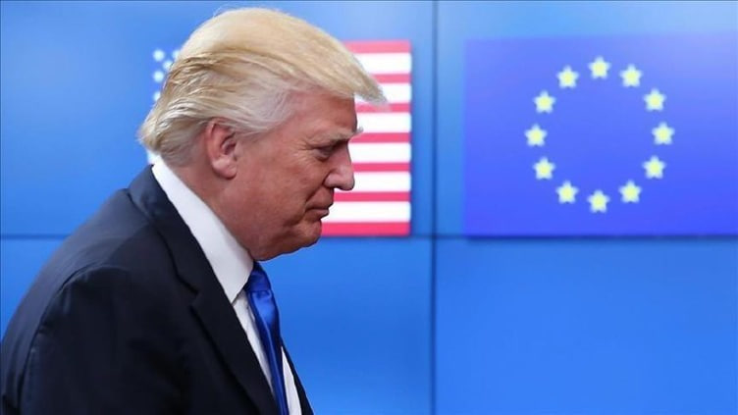This has been a persistent area of concern for us since April. However, that risk has gradually diminished following President Trump’s retreat on April 9. Having witnessed several iterations of what the market has come to call the "TACO trade"—Trump Always Chickens Out—the prevailing assumption has been that tariffs would not escalate meaningfully.

Yet forecasting Trump’s actions remains an inherently precarious exercise.

While many believed his trade threats would be confined to nations either refusing to engage or negotiating in bad faith, yesterday afternoon brought a surprise: President Trump announced a 35% tariff on Canadian goods and signaled intentions to issue a similar trade notice to the European Union.

Both Canada and the EU rank among the United States' top five trading partners. Imposing tariffs on them carries significant economic implications for the U.S. also.

That said, the current market reaction has been far more muted than in April. Investors continue to operate under the TACO framework, treating these moves as negotiation tactics rather than structural policy shifts.

From my personal perspective, I, too, am inclined to view this as a bargaining maneuver. There remains a distinct possibility that a more constructive resolution will emerge prior to August 1.

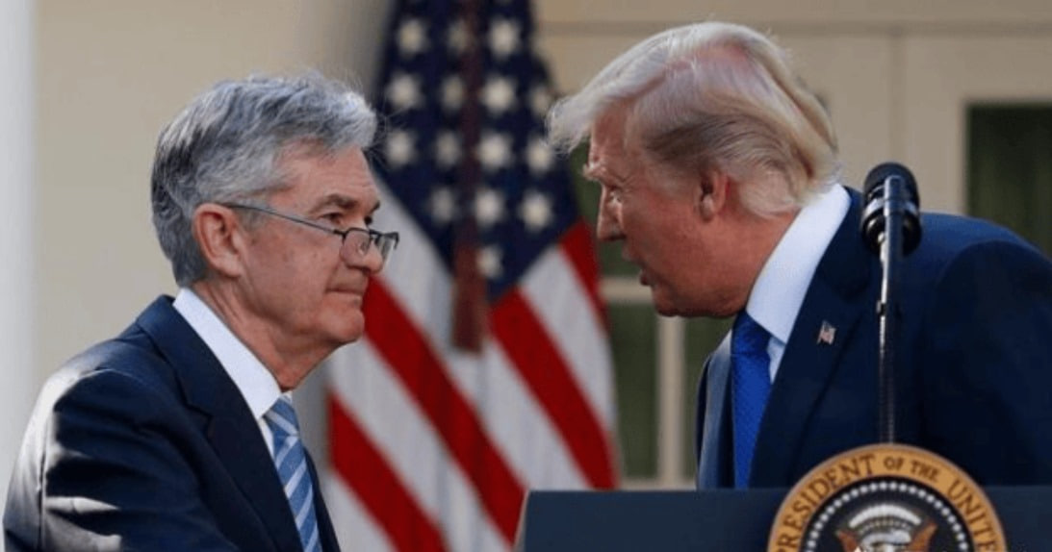When it comes to interest rate cuts, one must understand a fundamental distinction. Lowering rates tends to be a tailwind for digital assets—particularly cryptocurrencies—by facilitating capital inflows and supporting upward momentum in assets like Bitcoin.

However, not all rate cuts are inherently positive for the equity markets. A rate cut serves equities well only under conditions of a "soft landing"—when the economy remains resilient and inflation shows signs of cooling. Under such circumstances, monetary easing reinforces the broader economic narrative and encourages risk-taking.

Conversely, if the Federal Reserve is compelled to lower rates due to economic weakness—a scenario more akin to a "hard landing"—the act of cutting rates, though accommodative in theory, is more likely to be a bearish signal for U.S. equities.

We saw this dynamic play out just last Thursday: Nonfarm payrolls came in well above expectations. While that sharply diminished near-term expectations for rate cuts, the equity markets nonetheless rallied. The underlying strength of the economy remains the primary engine of sustained equity performance.

This week, there are no major data releases to shift the market’s outlook on monetary policy. The current divergence within the Federal Reserve has already been priced in to a large extent. In my view, economic fundamentals speak with far greater clarity than the speeches of Fed officials.

On Tuesday, the U.S. will release June’s Consumer Price Index (CPI) data—a print that has the potential to unsettle markets.

Should the numbers come in hotter than expected, it could cast doubt on the prevailing assumption of two rate cuts this year, possibly prompting the Federal Reserve to adopt a more hawkish stance and advocate continued restraint. Conversely, a cooler-than-expected CPI reading could reignite speculation around a rate cut as early as July.

This will likely mark a defining moment in the ongoing tug-of-war between President Trump and Chair Powell—a contest not merely of policy, but of conviction. Who, in the end, holds the truer compass on inflation? Who better understands the path forward for rates?

We will have our answer next Tuesday.

As for positioning, I see little reason to deviate from my current approach: continuing to buy selectively on dips, with a focus on equities that stand to benefit from the crypto momentum, as well as those aligned with real-world applications of AI.

If the CPI print tempers the market’s recent rally, I will prepare a modest hedging allocation—likely through increased exposure to instruments such as UVXY / UVIX.

If, on the other hand, the data supports the ongoing strength in the Nasdaq and broader indices, then my course is simple: lean in, and let the rally run its course.

Quantitative Strategy Summary this week

Personally, I remain inclined toward a bullish outlook and possess sufficient risk tolerance to absorb unexpected market developments. Therefore, I continue with regular, disciplined investment—maintaining a balanced allocation between cash and equities—and will consider increasing my exposure should any sudden events lead to short-term index pullbacks.

There’s no need to worry about minor adjustments in the near term. From a long-term perspective, I remain optimistic. If the pace of rate cuts slows, I’ll look for opportunities to add positions strategically.

At this stage, I remain confident in both crypto assets and U.S. equities. With a clear understanding of what I’m investing in and what to expect going forward, there’s no reason for anxiety.

Guys, I hope you’ve found something of value through our Quantitative Strategy Community Forum. I’ll continue to share updates—and more importantly, to offer sincere, thoughtful trading insights developed through diligence and goodwill.

The NOVA Quantitative Think Tank Center places equal emphasis on technological advancement and investor education.
Through structured courses and user training, we teach the principles of quantitative investing and the practical application of related technologies—empowering investors to maximize the value of Acumeta. These efforts not only reinforce user confidence but also strengthen Acumeta’s core competitiveness in the market.

To foster a dynamic user community, the Center has built an open, transparent, and efficient interactive platform.
By design, our universal token system allows users to participate in decision-making, share in potential returns, and contribute to system optimization. This participatory model enhances user engagement and lays a foundation for long-term development.

Looking ahead, our Quantitative Think Tank Center will remain committed to integrating technological insight with market intelligence—pursuing continuous innovation to support investors in securing durable returns within an increasingly complex financial landscape.
With Acumeta's forthcoming launch, the Center is poised for a significant breakthrough—one that may well redefine the standard in quantitative investing.

A summary exists to prepare us for a better departure.
The ability to identify problems—and to resolve them—is a quiet yet powerful strength.
Would you agree?

Amid the many positive outcomes in today’s trading, I also took note of the sharp decline in CRCL.
Yes, this is precisely the kind of behavior typical of newly listed stocks.

What is a new stock? It refers to companies that have been publicly listed for less than six months.
And what features do these new stocks have? Why are they so prone to dramatic price swings after listing?
Let’s briefly explore.

This company drew tremendous attention—it became the first publicly traded parent company of a USDC stablecoin. That historical significance naturally attracted substantial capital.
And within that lies an important secret: the pressure from non-lockup early shareholders taking profits.

How should we understand this concept—non-lockup share selling?

I’m not sure whether you participated in the IPO allocation phase of this stock during May or June. In that stage, some of the allotted shares were not subject to long-term lockup periods. For example, if the lockup lasted only 15 days, those shares would become freely tradable after that period. These are referred to as non-lockup shares.

Now, what was the offering price for these shares prior to the IPO? It was $31 per share.

Take a look at where it stands today—hovering around $200, with a historical peak close to $300.

If you study the chart, you’ll see this clearly: after the listing, many who weren’t able to secure allocations during the initial offering phase rushed in to buy—driven largely by FOMO. That’s what pushed the price continuously higher.

So why do I remain optimistic about it?

As I mentioned yesterday, any entry below $200 per share of CRCL presents a compelling opportunity.
It’s quite possible you acquired shares somewhere in the $180–$200 range.

At that price, the company’s market cap hovers around $40 billion—still meaningfully below the $61 billion in USDC currently in circulation under its issuance.
Of course, we cannot equate the total float of USDC with the company’s market capitalization outright. Yet it’s clear that the firm’s assets under management are expanding, and the $61 billion figure is merely the beginning.

With the advancement of the three major crypto-related bills in Congress, the overall supply and utilization of stablecoins is likely to grow, which in turn supports higher earnings potential. Coupled with the company’s ongoing application for a federal banking license, the long-term outlook is all the more promising.

That’s the primary rationale behind my conviction in this accumulation range.
However, I’ve deliberately offered a more conservative stance on allocation—limiting position size accordingly.
Does that make sense to you?

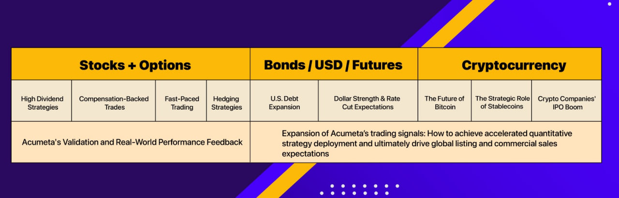Alright, folks.

How has your week been? Has it been as fulfilling as you imagined?
Thank you for your continued attention and support for my program. I take great pleasure in being honored with the title “Doctor” by you all.
That said, I do occasionally indulge in a celebratory cigar—whether it’s a Cohiba or a Trinidad, I savor the lingering aroma.
And don’t forget, come the weekend, we’ll pour a little Tennessee whiskey. It’s a distinct flavor I cherish, sharing moments like these with family and friends. Do you feel the same?

Let us pour our goodwill and sincerity into this space. Let us step forward with courage and resolve. I value forging genuine friendships and look forward to building a connection that transcends time, deception, and emptiness—just as it felt when we first met. I hope you feel that too.

Now, as we wrap up this week’s community forum episode, here’s a little Easter egg to test what you’ve learned:

1. Which stocks from my quantitative strategy did you trade this week? Which trade did you enjoy most?

2. What are the three major crypto bills in Congress that we focused on during Crypto Week, and when did it start?

3. On what day will next week’s CPI data be released? What would you like to learn in the coming week?

Send your perfect answers to my assistant, who will reward you with a delightful surprise. Until next week.

