An Inviting Weekend—How Did It Go, Folks?

This is the community forum session of the NOVA Quantitative Think Tank Center. Welcome back—I’m Robert Brown.

I know we’ve had some new faces join recently. To our new friends: don’t hesitate to participate. Your enthusiasm and voice are welcome here. Together, we navigate the sea of quantitative strategies to discover the most valuable signals and moments for action.

It’s been a sweltering weekend across many parts of the country. Some states may have experienced heavy storms, but I hope you’ve stayed safe—and found joy along the way.

As the sunlight of Monday rises once again to illuminate the world, how do you plan to begin your week?

If you’ve been wondering whether stock investments are now being guided by a force less visible, perhaps even elusive—you’re not alone.
What exactly is shaping the markets today?

With a sense of purpose and thoughtful inquiry, let us witness what insights Acumeta has to offer.

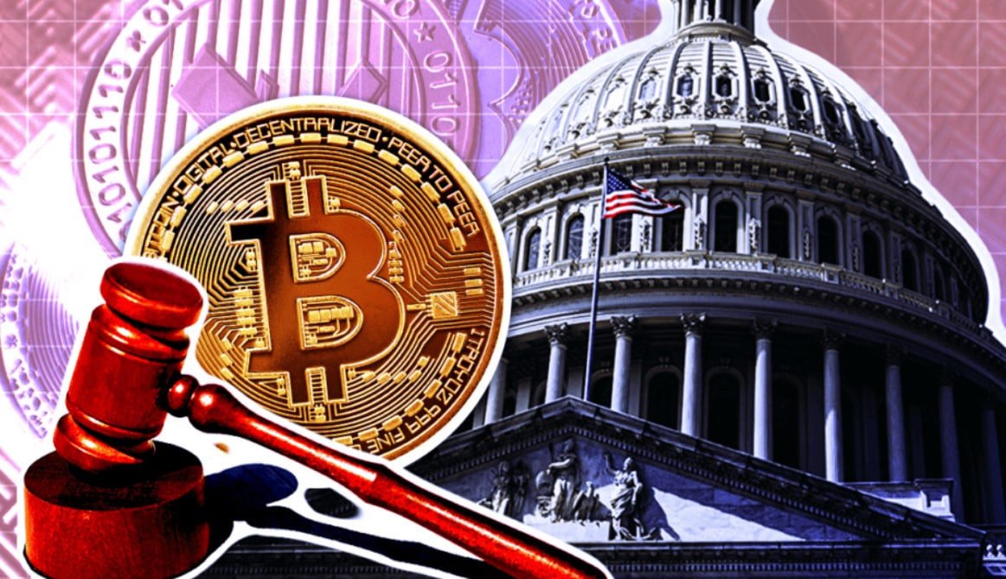I hope you all had a weekend full of energy and inspiration—especially for those of us who believe in the future of crypto, it felt like an early celebration.
As headlines about “Crypto Week” lighting up Capitol Hill dominated social media, there was a quiet sense of vindication—our conviction and foresight were, at last, receiving recognition from the highest levels.

This wasn’t just news. It was an invitation from the institutional world to the digital asset space.

Signals from the White House, direction from Congress—all of it points to a clear message: crypto is no longer a fringe subculture. It is taking confident strides into the center of everyday financial life, establishing itself as a foundational layer of the future economy.

This wave of institutional guidance suggests a new phase is underway—greater policy clarity, a more constructive regulatory environment, and, crucially, a green light for broader capital participation.

It’s the moment we’ve long anticipated.

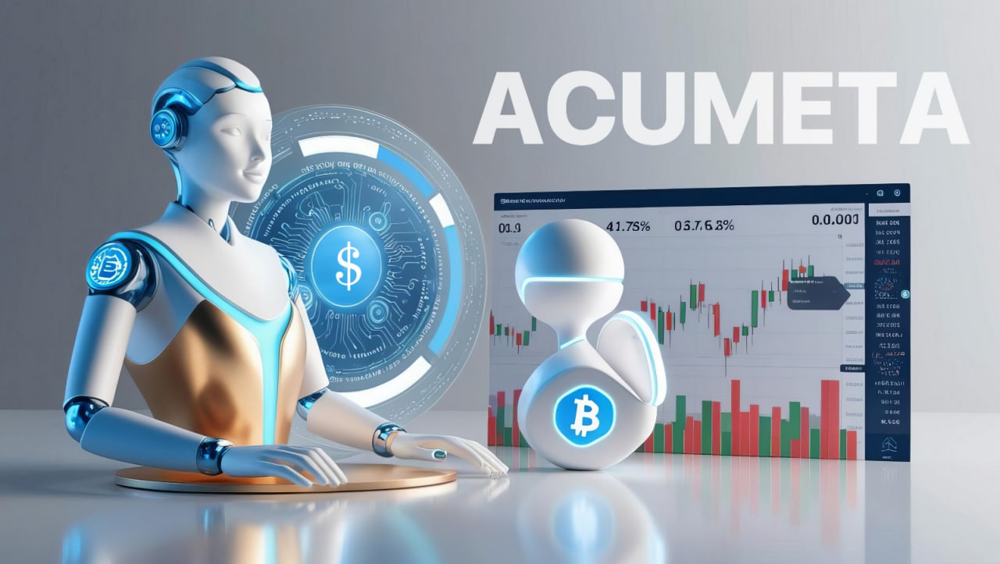Looking back on the weekend’s wave of crypto enthusiasm—from Bitcoin’s resilient performance to the momentum emerging across a range of new projects—it all serves as further validation of the foresight we’ve long held.
That sense of quiet exhilaration, the firm conviction that we were right, is something everyone deeply engaged in this space can surely relate to. It is the market’s highest form of acknowledgment for those who have remained confident and committed.

So, what lies ahead for crypto-related equities in the coming week?

I can say with confidence: as regulatory direction from Congress becomes increasingly clear, we anticipate a growing wave of institutional capital stepping in. Even the more risk-averse investors are beginning to set aside their reservations and take part in what’s unfolding.
This marks the beginning of a new growth cycle—one driven by policy signals and sustained by capital inflows. We are likely to see a surge in innovative projects, alongside a continued revaluation of existing ones.

How, then, do we approach this emerging wave with clarity and conviction?

The answer lies in the disciplined application of quantitative strategy.

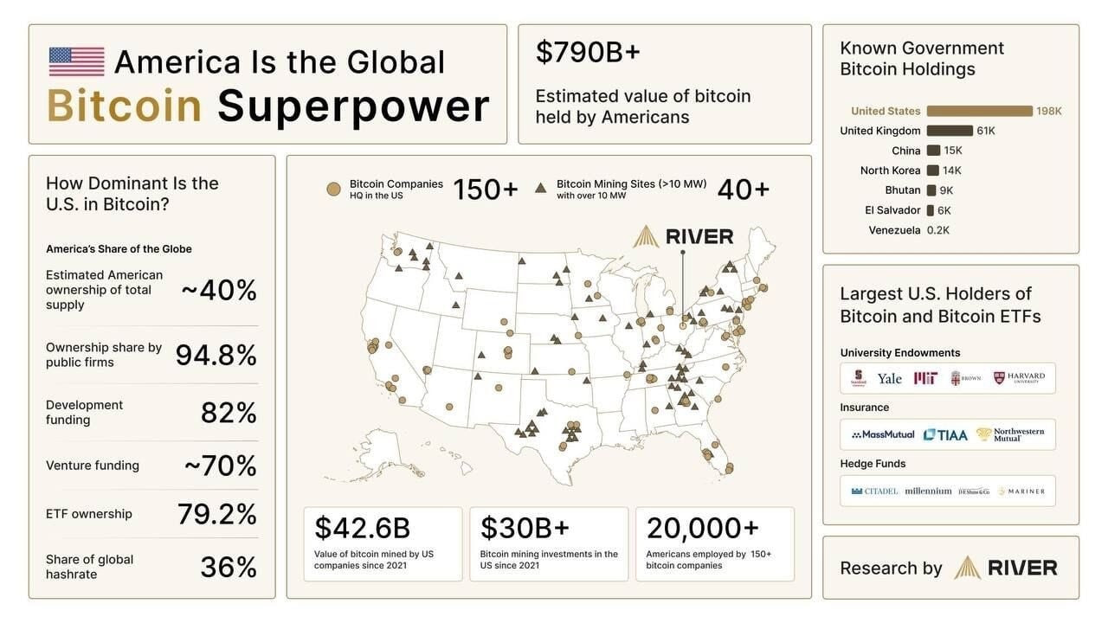Let’s begin with a fundamental question:
At levels above $120,000, is Bitcoin still worth holding as a reserve asset?

This is not merely a matter of timing or trend—it reflects a deeper understanding of U.S. Treasury dynamics, and, more broadly, one’s perspective on the future trajectory of this nation.

1. Bitcoin now functions as a form of U.S. strategic reserve—akin, in many respects, to traditional gold holdings. National reserves are quietly increasing.

2. Major Wall Street institutions are accumulating it—across funds, public companies, and as part of diversified financial planning frameworks.

3. American individuals hold the largest portion of global Bitcoin reserves. Whether publicly disclosed or not, many around us have already made the decision to allocate. It reflects a quiet but resolute belief in the emerging frontier of on-chain wealth.

4. Bitcoin is not at its peak. Its long-term appreciation remains intact, supported by structural shifts rather than speculation.

5. The underlying value logic of Bitcoin has fundamentally changed. It is no longer merely a decentralized asset—it is increasingly intertwined with the evolving global role of U.S. financial leadership.

So, do you now see why holding Bitcoin as a reserve asset is not about trend-following, but about positioning for the next chapter of financial history?

Of course, if you are new to this space or still forming your views, I invite you to follow our forum sessions for deeper, more structured learning.

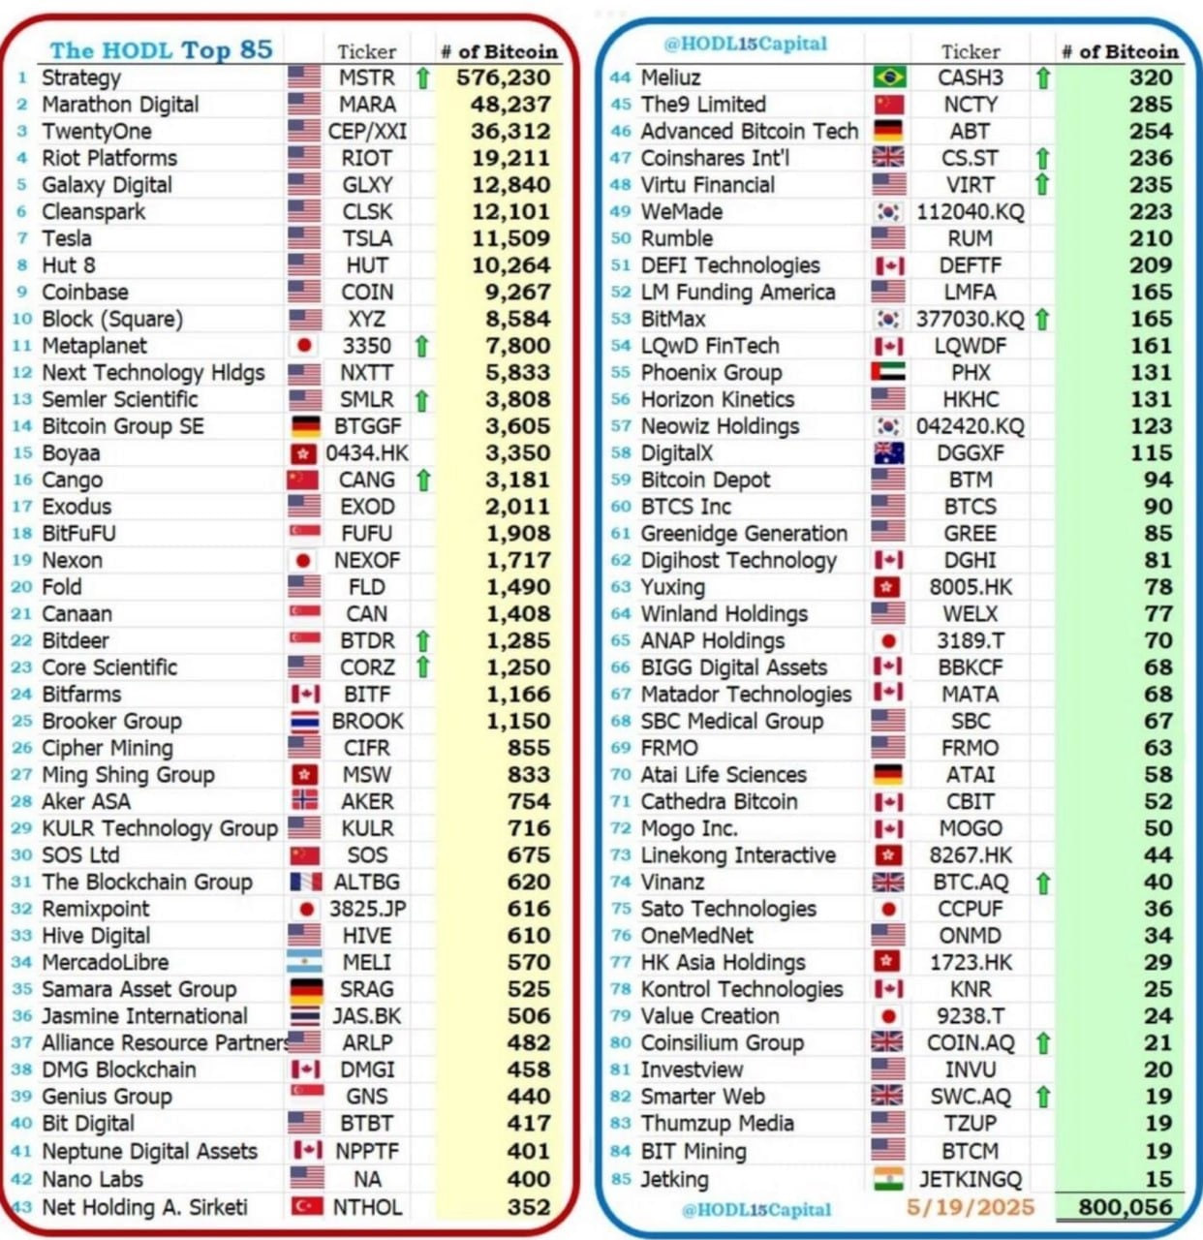Of course, if you’ve yet to fully grasp the rationale behind holding Bitcoin as a reserve asset, there remains another avenue to generate exceptional returns—through U.S. equities tied to the crypto sector.

These are stocks whose valuations and upward momentum are anchored in market confidence surrounding the rise of cryptocurrency prices.

The most straightforward investment logic here is this: companies that generate profit by directly holding Bitcoin on their balance sheets. In simple terms, they engage in continuous accumulation, and as the asset appreciates, the result is significant capital gains. The most prominent examples are MSTR / IBIT—one a publicly traded corporation, the other a fund. Both underscore the potential long-term returns of strategic reserve positioning.

Another type of company operates in mining—that is, generating Bitcoin through computational power. These firms invest in infrastructure and electricity in exchange for on-chain rewards. As the value of Bitcoin rises, so too does the valuation of these firms. CLSK / HUT exemplifies this model.

Have you traded these names before? Have they yielded meaningful profits for you?

There is another category of Bitcoin-linked businesses: service providers within the crypto ecosystem. Put simply, these are firms that offer integrated services such as trading, transfer, and token issuance.

Examples include HOOD / COIN—companies that serve as access points for market participation.

As Bitcoin continues to rise, the resulting surge in market demand tends to attract significant capital inflows. This wave of heightened activity often brings renewed optimism to the valuation outlook of such public companies. As their revenue grows alongside transaction volume, the improved fundamentals can strengthen institutional confidence and lead to price premiums in the equity market.

These firms also play a vital role in the broader movement toward the tokenization of financial assets. Tokenization is poised to become a foundational mechanism for on-chain assets and digital wealth—potentially representing a new chapter in the evolution of securitized markets.

In the past, the question was, Has your company gone public?
In the near future, it may well become, Has your company been tokenized?

Have you ever traded in these types of stocks? And how do you view their long-term prospects?

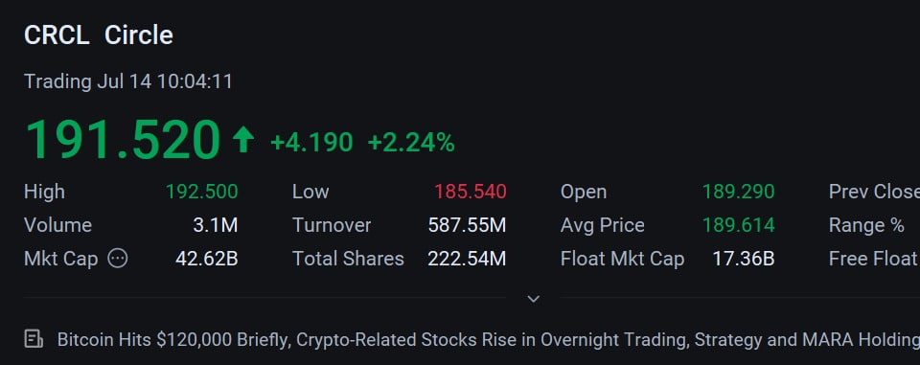The final category is foundational infrastructure: stablecoin issuers.

Take CRCL, for instance. As the world’s first publicly listed stablecoin issuer, its strategic significance is comparable to that of Coinbase—and, in time, it may well surpass it.

Stablecoins form the backbone of the crypto economy. With stablecoins, digital markets gain a reliable price anchor for transactional activity.

To draw a familiar analogy: without access to the U.S. dollar, global trade would have to rely on gold as a medium of exchange. Imagine a scenario in which Walmart prices a gallon of milk at 0.01 grams of gold. In such a system, every transaction would be exposed to constant price fluctuation, undermining liquidity and usability.

However, when that same item is priced at 5 USD, the transaction becomes intuitive, scalable, and efficient. In this sense, physical U.S. dollars function as a form of real-world stablecoin.

On-chain stablecoins operate according to the same logic. While they bear a distinct name, their role is to deliver price stability in decentralized environments, much as fiat currency does in traditional markets.

As Bitcoin prices continue to rise, demand for such foundational infrastructure grows in tandem. And with that, the outlook for CRCL becomes increasingly difficult to overstate.

Only when you gain a deep understanding of these core crypto-related stocks can you discern which investments deserve your focus this week.
So, how might the U.S. equity markets perform in the coming days? What concerns remain?

To begin: based on pre-market futures activity, the market sentiment appears to dip initially before rebounding, while the VIX—the so-called fear index—is undergoing a clear uptick.
This signals that Monday’s primary focus will be on the crypto sector, but broader market trading leans toward caution.

Why such prudence?

The new tariffs have unsettled markets, while earnings season, inflation data, and tensions surrounding the Federal Reserve have collectively sown anxiety among investors.

With Wall Street’s earnings season approaching, and geopolitical frictions intensified by Trump’s escalation of trade tensions, volatility and diplomatic unease have taken hold.

The week begins quietly, but this calm is unlikely to last.

As earnings reports roll out in earnest, the spotlight will shift to major banks. These financial institutions will provide critical insight into the underlying health of the economy.

Meanwhile, technology stocks remain in focus, their prospects shadowed by trade disputes threatening corporate profitability and global economic stability.

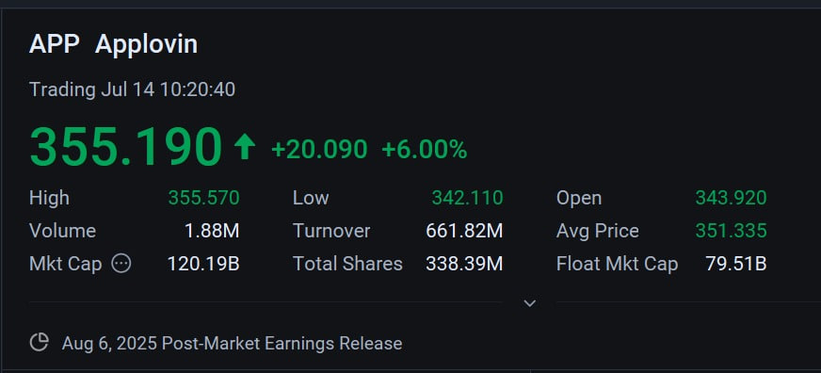When it comes to the technology sector, my focus remains on the application of AI—specifically, on companies that are advancing its real-world utility.

Looking back at our recent trades, we’ve consistently followed names like APP / DUOL / RGTI / RDDT. These four selections have formed the core of what I’ve been sharing over time.

The rationale is straightforward: technological innovation, in and of itself, holds little value if it cannot be meaningfully applied. It is only through real-world deployment that technology contributes to human progress and economic growth.

Since 2023, the primary thesis behind AI-related equities has centered on upstream infrastructure—large language models and computational power. In this framework, chipmakers and compute providers have served as foundational enablers, offering the processing capacity necessary to train increasingly complex models. Their strategic role has naturally translated into elevated market valuations.

The next phase, therefore, lies in application. The core investment logic will shift from foundational infrastructure to companies bringing AI into practical, scalable use.

That is precisely the transition we are positioning for today. And if you’ve been acting on this thesis, then the rebound in APP—paired with a “buy-the-dip” approach—is becoming a clear reflection of how theory transforms into disciplined execution.

Monday Market Outlook

Beyond the anticipated U.S. CPI release and the formal onset of earnings season, this week warrants particular attention to developments on Capitol Hill. Congress has officially designated this period as “Crypto Week,” with planned deliberations on the GENIUS Act, the CLARITY Act, and proposed legislation that would prohibit a U.S. Central Bank Digital Currency (CBDC). Collectively, these measures have the potential to redefine the structural landscape of digital assets.

Investor FOMO surrounding crypto is only beginning to take shape. According to Acumeta’s analytics, the current Greed Index stands at 70. As such, maintaining core positions during the first half of the week appears prudent, while short-term traders might consider securing gains in the latter half. For those with a longer horizon, the prevailing volatility should not be a cause for concern.

Last Friday’s market narrative was abruptly disrupted by speculation surrounding Fed Chair Jerome Powell’s potential resignation. The shift in tone—from exuberance to caution—was palpable. Powell’s position as the steward of global monetary policy places his tenure at the heart of institutional continuity. Any change introduces additional uncertainty into an already fragile equity environment.

Looking ahead, the CPI report scheduled for Tuesday may intensify market anxiety, particularly in the afternoon session, where heightened selling pressure could materialize.

For those newly joining us, it’s important that I provide a brief introduction to a key mechanism we employ here: compensation-backed verified equity trading.

At the Quantitative Think Tank Center, our work is grounded in equipping you with advanced, strategy-driven knowledge tailored for sophisticated trading in public markets. We also welcome thoughtful interaction—your insights and feedback on our quant models are not only valued, but essential to the spirit of ongoing refinement.

Beyond the pursuit of understanding, however, our goal is to help you realize measurable investment returns—returns that reflect the compounding of insight and discipline over time.

To ensure that our approach is both secure and grounded in practical accountability, we’ve implemented a validated compensation-backed mechanism for certain equity trades.

What does this mean, in practice?

Quite simply, when you execute trades in full alignment with the quantitative signals I publish—observing position sizing and entry points as specified—you may be eligible for downside protection on a defined allocation within a set timeframe. Should a covered position incur a loss, compensation may be provided.

To maintain verification standards, please document each transaction with a screenshot and submit it to my assistant.

This structure is designed to allow you to participate in our strategies with confidence—knowing that both your learning and your capital are treated with the seriousness they deserve.

If you’ve just joined our quantitative strategy discussion group, allow me to briefly introduce its purpose.

This community is dedicated to the long-term sharing of high-efficiency, value-oriented investment strategies. Over the coming months, all content will be provided free of charge. The goal is to establish a direct channel of communication—where I can listen to your feedback regarding my quantitative strategies, the Acumeta platform, the performance of my analyst team, and the results of our investment work.

Your input will serve as a foundation for refining and improving what we do—based not on theory, but on actual trading results.

Through this practical, real-world approach, we hope to draw the attention of a broader group of investors, and in doing so, further build the brand value of the NOVA Quantitative Think Tank Center.

Bringing Acumeta to a wider audience—so that more investors can witness and benefit from its tools and insights—is precisely what drives us forward.

For secure access to our platform, please visit our website: https://www.novaquantpro.com/news

And after the market closes, our community forum will continue to provide strategy updates—offering the most effective trade ideas and opportunities we see.

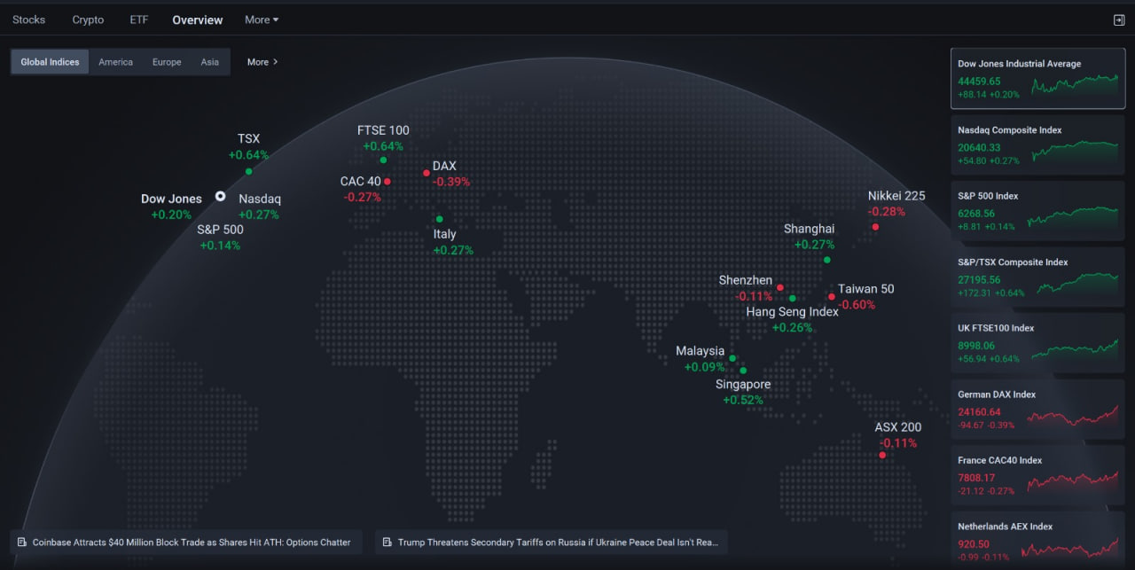Folks, wishing you a strong close to the day.

Clarity of thought is the foundation of conviction.

It is essential that we grasp the deeper implications behind Congressional signals—how they recalibrate market expectations and redirect capital flows.

Equally, data remains our compass. Through Acumeta’s most advanced quantitative strategies, we seek to identify subtle signals often invisible to the naked eye—real opportunities obscured by sentiment and noise.

Our models are not swayed by emotion. They are loyal only to the integrity of data, offering disciplined and objective decision support amid volatility.

In moments of heightened thrill, composure and discipline become paramount.

Let our quantitative strategies be your anchor—sharp when needed, grounded when most are swept away.

The call has been sounded.

Let us enter the coming week’s crypto-themed momentum with a quiet confidence—and the precision of Acumeta’s quantitative edge.

Opportunity awaits. Let’s meet it on our own terms.

Acumeta is currently in a live simulation phase, accessible through the official window on my website: https://www.novaquantpro.com/news
There, you can stay updated on its development timeline. At some point in the future—once it has been tested in real-world conditions, passed essential security checks, and generated a meaningful database of reference-grade parameters—we will begin to bring it to market and set pricing for our range of services.

At this stage, we are offering free access for validation purposes. The goal is for you to gain one specific outcome in the trading space: direct feedback on equity trading.
In the future, we plan to move vertically into broader domains—crypto markets, futures, and foreign exchange—each serving as a necessary testbed for making the system more mature and more intelligent.

I hope you will first become a validator and beneficiary—before ever becoming a customer.
Do you agree with this approach to distribution?

Over the next 6 to 9 months, I will be sharing and engaging through a series of community forum sessions, as outlined in the charted curriculum.
Each segment of this series will be broken down into key knowledge points—designed to offer every participant here a window into the analytical logic and decision-making frameworks drawn from top-tier quantitative strategies.

Ultimately, Acumeta is being trained to evolve beyond my personal capabilities—carrying forward years of accumulated trading experience and refined judgment, while integrating the strengths of multiple analysts. The goal is to create a highly efficient and secure investment support tool for future investors.

If you find this content meaningful, I will begin, starting today, to provide daily updates through these community forum sessions—continuously interpreting market trends in light of current events and policy shifts, highlighting active trading sectors, and sharing and tracking relevant equity signals.

Does this form of interactive, real-time learning resonate with you?

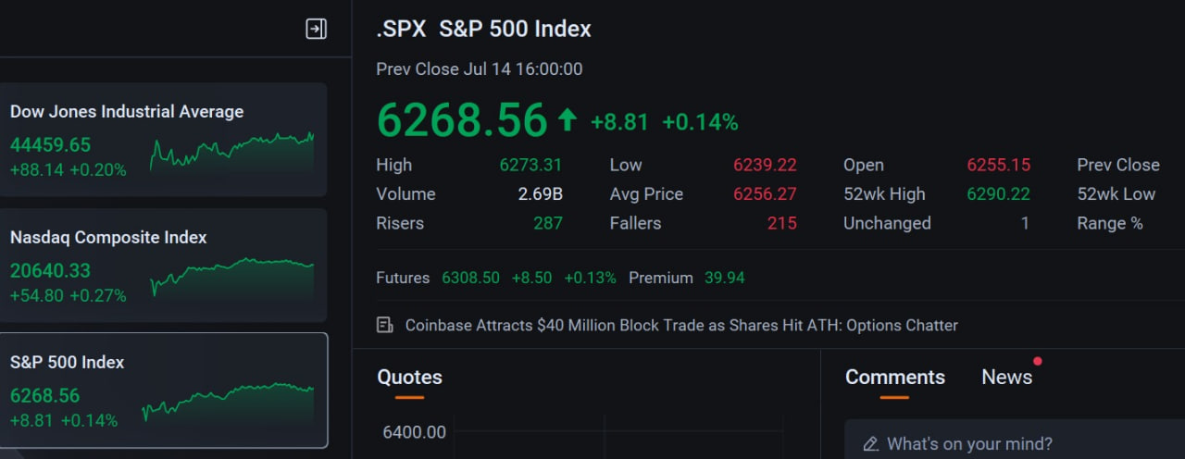How should we interpret Monday’s market performance?

By the close of U.S. trading, all three major indices recovered from early losses to end in positive territory—finishing with a cheerful green bar.
Beneath the surface, however, notable divergences emerged:

1. Crypto-related equities opened strong but lost momentum into the close. What does this suggest?
Despite the tailwind from the broader “Crypto Week” narrative, enthusiasm that had built up over the past week and weekend led to short-term profit accumulation. As a result, today's session saw increased selling pressure from those seeking to lock in gains amid heightened sentiment.

2. Within tech, Nvidia’s intraday tug-of-war at elevated levels signals the fading of short-term speculative exuberance and the emergence of market indecision. This shift in sentiment is evident in the candlestick patterns, which reflect a clear rotation of positioning between buyers and sellers.
That said, modest gains in other large-cap names helped stabilize the indices. Interestingly, Monday’s relative strength came from AI application stocks—likely driven by a tactical rotation into “buy the dip” within that theme.

Why is the market experiencing such a pronounced tug-of-war between bullish and bearish sentiment? Could this divergence lead to stronger market opportunities?

When a clear split between bullish and bearish positioning emerges, it often signals that the market has entered a critical temporal or policy-driven inflection point.

This Tuesday marks the release of the CPI data—a key event. In light of growing speculation around a potential rate cut in July, the data has taken on added significance. The market is increasingly treating it as a proxy for policy direction. Additionally, former President Trump’s ongoing pressure on Chair Powell has reinforced expectations of looser monetary policy.
Even with the VIX rising on Monday, signaling elevated short-term anxiety, the bulls stepped in with conviction.

On the other side of the divergence, the bears chose to lock in profits and de-risk ahead of Tuesday’s data—interpreting it as a potential catalyst for more volatility. Their approach reflects a conservative posture: anticipate, reduce exposure, and avoid being forced into reactive trades.

Adding to the caution is the broader concern around tariffs. The timing is sensitive, particularly around U.S.–EU negotiations. Any deterioration in the dialogue—or signals of retaliatory tariffs from Europe—has become a material concern for markets.

Still, divergences of this kind are not necessarily negative. They often precede pullbacks that create more attractive entry points. In this case, the setup may well reflect a classic buy-the-dip opportunity rather than a cause for alarm.

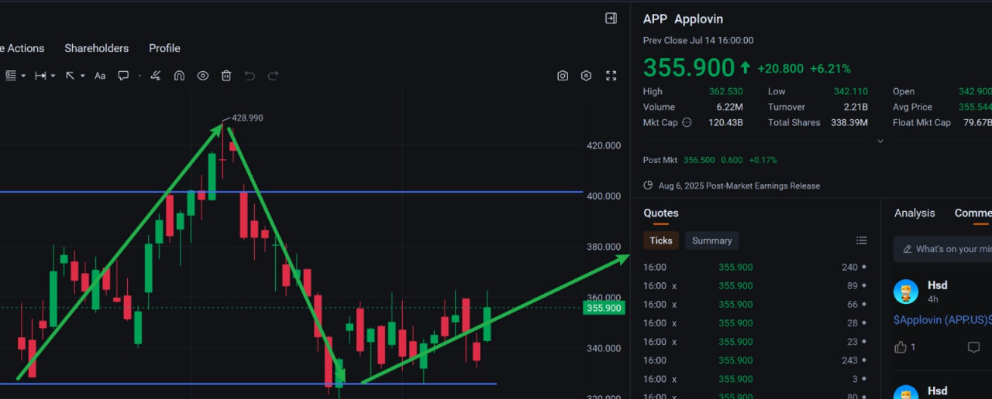In Monday’s tug-of-war market, the test of our quantitative decision-making holds particular weight.

Those who have consistently followed our trading signals likely recognize this by now: I’ve never been one to chase trends for the sake of momentum.
Instead, I’ve long favored identifying potential inflection points before they come into broad focus—positioning thoughtfully, rather than reactively.
If that’s your approach as well, you’re in good company.
In volatile environments like this, such foresight helps mitigate the whipsaw effects of short-term pullbacks. I often refer to this as a form of trading cadence—a kind of disciplined rhythm in navigating uncertainty.

Take our selected names in the AI application space—APP / RGTI / DUOL / RDDT.
All four posted intraday gains before giving back some ground, reflecting the emotional undercurrent of short-term trading.
Yet our strategy of buying on weakness has secured a favorable cost basis. Among them, APP stands out: a company offering AI-driven advertising infrastructure, now finding renewed interest at lower valuations.
With Q2 earnings approaching in early August, I believe we remain in the midst of its upward trajectory.

As you realize gains, I hope you’re also internalizing this cadence of positioning.

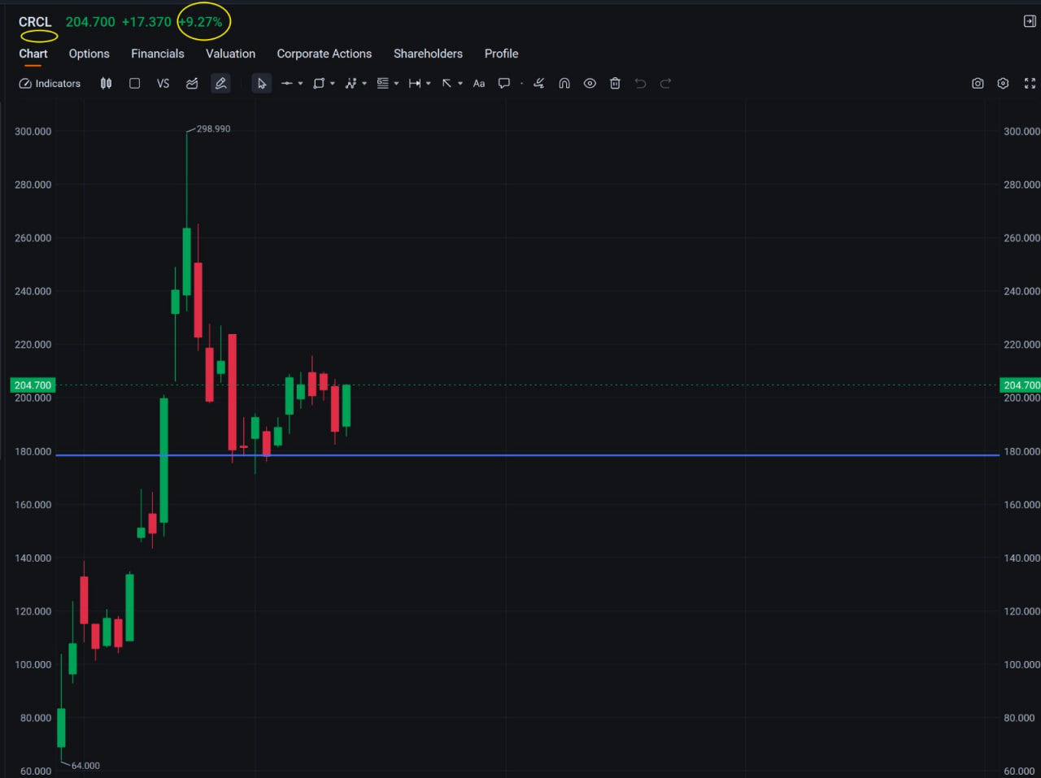Naturally, the most striking performance came from the crypto sector—specifically CRCL.

We issued a trading signal last Thursday. By Friday, the price pulled back below $200, establishing a well-defined accumulation range between $180 and $200.
Why do I view this range as strategically advantageous?
At its core, it’s a matter of valuation. From a long-term perspective, the company behind CRCL—the issuer of USDC—represents foundational infrastructure within the digital asset space.

As the issuer of a leading stablecoin, its role within the crypto ecosystem is comparable to that of electricity or oil during the Second Industrial Revolution.
Just as the countries that harnessed those energy sources went on to build dominant industrial civilizations and robust economic systems, so too does the foundation of USDC suggest the potential to shape the next generation of financial architecture.

In this context, USDC functions not simply as a stablecoin but as a form of infrastructural energy for the crypto economy. Its strategic importance may, in time, parallel that of utilities in earlier eras of economic transformation.

Secondly, it is only once we understand the structural importance of USDC that we can fully appreciate the long-term value proposition of CRCL.

The emergence of stablecoins has been a defining milestone in the evolution of the crypto industry—comparable, in many ways, to the role currency itself played in enabling the efficiency of global trade and commerce.
In nearly every form of crypto market participation—whether spot transactions, futures, options, or staking—stablecoins serve as the underlying unit of account.

This concept of asset labeling relies fundamentally on price stability. Without it, market confidence erodes, and volatility becomes unmanageable.

In that sense, USDC plays a non-negotiable role as the reference asset for the system—a layer of consistency essential to functioning markets. And where demand is essential, value follows.

Would you consider that a tailwind for CRCL?

The increasing market demand continues to drive up valuation. Is the demand for USDC steadily rising?

We all understand why Nvidia has become the leading chipmaker and the most valuable company globally—it’s due to the growth of the AI industry. From major corporations to small startups, everyone is seeking access to Nvidia’s chips. This continuously growing demand has pushed up Nvidia’s market cap. In the context of the AI era, this is a logical interpretation.

By the same logic, as the three major crypto bills move toward final implementation, the rapid development of the crypto industry will likely lead to a continued increase in the demand for stablecoins.
Whether from exchanges, P2P settlement providers, institutional traders, or individual investors—all of them will need more USDC for their activities. So the demand is almost certain to grow.

Do you believe this will lead to a higher valuation for CRCL?

At present, its market capitalization is $45.5 billion, managing an issuance of 61 billion USDC.
When that issuance surpasses 100 billion—or even 500 billion—do you believe the stock price will fall, or rise?

So, beyond market forces, what else is driving this growing demand?

The answer is: U.S. Treasury bonds.

According to current regulations on stablecoin issuance, every unit of USDC must be backed by an equivalent reserve in U.S. dollars, gold, or government securities.
Among these, Treasuries have become the primary reserve asset for most issuers—partly due to regulatory requirements, and partly because they represent a new and favorable channel for U.S. government debt distribution.

In addition, issuers benefit from the interest income generated by holding Treasuries. This structure provides a layer of stability and predictability—not unlike compensation-backed trading mechanisms that offer security and clarity in uncertain markets.

Why not hold reserves in cash? As is widely known, short-term bank interest rates in the U.S. are typically lower than Treasury yields. Moreover, banks themselves carry risk. As the collapse of Silicon Valley Bank reminded us, institutional failure is possible—and in such events, only limited deposit amounts are insured.

For an issuer managing large-scale reserves, this introduces unnecessary exposure.

In contrast, holding U.S. Treasuries carries virtually no bankruptcy risk—except in one unlikely scenario: a sovereign default brought about by a collapse in U.S. credibility or a full-scale political breakdown.
But as long as the U.S. military remains strong, and the peaceful transfer of power between parties remains intact, the risk of national insolvency remains remote. Wouldn’t you agree?

This is why, in this context, Treasuries > cash.

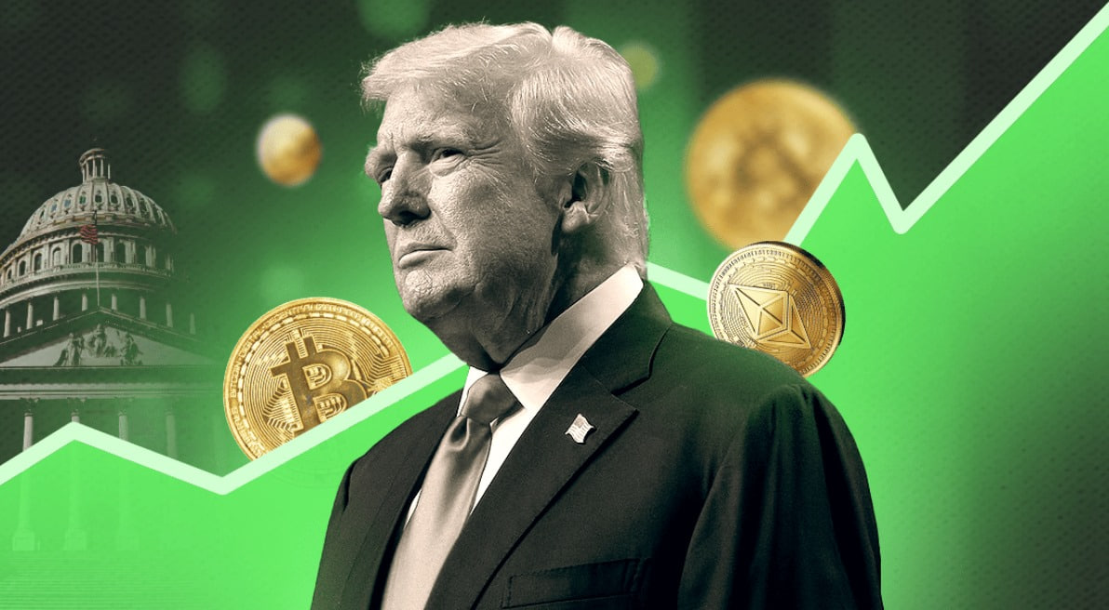During President Trump’s administration, the Big Beautiful Act led to an expansion of the debt ceiling—signaling that the U.S. government will likely continue issuing new Treasuries well into the future.
Beyond pressing the Federal Reserve to lower interest rates in order to reduce debt servicing costs, a more pressing question remains: Who will absorb these new issuances?

In this regard, stablecoin issuers may already be answering that call.

For now, the scale appears modest. But the long-term implications are substantial.

As demand for USDC expands, the trajectory becomes clear: should it surpass $100 billion—or even reach into the trillions—the associated demand for Treasuries will become economically meaningful.
And in that moment, every participant in the digital asset economy—by simply holding a stablecoin—becomes an indirect holder of U.S. government debt.
In essence, to hold USDC is to be aligned with the direction and strength of the United States itself.

In a certain sense, I find this deeply reassuring. I have great affection for this country and a genuine hope that America will continue to grow in strength, remaining a global leader in innovation, stability, and governance.

Viewed from this broader perspective, one begins to grasp the magnitude of CRCL’s potential role—not merely as a market actor, but as a company carrying a quiet national mandate.

By the time you’ve read this far, perhaps you now understand why I identified this as a compelling opportunity—despite it not being at the most “perfect” entry price.

CRCL does not represent the entirety of your portfolio, but it embodies a deeper mission for the future of crypto. I would encourage you to own it, observe it, and—perhaps in time—appreciate it. In many ways, it has become a symbol of on-chain wealth.

As you may know, in our community forum sessions, completing small tasks often leads to ceremonial raffles—with USDC rewards. For you, that may represent a stroke of luck, but more meaningfully, it serves as a gateway and stepping stone to the financial value that may emerge on-chain in the years ahead.

Naturally, there are many ways to gain exposure to CRCL. Beyond simply holding the underlying equity, you may also consider trading options.
If you reached out to my assistant last Thursday, you likely already received the relevant options signal.

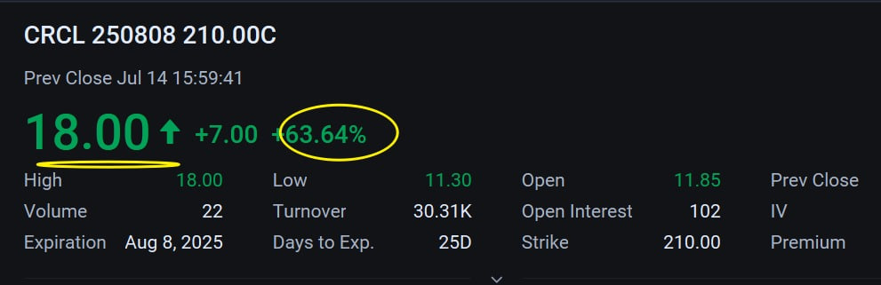The options trade signal shown in the chart surged by 63% today.
Yes, this is clearly an aggressive trading choice—and also one of the most profitable ways to capture gains in a highly volatile stock.

Why has the option price continued to rise? Taking this specific signal as an example:
The content of the signal indicates that I expect the stock CRCL to rise to $210 by its expiration date on August 8 this year.

Put simply, it's based on three elements: a bullish outlook, a timeframe, and a target price.

As of today, the stock has already risen back to $204.
There is still nearly a month until August 8. Do you think the stock will continue to rise? With continued positive developments during “Crypto Week,” could market demand be further stimulated?

If your understanding aligns with mine, then this trade is highly likely to achieve its intended target.

If I choose to trade CRCL options, must I wait until August 8 to decide whether to sell?

No—certainly not. The United States is a free country, and the beauty of its financial markets lies in precisely this kind of freedom of choice, evident even in the finer details of trading.

Suppose CRCL reaches $210 on July 15. You can choose to sell then.
The same applies for July 16, July 23—or any time before August 8.
The real question is whether the price of the option you hold has surpassed your entry cost.

What determines whether the price of your CRCL option rises? It’s simple: the stock price.
As CRCL’s share price climbs, the value of the option increases accordingly over the time window.

For example, the CRCL option signal released last Thursday had a cost basis of approximately $16 per contract.
As of now, it has already risen to $18 per contract.

So—have you made a profit? Have you captured the premium?

If the answer is yes, then you seized the moment.
If not—did you miss it, or did you learn from it?

My hope is that you’ll apply what you’ve learned to the next opportunity.
Can you do that, guys?

I'm truly grateful for your continued reading and thoughtful engagement each day.
The value we’re creating here is not the work of one individual alone—we are each driven by a sense of purpose.

For my part, I seek to build credibility through your feedback, to establish the reputation of my Quantitative Think Tank Center, and in doing so, to elevate the long-term valuation of Acumeta as a world-class platform.

Your duty, perhaps, is to expand your own investment horizon—to gain access to quantitative insights and strategies that may have previously felt out of reach. That knowledge may well serve as the foundation for your own family's generational wealth.

My friend, this mutual sense of purpose—this exchange of insight and ambition—will, in time, quietly strengthen the bonds of our friendship.

Each day we welcome new members to this growing community.
If you find yourself with lingering questions, I encourage you to revisit earlier sessions—and don't hesitate to reach out to my assistant. Her kindness and clarity will help you find the answers you're looking for more quickly.

Folks, I understand your pursuit—completely.

In the vast sea of investing, the most enduring wisdom is often found in radical simplicity. We have no need for ornamental language, nor do we gain anything by cloaking our insights in unnecessary complexity.

To grasp the essence of a thing is to cut through its surface—to see clearly the governing principle beneath.

In the world of markets, this is akin to parting the fog to reveal the engine that truly drives price and value. What we seek is not to forecast every minor fluctuation, but to discern those sweeping, irreversible trends that shape the future.
It is the movement of value, the disruption of technology, the repetition of human nature.

The deeper truths of investing are not hidden in shadow—they are in plain sight. But they require a clarity of mind, a discipline of focus.
Turn away from noise. Resist the temptation of the superficial. Focus instead on the few assets that can, over time, compound real value.

Together, let us use this key of simplicity to unlock the more lasting secrets of investment.

Bonus learning—answer for a chance to receive gifts: USDC, token vouchers, and more.

1. What is the current price of Bitcoin? In your view, which publicly traded stock is most closely and effectively tied to Bitcoin’s value?

2. Which stablecoin are you familiar with that is the foundational layer of the crypto economy?

3. In no more than 100 words: Why do you believe CRCL is a core position in any serious crypto equity portfolio?

Please share your answers with my assistant. Wishing you a wonderful evening—and let's meet again on Tuesday.

